##### Activity 6.6

Observe fish in an aquarium. They open and close their mouths and the gill-slits (or the operculum which covers the gill-slits) behind their eyes also open and close. Are the timings of the opening and closing of the mouth and gill-slits coordinated in some manner?

Count the number of times the fish opens and closes its mouth in a minute.

Compare this to the number of times you breathe in and out in a minute.

Since the amount of dissolved oxygen is fairly low compared to the amount of oxygen in the air, the rate of breathing in aquatic organisms is much faster than that seen in terrestrial organisms. Fishes take in water through their mouths and force it past the gills where the dissolved oxygen is taken up by blood.

Terrestrial organisms use the oxygen in the atmosphere for respiration. This oxygen is absorbed by different organs in different animals. All these organs have a structure that increases the surface area which is in contact with the oxygen-rich atmosphere. Since the exchange of oxygen and carbon dioxide has to take place across this surface, this surface is very fine and delicate. In order to protect this surface, it is usually placed within the body, so there have to be passages that will take air to this area. In addition, there is a mechanism for moving the air in and out of this area where the oxygen is absorbed.

In human beings (Fig. 6.9), air is taken into the body through the nostrils. The air passing through the nostrils is filtered by fine hairs that line the passage. The passage is also lined with mucus which helps in this process. From here, the air passes through the throat and into the lungs. Rings of cartilage are present in the throat. These ensure that the air-passage does not collapse.

Within the lungs, the passage divides into smaller and smaller tubes which finally terminate in balloon-like structures which are called alveoli (singular–alveolus). The alveoli provide a surface where the exchange of gases can take place. The walls of the alveoli contain an extensive network of blood-vessels. As we have seen in earlier years, when we breathe in, we lift our ribs and flatten our diaphragm, and the chest cavity becomes larger as a result. Because of this, air is sucked into the lungs and fills the expanded alveoli. The blood brings carbon dioxide from the rest of the body for release into the alveoli, and the oxygen in the alveolar air is taken up by blood in the alveolar blood vessels to be transported to all the cells in the body. During the breathing cycle, when air is taken in and let out, the lungs always contain a residual volume of air so that there is sufficient time for oxygen to be absorbed and for the carbon dioxide to be released.

When the body size of animals is large, the diffusion pressure alone cannot take care of oxygen delivery to all parts of the body. Instead, respiratory pigments take up oxygen from the air in the lungs and carry it to tissues which are deficient in oxygen before releasing it. In human beings, the respiratory pigment is haemoglobin which has a very high affinity for oxygen. This pigment is present in the red blood corpuscles. Carbon dioxide is more soluble in water than oxygen is and hence is mostly transported in the dissolved form in our blood.

##### More to Know!

Using tobacco directly or any product of tobacco in the form of cigar, cigarettes, *bidis, hookah, gutkha*, etc., is harmful. Use of tobacco most commonly affects the tongue, lungs, heart and liver. Smokeless tobacco is also a major risk factor for heart attacks, strokes, pulmonary diseases and several forms of cancers. There is a high incidence of oral cancer in India due to the chewing of tobacco in the form of gutkha. Stay healthy; just say NO to tobacco and its products!

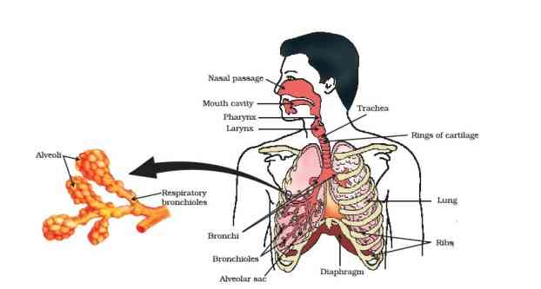

Figure 6.9 7 (a) Air being passed into lime water with a pichkari/syringe, (b) air being exhaled into lime water

##### Do you Know?

**Smoking is injurious to health.**

Lung cancer is one of common causes of deaths in the world. The upper part of respiratory tract is provided with small hair-like structures called cilia. These cilia help to remove germs, dust and other harmful particles from inhaled air. Smoking destroys these hair due to which germs, dust, smoke and other harmful chemicals enter lungs and cause infection, cough and even lung cancer.

##### Do you Know?

If the alveolar surface were spread out, it would cover about80m280m^{2}

. How much do you think the surface area of your body is? Consider how efficient exchange of gases becomes because of the large surface available for the exchange to take place.

If diffusion were to move oxygen in our body, it is estimated that it would take 3 years for a molecule of oxygen to get to our toes from our lungs. Aren’t you glad that we have haemoglobin?

#### Questions

What advantage over an aquatic organism does a terrestrial organism have with regard to obtaining oxygen for respiration?

What are the different ways in which glucose is oxidised to provide energy in various organisms?

How is oxygen and carbon dioxide transported in human beings?

How are the lungs designed in human beings to maximise the area for exchange of gases?

### 6.4 - Transportation

#### 6.4.1 - Transportation in Human Beings

##### Activity 6.7

Visit a health centre in your locality and find out what is the normal range of haemoglobin content in human beings.

Is it the same for children and adults?

Is there any difference in the haemoglobin levels for men and women?

Visit a veterinary clinic in your locality. Find out what is the normal range of haemoglobin content in an animal like the buffalo or cow.

Is this content different in calves, male and female animals?

Compare the difference seen in male and female human beings and animals.

How would the difference, if any, be explained?

We have seen in previous sections that blood transports food, oxygen and waste materials in our bodies. In Class IX, we learnt about blood being a fluid connective tissue. Blood consists of a fluid medium called plasma in which the cells are suspended. Plasma transports food, carbon dioxide and nitrogenous wastes in dissolved form. Oxygen is carried by the red blood corpuscles. Many other substances like salts, are also transported by the blood. We thus need a pumping organ to push blood around the body, a network of tubes to reach all the tissues and a system in place to ensure that this network can be repaired if damaged.

##### Our pump — the heart

The heart is a muscular organ which is as big as our fist (Fig. 6.10). Because both oxygen and carbon dioxide have to be transported by the blood, the heart has different chambers to prevent the oxygen-rich blood from mixing with the blood containing carbon dioxide. The carbon dioxide-rich blood has to reach the lungs for the carbon dioxide to be removed, and the oxygenated blood from the lungs has to be brought back to the heart. This oxygen-rich blood is then pumped to the rest of the body.

We can follow this process step by step (Fig. 6.11). Oxygen-rich blood from the lungs comes to the thin-walled upper chamber of the heart on the left, the left atrium. The left atrium relaxes when it is collecting this blood. It then contracts, while the next chamber, the left ventricle, relaxes, so that the blood is transferred to it. When the muscular left ventricle contracts in its turn, the blood is pumped out to the body. De-oxygenated blood comes from the body to the upper chamber on the right, the right atrium, as it relaxes. As the right atrium contracts, the corresponding lower chamber, the right ventricle, dilates. This transfers blood to the right ventricle, which in turn pumps it to the lungs for oxygenation. Since ventricles have to pump blood into various organs, they have thicker muscular walls than the atria do. Valves ensure that blood does not flow backwards when the atria or ventricles contract.

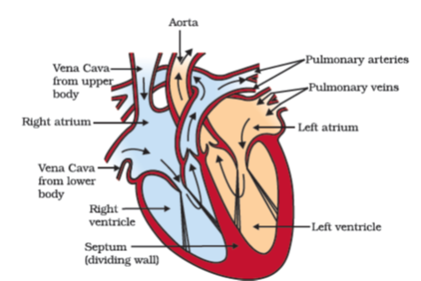

Figure 6.10 Schematic sectional view of the human heart

##### Oxygen enters the blood in the lungs

The separation of the right side and the left side of the heart is useful to keep oxygenated and de-oxygenated blood from mixing. Such separation allows a highly efficient supply of oxygen to the body. This is useful in animals that have high energy needs, such as birds and mammals, which constantly use energy to maintain their body temperature. In animals that do not use energy for this purpose, the body temperature depends on the temperature in the environment. Such animals, like amphibians or many reptiles have three-chambered hearts, and tolerate some mixing of the oxygenated and de-oxygenated blood streams. Fishes, on the other hand, have only two chambers to their hearts, and the blood is pumped to the gills, is oxygenated there, and passes directly to the rest of the body. Thus, blood goes only once through the heart in the fish during one cycle of passage through the body. On the other hand, it goes through the heart twice during each cycle in other vertebrates. This is known as double circulation.

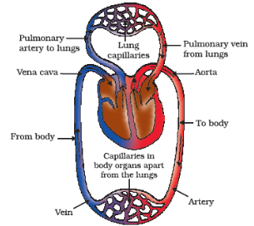

Figure 6.11 Schematic representation of transport and exchange of oxygen and carbon dioxide

##### More to know!

**Blood pressure**

The force that blood exerts against the wall of a vessel is called blood pressure. This pressure is much greater in arteries than in veins. The pressure of blood inside the artery during ventricular systole (contraction) is called systolic pressure and pressure in artery during ventricular diastole (relaxation) is called diastolic pressure. The normal systolic pressure is about 120 mm of Hg and diastolic pressure is 80 mm of Hg.

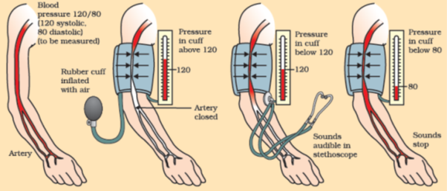

Blood pressure is measured with an instrument called sphygmomanometer. High blood pressure is also called hypertension and is caused by the constriction of arterioles, which results in increased resistance to blood flow. It can lead to the rupture of an artery and internal bleeding.

##### The tubes – blood vessels

Arteries are the vessels which carry blood away from the heart to various organs of the body. Since the blood emerges from the heart under high pressure, the arteries have thick, elastic walls. Veins collect the blood from different organs and bring it back to the heart. They do not need thick walls because the blood is no longer under pressure, instead they have valves that ensure that the blood flows only in one direction.

On reaching an organ or tissue, the artery divides into smaller and smaller vessels to bring the blood in contact with all the individual cells. The smallest vessels have walls which are one-cell thick and are called capillaries. Exchange of material between the blood and surrounding cells takes place across this thin wall. The capillaries then join together to form veins that convey the blood away from the organ or tissue.

##### Maintenance by platelets

What happens if this system of tubes develops a leak? Think about situations when we are injured and start bleeding. Naturally the loss of blood from the system has to be minimised. In addition, leakage would lead to a loss of pressure which would reduce the efficiency of the

pumping system. To avoid this, the blood has platelet cells which circulate around the body and plug these leaks by helping to clot the blood at these points of injury.

##### Lymph

There is another type of fluid also involved in transportation. This is called lymph or tissue fluid. Through the pores present in the walls of capillaries some amount of plasma, proteins and blood cells escape into intercellular spaces in the tissues to form the tissue fluid or lymph. It is similar to the plasma of blood but colourless and contains less protein. Lymph drains into lymphatic capillaries from the intercellular spaces, which join to form large lymph vessels that finally open into larger veins. Lymph carries digested and absorbed fat from intestine and drains excess fluid from extra cellular space back into the blood.

#### 6.4.2 - Transportation in Plants

We have discussed earlier how plants take in simple compounds such as CO2\text{CO}_{2}

and photosynthesise energy stored in their chlorophyll-containing organs, namely leaves. The other kinds of raw materials needed for building plant bodies will also have to be taken up separately. For plants, the soil is the nearest and richest source of raw materials like nitrogen, phosphorus and other minerals. The absorption of these substances therefore occurs through the part in contact with the soil, namely roots. If the distances between soil-contacting organs and chlorophyll-containing organs are small, energy and raw materials can easily diffuse to all parts of the plant body. But if these distances become large because of changes in plant body design, diffusion processes will not be sufficient to provide raw material in leaves and energy in roots. A proper system of transportation is therefore essential in such situations.

Energy needs differ between different body designs. Plants do not move, and plant bodies have a large proportion of dead cells in many tissues. As a result, plants have low energy needs, and can use relatively slow transport systems. The distances over which transport systems have to operate, however, can be very large in plants such as very tall trees.

Plant transport systems will move energy stores from leaves and raw materials from roots. These two pathways are constructed as independently organised conducting tubes. One, the xylem moves water and minerals obtained from the soil. The other, phloem transports products of photosynthesis from the leaves where they are synthesised to other parts of the plant. We have studied the structure of these tissues in detail in Class IX.

##### Transport of water

In xylem tissue, vessels and tracheids of the roots, stems and leaves are interconnected to form a continuous system of water-conducting channels reaching all parts of the plant. At the roots, cells in contact with the soil actively take up ions. This creates a difference in the concentration of these ions between the root and the soil. Water, therefore, moves into the root from the soil to eliminate this difference. This means that there is steady movement of water into root xylem, creating a column of water that is steadily pushed upwards.

However, this pressure by itself is unlikely to be enough to move water over the heights that we commonly see in plants. Plants use another strategy to move water in the xylem upwards to the highest points of the plant body.

Provided that the plant has an adequate supply of water, the water which is lost through the stomata is replaced by water from the xylem vessels in the leaf. In fact, evaporation of water molecules from the cells of a leaf creates a suction which pulls water from the xylem cells of roots. The loss of water in the form of vapour from the aerial parts of the plant is known as transpiration.

Thus, transpiration helps in the absorption and upward movement of water and minerals dissolved in it from roots to the leaves. It also helps in temperature regulation. The effect of root pressure in transport of water is more important at night. During the day when the stomata are open, the transpiration pull becomes the major driving force in the movement of water in the xylem.

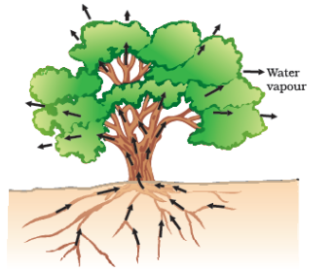

Figure 6.12 Movement of water during transpiration in a tree

##### Activity 6.8

Take two small pots of approximately the same size and having the same amount of soil. One should have a plant in it. Place a stick of the same height as the plant in the other pot.

Cover the soil in both pots with a plastic sheet so that moisture cannot escape by evaporation.

Cover both sets, one with the plant and the other with the stick, with plastic sheets and place in bright sunlight for half an hour.

Do you observe any difference in the two cases?

##### Transport of food and other substances

So far we have discussed the transport of water and minerals in plants. Now let us consider how the products of metabolic processes, particularly photosynthesis, are moved from leaves, where they are formed, to other parts of the plant. This transport of soluble products of photosynthesis is called translocation and it occurs in the part of the vascular tissue known as phloem. Besides the products of photosynthesis, the phloem transports amino acids and other substances. These substances are especially delivered to the storage organs of roots, fruits and seeds and to growing organs. The translocation of food and other substances takes place in the sieve tubes with the help of adjacent companion cells both in upward and downward directions.

Unlike transport in xylem which can be largely explained by simple physical forces, the translocation in phloem is achieved by utilizing energy. Material like sucrose is transferred into phloem tissue using energy from ATP. This increases the osmotic pressure of the tissue causing water to move into it. This pressure moves the material in the phloem to tissues which have less pressure. This allows the phloem to move material according to the plant’s needs. For example, in the spring, sugar stored in root or stem tissue would be transported to the buds which need energy to grow.

#### Questions

What are the components of the transport system in human beings? What are the functions of these components?

Why is it necessary to separate oxygenated and deoxygenated blood in mammals and birds?

What are the components of the transport system in highly organised plants?

How are water and minerals transported in plants?

How is food transported in plants?

### 6.5 - Excretion

We have already discussed how organisms get rid of gaseous wastes generated during photosynthesis or respiration. Other metabolic activities generate nitrogenous materials which need to be removed. The biological process involved in the removal of these harmful metabolic wastes from the body is called excretion. Different organisms use varied strategies to do this. Many unicellular organisms remove these wastes by simple diffusion from the body surface into the surrounding water. As we have seen in other processes, complex multi-cellular organisms use specialised organs to perform the same function.

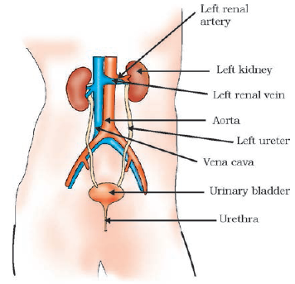

Figure 6.13 Excretory system in human beings

#### 6.5.1 - Excretion in Human Beings

The excretory system of human beings (Fig. 6.13) includes a pair of kidneys, a pair of ureters, a urinary bladder and a urethra. Kidneys are located in the abdomen, one on either side of the backbone. Urine produced in the kidneys passes through the ureters into the urinary bladder where it is stored until it is released through the urethra.

How is urine produced? The purpose of making urine is to filter out waste products from the blood. Just as CO2\text{CO}_{2}

is removed from the blood in the lungs, nitrogenous waste such as urea or uric acid are removed from blood in the kidneys. It is then no surprise that the basic filtration unit in the kidneys, like in the lungs, is a cluster of very thin-walled blood capillaries. Each capillary cluster in the kidney is associated with the cup-shaped end of a coiled tube called Bowman’s capsule that collects the filtrate (Fig. 6.14). Each kidney has large numbers of these filtration units called nephrons packed close together. Some substances in the initial filtrate, such as glucose, amino acids, salts and a major amount of water, are selectively re-absorbed as the urine flows along the tube. The amount of water re-absorbed depends on how much excess water there is in the body, and on how much of dissolved waste there is to be excreted. The urine forming in each kidney eventually enters a long tube, the ureter, which connects the kidneys with the urinary bladder. Urine is stored in the urinary bladder until the pressure of the expanded bladder leads to the urge to pass it out through the urethra. The bladder is muscular, so it is under nervous control, as we have discussed elsewhere. As a result, we can usually control the urge to urinate.

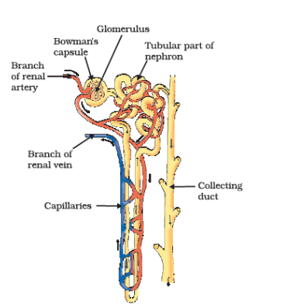

Figure 6.14 Structure of a nephron

##### More to know!

**Artificial kidney (Hemodialysis)**

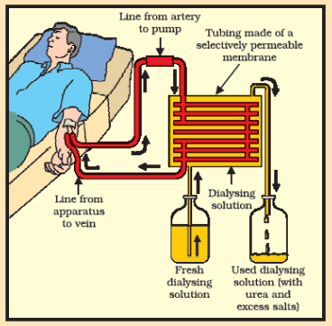

Kidneys are vital organs for survival. Several factors like infections, injury or restricted blood flow to kidneys reduce the activity of kidneys. This leads to accumulation of poisonous wastes in the body, which can even lead to death. In case of kidney failure, an artificial kidney can be used. An artificial kidney is a device to remove nitrogenous waste products from the blood through *dialysis*.

Artificial kidneys contain a number of tubes with a semi-permeable lining, suspended in a tank filled with dialysing fluid. This fluid has the same osmotic pressure as blood, except that it is devoid of nitrogenous wastes. The patient’s blood is passed through these tubes. During this passage, the waste products from the blood pass into dialysing fluid by diffusion. The purified blood is pumped back into the patient. This is similar to the function of the kidney, but it is different since there is no re-absorption involved. Normally, in a healthy adult, the initial filtrate in the kidneys is about 180 L daily. However, the volume actually excreted is only a litre or two a day, because the remaining filtrate is re-absorbed in the kidney tubules.

##### Think it over!

**Organ donation**

Organ donation is a generous act of donating an organ to a person who suffers from non-function of organ(s). Donation of an organ may be done by the consent of the donor and his/her family. Anyone regardless of age or gender can become an organ and tissue donor. Organ transplants can save or transform the life of a person. Transplantation is required because recipient’s organ has been damaged or has failed by disease or injury. In organ transplantation the organ is surgically removed from one person (organ donor) and transplanted to another person (the recipient). Common transplantations include corneas, kidneys, heart, liver, pancreas, lungs, intestines and bone marrow. Most organ and tissue donations occur just after the donor has died or when the doctor declares a person brain dead. But some organs such as kidney, part of a liver, lung, etc., and tissues can be donated while the donor is alive.

#### 6.5.2 - Excretion in Plants

Plants use completely different strategies for excretion than those of animals. Oxygen itself can be thought of as a waste product generated during photosynthesis! We have discussed earlier how plants deal with oxygen as well as CO2\text{CO}_{2}

. They can get rid of excess water by transpiration. For other wastes, plants use the fact that many of their tissues consist of dead cells, and that they can even lose some parts such as leaves. Many plant waste products are stored in cellular vacuoles. Waste products may be stored in leaves that fall off. Other waste products are stored as resins and gums, especially in old xylem. Plants also excrete some waste substances into the soil around them.

#### Questions

Describe the structure and functioning of nephrons.

What are the methods used by plants to get rid of excretory products?

How is the amount of urine produced regulated?

### What you have learnt

Movement of various types can be taken as an indication of life.

Maintenance of life requires processes like nutrition, respiration, transport of materials within the body and excretion of waste products.

Autotrophic nutrition involves the intake of simple inorganic materials from the environment and using an external energy source like the Sun to synthesise complex high-energy organic material.

Heterotrophic nutrition involves the intake of complex material prepared by other organisms.

In human beings, the food eaten is broken down by various steps along the alimentary canal and the digested food is absorbed in the small intestine to be sent to all cells in the body.

During the process of respiration, organic compounds such as glucose are broken down to provide energy in the form of ATP. ATP is used to provide energy for other reactions in the cell.

Respiration may be aerobic or anaerobic. Aerobic respiration makes more energy available to the organism.

In human beings, the transport of materials such as oxygen, carbon dioxide, food and excretory products is a function of the circulatory system. The circulatory system consists of the heart, blood and blood vessels.

In highly differentiated plants, transport of water, minerals, food and other materials is a function of the vascular tissue which consists of xylem and phloem.

In human beings, excretory products in the form of soluble nitrogen compounds are removed by the nephrons in the kidneys.

Plants use a variety of techniques to get rid of waste material. For example, waste material may be stored in the cell-vacuoles or as gum and resin, removed in the falling leaves, or excreted into the surrounding soil.

### Exercises

The kidneys in human beings are a part of the system for

nutrition.

respiration.

excretion.

transportation.

The xylem in plants are responsible for

transport of water.

transport of food.

transport of amino acids.

transport of oxygen.

The autotrophic mode of nutrition requires

carbon dioxide and water.

chlorophyll.

sunlight.

all of the above.

The breakdown of pyruvate to give carbon dioxide, water and energy takes place in

cytoplasm.

mitochondria.

chloroplast.

nucleus.

How are fats digested in our bodies? Where does this process take place?

What is the role of saliva in the digestion of food?

What are the necessary conditions for autotrophic nutrition and what are its by-products?

What are the differences between aerobic and anaerobic respiration? Name some organisms that use the anaerobic mode of respiration.

How are the alveoli designed to maximise the exchange of gases?

What would be the consequences of a deficiency of haemoglobin in our bodies?

Describe double circulation of blood in human beings. Why is it necessary?

What are the differences between the transport of materials in xylem and phloem?

Compare the functioning of alveoli in the lungs and nephrons in the kidneys with respect to their structure and functioning.

## Chapter 7 – Control and Coordination



1064CH07

In the previous chapter, we looked at life processes involved in the maintenance functions in living organisms. There, we had started with a notion we all have, that if we see something moving, it is alive. Some of these movements are in fact the result of growth, as in plants. A seed germinates and grows, and we can see that the seedling moves over the course of a few days, it pushes soil aside and comes out. But if its growth were to be stopped, these movements would not happen. Some movements, as in many animals and some plants, are not connected with growth. A cat running, children playing on swings, buffaloes chewing cud – these are not movements caused by growth.

Why do we associate such visible movements with life? A possible answer is that we think of movement as a response to a change in the environment of the organism. The cat may be running because it has seen a mouse. Not only that, we also think of movement as an attempt by living organisms to use changes in their environment to their advantage. Plants grow out into the sunshine. Children try to get pleasure and fun out of swinging. Buffaloes chew cud to help break up tough food so as to be able to digest it better. When bright light is focussed on our eyes or when we touch a hot object, we detect the change and respond to it with movement in order to protect ourselves.

If we think a bit more about this, it becomes apparent that all this movement, in response to the environment, is carefully controlled. Each kind of a change in the environment evokes an appropriate movement in response. When we want to talk to our friends in class, we whisper, rather than shouting loudly. Clearly, the movement to be made depends on the event that is triggering it. Therefore, such controlled movement must be connected to the recognition of various events in the environment, followed by only the correct movement in response. In other words, living organisms must use systems providing control and coordination. In keeping with the general principles of body organisation in multicellular organisms, specialised tissues are used to provide these control and coordination activities.

### 7.1 – Animals: Nervous System

In animals, such control and coordination are provided by nervous and muscular tissues, which we have studied in Class IX. Touching a hot object is an urgent and dangerous situation for us. We need to detect it, and respond to it. How do we detect that we are touching a hot object? All information from our environment is detected by the specialised tips of some nerve cells. These receptors are usually located in our sense organs, such as the inner ear, the nose, the tongue, and so on. So gustatory receptors will detect taste while olfactory receptors will detect smell.

This information, acquired at the end of the dendritic tip of a nerve cell [Fig. 7.1 (a)], sets off a chemical reaction that creates an electrical impulse. This impulse travels from the dendrite to the cell body, and then along the axon to its end. At the end of the axon, the electrical impulse sets off the release of some chemicals. These chemicals cross the gap, or synapse, and start a similar electrical impulse in a dendrite of the next neuron. This is a general scheme of how nervous impulses travel in the body. A similar synapse finally allows delivery of such impulses from neurons to other cells, such as muscles cells or gland [Fig. 7.1 (b)].

It is thus no surprise that nervous tissue is made up of an organised network of nerve cells or neurons, and is specialised for conducting information via electrical impulses from one part of the body to another.

Look at Fig. 7.1 (a) and identify the parts of a neuron (i) where information is acquired, (ii) through which information travels as an electrical impulse, and (iii) where this impulse must be converted into a chemical signal for onward transmission.

#### Activity 7.1

Put some sugar in your mouth. How does it taste?

Block your nose by pressing it between your thumb and index finger. Now eat sugar again. Is there any difference in its taste?

While eating lunch, block your nose in the same way and notice if you can fully appreciate the taste of the food you are eating.

Is there a difference in how sugar and food taste if your nose is blocked? If so, why might this be happening? Read and talk about possible explanations for these kinds of differences. Do you come across a similar situation when you have a cold?

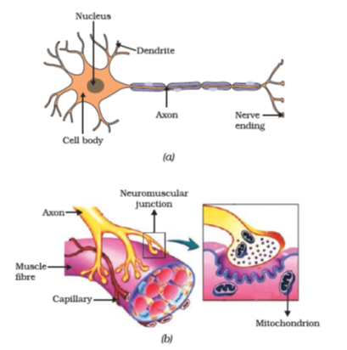

Figure 7.1 (a) Structure of neuron, (b) Neuromuscular junction

#### 7.1.1 - What happens in Reflex Actions?

‘Reflex’ is a word we use very commonly when we talk about some sudden action in response to something in the environment. We say ‘I jumped out of the way of the bus reflexly’, or ‘I pulled my hand back from the flame reflexly’, or ‘I was so hungry my mouth started watering reflexly’. What exactly do we mean? A common idea in all such examples is that we do something without thinking about it, or without feeling in control of our reactions. Yet these are situations where we are responding with some action to changes in our environment. How is control and coordination achieved in such situations?

Let us consider this further. Take one of our examples. Touching a flame is an urgent and dangerous situation for us, or in fact, for any animal! How would we respond to this? One seemingly simple way is to think consciously about the pain and the possibility of getting burnt, and therefore move our hand. An important question then is, how long will it take us to think all this? The answer depends on how we think. If nerve impulses are sent around the way we have talked about earlier, then thinking is also likely to involve the creation of such impulses. Thinking is a complex activity, so it is bound to involve a complicated interaction of many nerve impulses from many neurons.

If this is the case, it is no surprise that the thinking tissue in our body consists of dense networks of intricately arranged neurons. It sits in the forward end of the skull, and receives signals from all over the body which it thinks about before responding to them. Obviously, in order to receive these signals, this thinking part of the brain in the skull must be connected to nerves coming from various parts of the body. Similarly, if this part of the brain is to instruct muscles to move, nerves must carry this signal back to different parts of the body. If all of this is to be done when we touch a hot object, it may take enough time for us to get burnt!

How does the design of the body solve this problem? Rather than having to think about the sensation of heat, if the nerves that detect heat were to be connected to the nerves that move muscles in a simpler way, the process of detecting the signal or the input and responding to it by an output action might be completed quickly. Such a connection is commonly called a reflex arc (Fig. 7.2). Where should such reflex arc connections be made between the input nerve and the output nerve? The best place, of course, would be at the point where they first meet each other. Nerves from all over the body meet in a bundle in the spinal cord on their way to the brain. Reflex arcs are formed in this spinal cord itself, although the information input also goes on to reach the brain.

Of course, reflex arcs have evolved in animals because the thinking process of the brain is not fast enough. In fact many animals have very little or none of the complex neuron network needed for thinking. So it is quite likely that reflex arcs have evolved as efficient ways of functioning in the absence of true thought processes. However, even after complex neuron networks have come into existence, reflex arcs continue to be more efficient for quick responses.

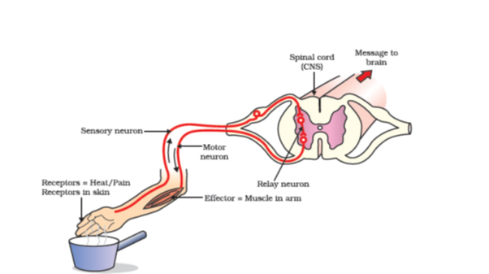

Figure 7.2 Reflex arc

Can you now trace the sequence of events which occur when a bright light is focussed on your eyes?

#### 7.1.2 - Human Brain

Is reflex action the only function of the spinal cord? Obviously not, since we know that we are thinking beings. Spinal cord is made up of nerves which supply information to think about. Thinking involves more complex mechanisms and neural connections. These are concentrated in the brain, which is the main coordinating centre of the body. The brain and spinal cord constitute the central nervous system. They receive information from all parts of the body and integrate it.

We also think about our actions. Writing, talking, moving a chair, clapping at the end of a programme are examples of voluntary actions which are based on deciding what to do next. So, the brain also has to send messages to muscles. This is the second way in which the nervous system communicates with the muscles. The communication between the central nervous system and the other parts of the body is facilitated by the peripheral nervous system consisting of cranial nerves arising from the brain and spinal nerves arising from the spinal cord. The brain thus allows us to think and take actions based on that thinking. As you will expect, this is accomplished through a complex design, with different parts of the brain responsible for integrating different inputs and outputs. The brain has three such major parts or regions, namely the fore-brain, mid-brain and hind-brain.

The fore-brain is the main thinking part of the brain. It has regions which receive sensory impulses from various receptors. Separate areas of the fore-brain are specialised for hearing, smell, sight and so on. There are separate areas of association where this sensory information is interpreted by putting it together with information from other receptors as well as with information that is already stored in the brain. Based on all this, a decision is made about how to respond and the information is passed on to the motor areas which control the movement of voluntary muscles, for example, our leg muscles. However, certain sensations are distinct from seeing or hearing, for example, how do we know that we have eaten enough? The sensation of feeling full is because of a centre associated with hunger, which is in a separate part of the fore-brain.

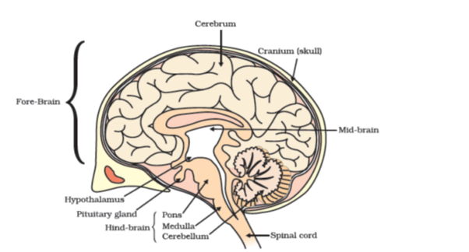

Figure 7.3 Human brain

Study the labelled diagram of the human brain. We have seen that the different parts have specific functions. Can we find out the function of each part?

Let us look at the other use of the word ‘reflex’ that we have talked about in the introduction. Our mouth waters when we see food we like without our meaning to. Our hearts beat without our thinking about it. In fact, we cannot control these actions easily by thinking about them even if we wanted to. Do we have to think about or remember to breathe or digest food? So, in between the simple reflex actions like change in the size of the pupil, and the thought out actions such as moving a chair, there is another set of muscle movements over which we do not have any thinking control. Many of these involuntary actions are controlled by the mid-brain and hind-brain. All these involuntary actions including blood pressure, salivation and vomiting are controlled by the medulla in the hind-brain.

Think about activities like walking in a straight line, riding a bicycle, picking up a pencil. These are possible due to a part of the hind-brain called the cerebellum. It is responsible for precision of voluntary actions and maintaining the posture and balance of the body. Imagine what would happen if each of these events failed to take place if we were not thinking about it.

#### 7.1.3 - How are these Tissues protected?

A delicate organ like the brain, which is so important for a variety of activities, needs to be carefully protected. For this, the body is designed so that the brain sits inside a bony box. Inside the box, the brain is contained in a fluid-filled balloon which provides further shock absorption. If you run your hand down the middle of your back, you will feel a hard, bumpy structure. This is the vertebral column or backbone which protects the spinal cord.

#### 7.1.4 - How does the Nervous Tissue cause Action?

So far, we have been talking about nervous tissue, and how it collects information, sends it around the body, processes information, makes decisions based on information, and conveys decisions to muscles for action. In other words, when the action or movement is to be performed, muscle tissue will do the final job. How do animal muscles move? When a nerve impulse reaches the muscle, the muscle fibre must move. How does a muscle cell move? The simplest notion of movement at the cellular level is that muscle cells will move by changing their shape so that they shorten. So the next question is, how do muscle cells change their shape? The answer must lie in the chemistry of cellular components. Muscle cells have special proteins that change both their shape and their arrangement in the cell in response to nervous electrical impulses. When this happens, new arrangements of these proteins give the muscle cells a shorter form. Remember when we talked about muscle tissue in Class IX, there were different kinds of muscles, such as voluntary muscles and involuntary muscles. Based on what we have discussed so far, what do you think the differences between these would be?

#### Questions

What is the difference between a reflex action and walking?

What happens at the synapse between two neurons?

Which part of the brain maintains posture and equilibrium of the body?

How do we detect the smell of an *agarbatti* (incense stick)?

What is the role of the brain in reflex action?

### 7.2 - Coordination In Plants

Animals have a nervous system for controlling and coordinating the activities of the body. But plants have neither a nervous system nor muscles. So, how do they respond to stimuli? When we touch the leaves of a *chhui-mui* (the ‘sensitive’ or ‘touch-me-not’ plant of the Mimosa family), they begin to fold up and droop. When a seed germinates, the root goes down, the stem comes up into the air. What happens? Firstly, the leaves of the sensitive plant move very quickly in response to touch. There is no growth involved in this movement. On the other hand, the directional movement of a seedling is caused by growth. If it is prevented from growing, it will not show any movement. So plants show two different types of movement – one dependent on growth and the other independent of growth.

#### 7.2.1 - Immediate Response to Stimulus

Let us think about the first kind of movement, such as that of the sensitive plant. Since no growth is involved, the plant must actually move its leaves in response to touch. But there is no nervous tissue, nor any muscle tissue. How does the plant detect the touch, and how do the leaves move in response?

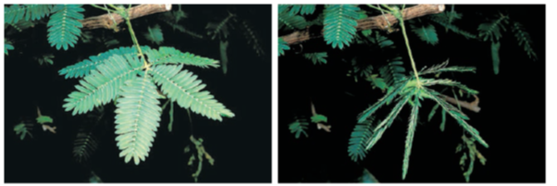

Figure 7.4 The sensitive plant

If we think about where exactly the plant is touched, and what part of the plant actually moves, it is apparent that movement happens at a point different from the point of touch. So, information that a touch has occurred must be communicated. The plants also use electrical-chemical means to convey this information from cell to cell, but unlike in animals, there is no specialised tissue in plants for the conduction of information. Finally, again as in animals, some cells must change shape in order for movement to happen. Instead of the specialised proteins found in animal muscle cells, plant cells change shape by changing the amount of water in them, resulting in swelling or shrinking, and therefore in changing shapes.

#### 7.2.2 - Movement Due to Growth

Some plants like the pea plant climb up other plants or fences by means of tendrils. These tendrils are sensitive to touch. When they come in contact with any support, the part of the tendril in contact with the object does not grow as rapidly as the part of the tendril away from the object. This causes the tendril to circle around the object and thus cling to it. More commonly, plants respond to stimuli slowly by growing in a particular direction. Because this growth is directional, it appears as if the plant is moving. Let us understand this type of movement with the help of an example.

##### Activity 7.2

Fill a conical flask with water.

Cover the neck of the flask with a wire mesh.

Keep two or three freshly germinated bean seeds on the wire mesh.

Take a cardboard box which is open from one side.

Keep the flask in the box in such a manner that the open side of the box faces light coming from a window (Fig. 7.5).

After two or three days, you will notice that the shoots bend towards light and roots away from light.

Now turn the flask so that the shoots are away from light and the roots towards light. Leave it undisturbed in this condition for a few days.

Have the old parts of the shoot and root changed direction?

Are there differences in the direction of the new growth?

What can we conclude from this activity?

Environmental triggers such as light, or gravity will change the directions that plant parts grow in. These directional, or tropic, movements can be either towards the stimulus, or away from it. So, in two different kinds of phototropic movement, shoots respond by bending towards light while roots respond by bending away from it. How does this help the plant?

Plants show tropism in response to other stimuli as well. The roots of a plant always grow downwards while the shoots usually grow upwards and away from the earth. This upward and downward growth of shoots and roots, respectively, in response to the pull of earth or gravity is, obviously, geotropism (Fig. 7.6). If ‘hydro’ means water and ‘chemo’ refers to chemicals, what would ‘hydrotropism’ and ‘chemotropism’ mean? Can we think of examples of these kinds of directional growth movements? One example of chemotropism is the growth of pollen tubes towards ovules, about which we will learn more when we examine the reproductive processes of living organisms.

Let us now once again think about how information is communicated in the bodies of multicellular organisms. The movement of the sensitive plant in response to touch is very quick. The movement of sunflowers in response to day or night, on the other hand, is quite slow. Growth-related movement of plants will be even slower.

Even in animal bodies, there are carefully controlled directions to growth. Our arms and fingers grow in certain directions, not haphazardly. So controlled movements can be either slow or fast. If fast responses to stimuli are to be made, information transfer must happen very quickly. For this, the medium of transmission must be able to move rapidly. Electrical impulses are an excellent means for this. But there are limitations to the use of electrical impulses. Firstly, they will reach only those cells that are connected by nervous tissue, not each and every cell in the animal body. Secondly, once an electrical impulse is generated in a cell and transmitted, the cell will take some time to reset its mechanisms before it can generate and transmit a new impulse. In other words, cells cannot continually create and transmit electrical impulses. It is thus no wonder that most multicellular organisms use another means of communication between cells, namely, chemical communication.

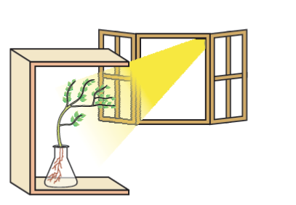

Figure 7.5 Response of the plant to the direction of light

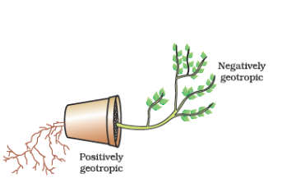

Figure 7.6 Plant showing geotropism

If, instead of generating an electrical impulse, stimulated cells release a chemical compound, this compound would diffuse all around the original cell. If other cells around have the means to detect this compound using special molecules on their surfaces, then they would be able to recognise information, and even transmit it. This will be slower, of course, but it can potentially reach all cells of the body, regardless of nervous connections, and it can be done steadily and persistently. These compounds, or hormones used by multicellular organisms for control and coordination show a great deal of diversity, as we would expect. Different plant hormones help to coordinate growth, development and responses to the environment. They are synthesised at places away from where they act and simply diffuse to the area of action.

Let us take an example that we have worked with earlier [Activity 7.2]. When growing plants detect light, a hormone called auxin, synthesised at the shoot tip, helps the cells to grow longer. When light is coming from one side of the plant, auxin diffuses towards the shady side of the shoot. This concentration of auxin stimulates the cells to grow longer on the side of the shoot which is away from light. Thus, the plant appears to bend towards light.

Another example of plant hormones are gibberellins which, like auxins, help in the growth of the stem. Cytokinins promote cell division, and it is natural then that they are present in greater concentration in areas of rapid cell division, such as in fruits and seeds. These are examples of plant hormones that help in promoting growth. But plants also need signals to stop growing. Abscisic acid is one example of a hormone which inhibits growth. Its effects include wilting of leaves.

#### Questions

What are plant hormones?

How is the movement of leaves of the sensitive plant different from the movement of a shoot towards light?

Give an example of a plant hormone that promotes growth.

How do auxins promote the growth of a tendril around a support?

Design an experiment to demonstrate hydrotropism.

### 7.3 - Hormones In Animals

How are such chemical, or hormonal, means of information transmission used in animals? What do some animals, for instance squirrels, experience when they are in a scary situation? Their bodies have to prepare for either fighting or running away. Both are very complicated activities that will use a great deal of energy in controlled ways. Many different tissue types will be used and their activities integrated together in these actions. However, the two alternate activities, fighting or running, are also quite different! So here is a situation in which some common preparations can be usefully made in the body. These preparations should ideally make it easier to do either activity in the near future. How would this be achieved?

If the body design in the squirrel relied only on electrical impulses via nerve cells, the range of tissues instructed to prepare for the coming activity would be limited. On the other hand, if a chemical signal were to be sent as well, it would reach all cells of the body and provide the wide-ranging changes needed. This is done in many animals, including human beings, using a hormone called adrenaline that is secreted from the adrenal glands. Look at Fig. 7.7 to locate these glands.

Adrenaline is secreted directly into the blood and carried to different parts of the body. The target organs or the specific tissues on which it acts include the heart. As a result, the heart beats faster, resulting in supply of more oxygen to our muscles. The blood to the digestive system and skin is reduced due to contraction of muscles around small arteries in these organs. This diverts the blood to our skeletal muscles. The breathing rate also increases because of the contractions of the diaphragm and the rib muscles. All these responses together enable the animal body to be ready to deal with the situation. Such animal hormones are part of the endocrine system which constitutes a second way of control and coordination in our body.

#### Activity 7.3

Look at Fig. 7.7.

Identify the endocrine glands mentioned in the figure.

Some of these glands have been listed in Table 7.1 and discussed in the text. Consult books in the library and discuss with your teachers to find out about other glands.

Remember that plants have hormones that control their directional growth. What functions do animal hormones perform? On the face of it, we cannot imagine their role in directional growth. We have never seen an animal growing more in one direction or the other, depending on light or gravity! But if we think about it a bit more, it will become evident that, even in animal bodies, growth happens in carefully controlled places. Plants will grow leaves in many places on the plant body, for example. But we do not grow fingers on our faces. The design of the body is carefully maintained even during the growth of children.

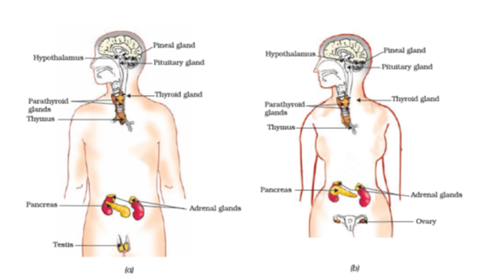

Figure 7.7 Endocrine glands in human beings (a) male, (b) female

Let us examine some examples to understand how hormones help in coordinated growth. We have all seen salt packets which say ‘iodised salt’ or ‘enriched with iodine’. Why is it important for us to have iodised salt in our diet? Iodine is necessary for the thyroid gland to make thyroxin hormone. Thyroxin regulates carbohydrate, protein and fat metabolism in the body so as to provide the best balance for growth. Iodine is essential for the synthesis of thyroxin. In case iodine is deficient in our diet, there is a possibility that we might suffer from goitre. One of the symptoms in this disease is a swollen neck. Can you correlate this with the position of the thyroid gland in Fig. 7.7?

Sometimes we come across people who are either very short (dwarfs) or extremely tall (giants). Have you ever wondered how this happens? Growth hormone is one of the hormones secreted by the pituitary. As its name indicates, growth hormone regulates growth and development of the body. If there is a deficiency of this hormone in childhood, it leads to dwarfism.

You must have noticed many dramatic changes in your appearance as well as that of your friends as you approached 10-12 years of age. These changes associated with puberty are because of the secretion of testosterone in males and oestrogen in females.

Do you know anyone in your family or friends who has been advised by the doctor to take less sugar in their diet because they are suffering from diabetes? As a treatment, they might be taking injections of insulin. This is a hormone which is produced by the pancreas and helps in regulating blood sugar levels. If it is not secreted in proper amounts, the sugar level in the blood rises causing many harmful effects.

If it is so important that hormones should be secreted in precise quantities, we need a mechanism through which this is done. The timing and amount of hormone released are regulated by feedback mechanisms. For example, if the sugar levels in blood rise, they are detected by the cells of the pancreas which respond by producing more insulin. As the blood sugar level falls, insulin secretion is reduced.

##### Do You Know?

Hypothalamus plays an important role in the release of many hormones. For example, when the level of growth hormone is low, the hypothalamus releases growth hormone releasing factor which stimulates the pituitary gland to release growth hormone.

##### Activity 7.4

Hormones are secreted by endocrine glands and have specific functions. Complete Table 7.1 based on the hormone, the endocrine gland or the functions provided.

**Table 7.1: Some important hormones and their functions**

| **S. No.** | **Hormone** | **Endocrine Gland** | **Functions** |
| --- | --- | --- | --- |
|  | Growth hormone | Pituitary gland | Stimulates growth in all organs |
|  |  | Thyroid gland | Regulates metabolism for body growth |
|  | Insulin |  | Regulates blood sugar level |
|  | Testosterone | Testes |  |
|  |  | Ovaries | Development of female sex organs, regulates menstrual cycle, etc. |
|  | Adrenaline | Adrenal gland |  |
|  | Releasing hormones |  | Stimulates pituitary gland to release hormones |

#### Questions

How does chemical coordination take place in animals?

Why is the use of iodised salt advisable?

How does our body respond when adrenaline is secreted into the blood?

Why are some patients of diabetes treated by giving injections of insulin?

### What you have learnt

Control and coordination are the functions of the nervous system and hormones in our bodies.

The responses of the nervous system can be classified as reflex action, voluntary action or involuntary action.

The nervous system uses electrical impulses to transmit messages.

The nervous system gets information from our sense organs and acts through our muscles.

Chemical coordination is seen in both plants and animals.

Hormones produced in one part of an organism move to another part to achieve the desired effect.

A feedback mechanism regulates the action of the hormones.

### Exercises

Which of the following is a plant hormone?

Insulin

Thyroxin

Oestrogen

Cytokinin.

The gap between two neurons is called a

dendrite.

synapse.

axon.

impulse.

The brain is responsible for

thinking.

regulating the heart beat.

balancing the body.

all of the above.

What is the function of receptors in our body? Think of situations where receptors do not work properly. What problems are likely to arise?

Draw the structure of a neuron and explain its function.

How does phototropism occur in plants?

Which signals will get disrupted in case of a spinal cord injury?

How does chemical coordination occur in plants?

What is the need for a system of control and coordination in an organism?

How are involuntary actions and reflex actions different from each other?

Compare and contrast nervous and hormonal mechanisms for control and coordination in animals.

What is the difference between the manner in which movement takes place in a sensitive plant and the movement in our legs?

## Chapter 8 – How do Organisms Reproduce?



1064C08

Before we discuss the mechanisms by which organisms reproduce, let us ask a more basic question – why do organisms reproduce? After all, reproduction is not necessary to maintain the life of an individual organism, unlike the essential life processes such as nutrition, respiration, or excretion. On the other hand, if an individual organism is going to create more individuals, a lot of its energy will be spent in the process. So why should an individual organism waste energy on a process it does not need to stay alive? It would be interesting to discuss the possible answers in the classroom!

Whatever the answer to this question, it is obvious that we notice organisms because they reproduce. If there were to be only one, non-reproducing member of a particular kind, it is doubtful that we would have noticed its existence. It is the large numbers of organisms belonging to a single species that bring them to our notice. How do we know that two different individual organisms belong to the same species? Usually, we say this because they look similar to each other. Thus, reproducing organisms create new individuals that look very much like themselves.

### 8.1 - Do Organisms Create Exact Copies of Themselves?

Organisms look similar because their body designs are similar. If body designs are to be similar, the blueprints for these designs should be similar. Thus, reproduction at its most basic level will involve making copies of the blueprints of body design. In Class IX, we learnt that the chromosomes in the nucleus of a cell contain information for inheritance of features from parents to next generation in the form of DNA (Deoxyribo Nucleic Acid) molecules. The DNA in the cell nucleus is the information source for making proteins. If the information is changed, different proteins will be made. Different proteins will eventually lead to altered body designs.

Therefore, a basic event in reproduction is the creation of a DNA copy. Cells use chemical reactions to build copies of their DNA. This creates two copies of the DNA in a reproducing cell, and they will need to be separated from each other. However, keeping one copy of DNA in the original cell and simply pushing the other one out would not work, because the copy pushed out would not have any organised cellular structure for maintaining life processes. Therefore, DNA copying is accompanied by the creation of an additional cellular apparatus, and then the DNA copies separate, each with its own cellular apparatus. Effectively, a cell divides to give rise to two cells.

These two cells are of course similar, but are they likely to be absolutely identical? The answer to this question will depend on how accurately the copying reactions involved occur. No bio-chemical reaction is absolutely reliable. Therefore, it is only to be expected that the process of copying the DNA will have some variations each time. As a result, the DNA copies generated will be similar, but may not be identical to the original. Some of these variations might be so drastic that the new DNA copy cannot work with the cellular apparatus it inherits. Such a newborn cell will simply die. On the other hand, there could still be many other variations in the DNA copies that would not lead to such a drastic outcome. Thus, the surviving cells are similar to, but subtly different from each other. This inbuilt tendency for variation during reproduction is the basis for evolution, as we will discuss in the next chapter.

#### 8.1.1 - The Importance of Variation

Populations of organisms fill well-defined places, or niches, in the ecosystem, using their ability to reproduce. The consistency of DNA copying during reproduction is important for the maintenance of body design features that allow the organism to use that particular niche. Reproduction is therefore linked to the stability of populations of species.

However, niches can change because of reasons beyond the control of the organisms. Temperatures on earth can go up or down, water levels can vary, or there could be meteorite hits, to think of a few examples. If a population of reproducing organisms were suited to a particular niche and if the niche were drastically altered, the population could be wiped out. However, if some variations were to be present in a few individuals in these populations, there would be some chance for them to survive. Thus, if there were a population of bacteria living in temperate waters, and if the water temperature were to be increased by global warming, most of these bacteria would die, but the few variants resistant to heat would survive and grow further. Variation is thus useful for the survival of species over time.

#### Questions

What is the importance of DNA copying in reproduction?

Why is variation beneficial to the species but not necessarily for the individual?

### 8.2 - Modes of Reproduction Used by Single Organisms

#### Activity 8.1

Dissolve about 10 gm of sugar in 100 mL of water.

Take 20 mL of this solution in a test tube and add a pinch of yeast granules to it.

Put a cotton plug on the mouth of the test tube and keep it in a warm place.

After 1 or 2 hours, put a small drop of yeast culture from the test tube on a slide and cover it with a coverslip.

Observe the slide under a microscope.

#### Activity 8.2

Wet a slice of bread, and keep it in a cool, moist and dark place.

Observe the surface of the slice with a magnifying glass.

Record your observations for a week.

Compare and contrast the ways in which yeast grows in the first case, and how mould grows in the second.

Having discussed the context in which reproductive processes work, let us now examine how different organisms actually reproduce. The modes by which various organisms reproduce depend on the body design of the organisms.

#### 8.2.1 - Fission

For unicellular organisms, cell division, or fission, leads to the creation of new individuals. Many different patterns of fission have been observed. Many bacteria and protozoa simply split into two equal halves during cell division. In organisms such as *Amoeba*, the splitting of the two cells during division can take place in any plane.

##### Activity 8.3

Observe a permanent slide of *Amoeba* under a microscope.

Similarly observe another permanent slide of *Amoeba* showing binary fission.

Now, compare the observations of both the slides.

However, some unicellular organisms show somewhat more organisation of their bodies, such as is seen in *Leishmania* (which cause *kala-azar*), which have a whip-like structure at one end of the cell. In such organisms, binary fission occurs in a definite orientation in relation to these structures. Other single-celled organisms, such as the malarial parasite, *Plasmodium*, divide into many daughter cells simultaneously by multiple fission.

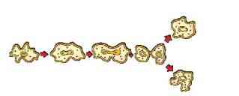

Figure 8.1 (a) Binary fission in Amoeba

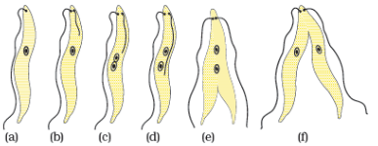

Figure 8.1 (b) Binary fission in Leishmania

Yeast, on the other hand, can put out small buds that separate and grow further, as we saw in Activity 8.1.

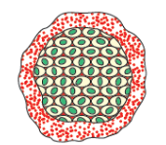

Figure 8.2 Multiple fission in Plasmodium

#### 8.2.2 - Fragmentation

##### Activity 8.4

Collect water from a lake or pond that appears dark green and contains filamentous structures.

Put one or two filaments on a slide.

Put a drop of glycerine on these filaments and cover it with a coverslip.

Observe the slide under a microscope.

Can you identify different tissues in the *Spirogyra* filaments?

In multi-cellular organisms with relatively simple body organisation, simple reproductive methods can still work. *Spirogyra*, for example, simply breaks up into smaller pieces upon maturation. These pieces or fragments grow into new individuals. Can we work out the reason for this, based on what we saw in Activity 8.4?

This is not true for all multi-cellular organisms. They cannot simply divide cell-by-cell. The reason is that many multi-cellular organisms, as we have seen, are not simply a random collection of cells. Specialised cells are organised as tissues, and tissues are organised into organs, which then have to be placed at definite positions in the body. In such a carefully organised situation, cell-by-cell division would be impractical. Multi-cellular organisms, therefore, need to use more complex ways of reproduction.

A basic strategy used in multi-cellular organisms is that different cell types perform different specialised functions. Following this general pattern, reproduction in such organisms is also the function of a specific cell type. How is reproduction to be achieved from a single cell type, if the organism itself consists of many cell types? The answer is that there must be a single cell type in the organism that is capable of growing, proliferating and making other cell types under the right circumstances.

#### 8.2.3 - Regeneration

Many fully differentiated organisms have the ability to give rise to new individual organisms from their body parts. That is, if the individual is somehow cut or broken up into many pieces, many of these pieces grow into separate individuals. For example, simple animals like *Hydra* and *Planaria* can be cut into any number of pieces and each piece grows into a complete organism. This is known as regeneration (see Fig. 8.3). Regeneration is carried out by specialised cells. These cells proliferate and make large numbers of cells. From this mass of cells, different cells undergo changes to become various cell types and tissues. These changes take place in an organised sequence referred to as development. However, regeneration is not the same as reproduction, since most organisms would not normally depend on being cut up to be able to reproduce.

#### 8.2.4 - Budding

Organisms such as *Hydra* use regenerative cells for reproduction in the process of budding. In *Hydra*, a bud develops as an outgrowth due to repeated cell division at one specific site (Fig. 8.4). These buds develop into tiny individuals and when fully mature, detach from the parent body and become new independent individuals.

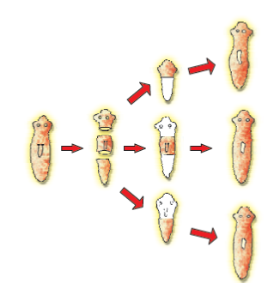

Figure 8.3 Regeneration in Planaria

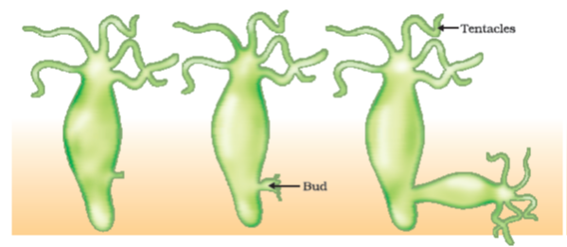

Figure 8.4 Budding in Hydra

#### 8.2.5 - Vegetative Propagation

There are many plants in which parts like the root, stem and leaves develop into new plants under appropriate conditions. Unlike in most animals, plants can indeed use such a mode for reproduction. This property of vegetative propagation is used in methods such as layering or grafting to grow many plants like sugarcane, roses, or grapes for agricultural purposes. Plants raised by vegetative propagation can bear flowers and fruits earlier than those produced from seeds. Such methods also make possible the propagation of plants such as banana, orange, rose and jasmine that have lost the capacity to produce seeds. Another advantage of vegetative propagation is that all plants produced are genetically similar enough to the parent plant to have all its characteristics.

##### Activity 8.5

Take a potato and observe its surface. Can notches be seen?

Cut the potato into small pieces such that some pieces contain a notch or bud and some do not.

Spread some cotton on a tray and wet it. Place the potato pieces on this cotton. Note where the pieces with the buds are placed.

Observe changes taking place in these potato pieces over the next few days. Make sure that the cotton is kept moistened.

Which are the potato pieces that give rise to fresh green shoots and roots?

Similarly buds produced in the notches along the leaf margin of *Bryophyllum* fall on the soil and develop into new plants (Fig. 8.5).

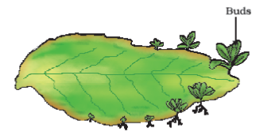

Figure 8.5 Leaf of Bryophyllum with buds

##### Activity 8.6

Select a money-plant.

Cut some pieces such that they contain at least one leaf.

Cut out some other portions between two leaves.

Dip one end of all the pieces in water and observe over the next few days.

Which ones grow and give rise to fresh leaves?

What can you conclude from your observations?

##### More to know!

**Tissue culture**

In tissue culture, new plants are grown by removing tissue or separating cells from the growing tip of a plant. The cells are then placed in an artificial medium where they divide rapidly to form a small group of cells or callus. The callus is transferred to another medium containing hormones for growth and differentiation. The plantlets are then placed in the soil so that they can grow into mature plants. Using tissue culture, many plants can be grown from one parent in disease-free conditions. This technique is commonly used for ornamental plants.

#### 8.2.6 - Spore Formation

Even in many simple multi-cellular organisms, specific reproductive parts can be identified. The thread-like structures that developed on the bread in Activity 8.2 above are the hyphae of the bread mould (*Rhizopus*). They are not reproductive parts. On the other hand, the tiny blob-on-a-stick structures are involved in reproduction. The blobs are sporangia, which contain cells, or spores, that can eventually develop into new *Rhizopus* individuals (Fig. 8.6). The spores are covered by thick walls that protect them until they come into contact with another moist surface and can begin to grow.

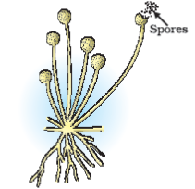

Figure 8.6 Spore formation in Rhizopus

All the modes of reproduction that we have discussed so far allow new generations to be created from a single individual. This is known as asexual reproduction.

#### Questions

How does binary fission differ from multiple fission?

How will an organism be benefited if it reproduces through spores?

Can you think of reasons why more complex organisms cannot give rise to new individuals through regeneration?

Why is vegetative propagation practised for growing some types of plants?

Why is DNA copying an essential part of the process of reproduction?

### 8.3 - Sexual Reproduction

We are also familiar with modes of reproduction that depend on the involvement of two individuals before a new generation can be created. Bulls alone cannot produce new calves, nor can hens alone produce new chicks. In such cases, both sexes, males and females, are needed to produce new generations. What is the significance of this sexual mode of reproduction? Are there any limitations of the asexual mode of reproduction, which we have been discussing above?

#### 8.3.1 - Why the Sexual Mode of Reproduction?

The creation of two new cells from one involves copying of the DNA as well as of the cellular apparatus. The DNA copying mechanism, as we have noted, cannot be absolutely accurate, and the resultant errors are a source of variations in populations of organisms. Every individual organism cannot be protected by variations, but in a population, variations are useful for ensuring the survival of the species. It would therefore make sense if organisms came up with reproductive modes that allowed more and more variation to be generated.

While DNA-copying mechanisms are not absolutely accurate, they are precise enough to make the generation of variation a fairly slow process. If the DNA copying mechanisms were to be less accurate, many of the resultant DNA copies would not be able to work with the cellular apparatus, and would die. So how can the process of making variants be speeded up? Each new variation is made in a DNA copy that already has variations accumulated from previous generations. Thus, two different individuals in a population would have quite different patterns of accumulated variations. Since all of these variations are in living individuals, it is assured that they do not have any really bad effects. Combining variations from two or more individuals would thus create new combinations of variants. Each combination would be novel, since it would involve two different individuals. The sexual mode of reproduction incorporates such a process of combining DNA from two different individuals during reproduction.

But this creates a major difficulty. If each new generation is to be the combination of the DNA copies from two pre-existing individuals, then each new generation will end up having twice the amount of DNA that the previous generation had. This is likely to mess up the control of the cellular apparatus by the DNA. How many ways can we think of for solving this difficulty?

We have seen earlier that as organisms become more complex, the specialisation of tissue increases. One solution that many multi-cellular organisms have found for the problem mentioned above is to have special lineages of cells in specialised organs in which only half the number of chromosomes and half the amount of DNA as compared to the non-reproductive body cells. This is achieved by a process of cell division called meiosis. Thus, when these germ-cells from two individuals combine during sexual reproduction to form a new individual, it results in re-establishment of the number of chromosomes and the DNA content in the new generation.

If the zygote is to grow and develop into an organism which has highly specialised tissues and organs, then it has to have sufficient stores of energy for doing this. In very simple organisms, it is seen that the two germ-cells are not very different from one another, or may even be similar. But as the body designs become more complex, the germ-cells also specialise. One germ-cell is large and contains the food-stores while the other is smaller and likely to be motile. Conventionally, the motile germ-cell is called the male gamete and the germ-cell containing the stored food is called the female gamete. We shall see in the next few sections how the need to create these two different types of gametes give rise to differences in the male and female reproductive organs and, in some cases, differences in the bodies of the male and female organisms.

#### 8.3.2 - Sexual Reproduction in Flowering Plants

The reproductive parts of angiosperms are located in the flower. You have already studied the different parts of a flower – sepals, petals, stamens and pistil. Stamens and pistil are the reproductive parts of a flower which contain the germ-cells. What possible functions could the petals and sepals serve?

The flower may be unisexual (papaya, watermelon) when it contains either stamens or pistil or bisexual (*Hibiscus*, mustard) when it contains both stamens and pistil. Stamen is the male reproductive part and it produces pollen grains that are yellowish in colour. You must have seen this yellowish powder that often sticks to our hands if we touch the stamen of a flower. Pistil is present in the centre of a flower and is the female reproductive part. It is made of three parts. The swollen bottom part is the ovary, middle elongated part is the style and the terminal part which may be sticky is the stigma. The ovary contains ovules and each ovule has an egg cell. The male germ-cell produced by pollen grain fuses with the female gamete present in the ovule. This fusion of the germ-cells or fertilisation gives us the zygote which is capable of growing into a new plant.

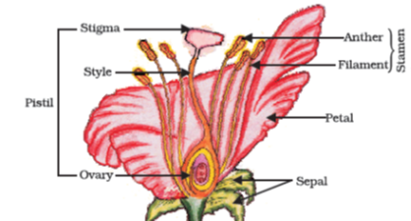

Figure 8.7 Longitudinal section of flower

Thus the pollen needs to be transferred from the stamen to the stigma. If this transfer of pollen occurs in the same flower, it is referred to as self-pollination. On the other hand, if the pollen is transferred from one flower to another, it is known as cross-pollination. This transfer of pollen from one flower to another is achieved by agents like wind, water or animals.

After the pollen lands on a suitable stigma, it has to reach the female germ-cells which are in the ovary. For this, a tube grows out of the pollen grain and travels through the style to reach the ovary.

After fertilisation, the zygote divides several times to form an embryo within the ovule. The ovule develops a tough coat and is gradually converted into a seed. The ovary grows rapidly and ripens to form a fruit. Meanwhile, the petals, sepals, stamens, style and stigma may shrivel and fall off. Have you ever observed any flower part still persisting in the fruit? Try and work out the advantages of seed-formation for the plant. The seed contains the future plant or embryo which develops into a seedling under appropriate conditions. This process is known as germination.

##### Activity 8.7

Soak a few seeds of Bengal gram (*chana*) and keep them overnight.

Drain the excess water and cover the seeds with a wet cloth and leave them for a day. Make sure that the seeds do not become dry.

Cut open the seeds carefully and observe the different parts.

Compare your observations with the Fig. 8.9 and see if you can identify all the parts.

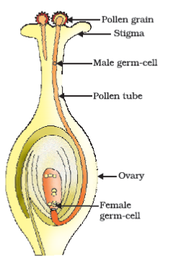

Figure 8.8 Germination of pollen on stigma

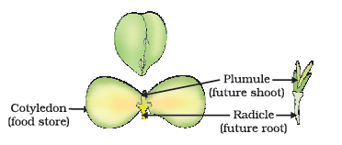

Figure 8.9 Germination

#### 8.3.3 - Reproduction in Human Beings

So far, we have been discussing the variety of modes that different species use for reproduction. Let us now look at the species that we are most interested in, namely, humans. Humans use a sexual mode of reproduction. How does this process work?

Let us begin at an apparently unrelated point. All of us know that our bodies change as we become older. You have learnt changes that take place in your body earlier in Class VIII also. We notice that our height has increased continuously from early age till now. We acquire teeth, we even lose the old, so-called milk teeth and acquire new ones. All of these are changes that can be grouped under the general process of growth, in which the body becomes larger. But in early teenage years, a whole new set of changes occurs that cannot be explained simply as body enlargement. Instead, the appearance of the body changes. Proportions change, new features appear, and so do new sensations.

Some of these changes are common to both boys and girls. We begin to notice thick hair growing in new parts of the body such as armpits and the genital area between the thighs, which can also become darker in colour. Thinner hair can also appear on legs and arms, as well as on the face. The skin frequently becomes oily and we might begin to develop pimples. We begin to be conscious and aware of both our own bodies and those of others in new ways.

On the other hand, there are also changes taking place that are different between boys and girls. In girls, breast size begins to increase, with darkening of the skin of the nipples at the tips of the breasts. Also, girls begin to menstruate at around this time. Boys begin to have new thick hair growth on the face and their voices begin to crack. Further, the penis occasionally begins to become enlarged and erect, either in daydreams or at night.

All of these changes take place slowly, over a period of months and years. They do not happen all at the same time in one person, nor do they happen at an exact age. In some people, they happen early and quickly, while in others, they can happen slowly. Also, each change does not become complete quickly either. So, for example, thick hair on the face in boys appears as a few scattered hairs first, and only slowly does the growth begin to become uniform. Even so, all these changes show differences between people. Just as we have differently shaped noses or fingers, so also we have different patterns of hair growth, or size and shape of breast or penis. All of these changes are aspects of the sexual maturation of the body.

Why does the body show sexual maturation at this age? We have talked about the need for specialised cell types in multi-cellular bodies to carry out specialised functions. The creation of germ-cells to participate in sexual reproduction is another specialised function, and we have seen that plants develop special cell and tissue types to create them. Human beings also develop special tissues for this purpose. However, while the body of the individual organism is growing to its adult size, the resources of the body are mainly directed at achieving this growth. While that is happening, the maturation of the reproductive tissue is not likely to be a major priority. Thus, as the rate of general body growth begins to slow down, reproductive tissues begin to mature. This period during adolescence is called puberty.

So how do all the changes that we have talked about link to the reproductive process? We must remember that the sexual mode of reproduction means that germ-cells from two individuals have to join together. This can happen by the external release of germ-cells from the bodies of individuals, as happens in flowering plants. Or it can happen by two individuals joining their bodies together for internal transfer of germ-cells for fusion, as happens in many animals. If animals are to participate in this process of mating, their state of sexual maturity must be identifiable by other individuals. Many changes during puberty, such as new hair-growth patterns, are signals that sexual maturation is taking place.

On the other hand, the actual transfer of germ-cells between two people needs special organs for the sexual act, such as the penis when it is capable of becoming erect. In mammals such as humans, the baby is carried in the mother’s body for a long period, and will be breast-fed later. The female reproductive organs and breasts will need to mature to accommodate these possibilities. Let us look at the systems involved in the process of sexual reproduction.

#### 8.3.3 (a) - Male Reproductive System

The male reproductive system (Fig. 8.10) consists of portions which produce the germ-cells and other portions that deliver the germ-cells to the site of fertilisation.

The formation of germ-cells or sperms takes place in the testes. These are located outside the abdominal cavity in scrotum because sperm formation requires a lower temperature than the normal body temperature. We have discussed the role of the testes in the secretion of the hormone, testosterone, in the previous chapter. In addition to regulating the formation of sperms, testosterone brings about changes in appearance seen in boys at the time of puberty.

The sperms formed are delivered through the vas deferens which unites with a tube coming from the urinary bladder. The urethra thus forms a common passage for both the sperms and urine. Along the path of the vas deferens, glands like the prostate and the seminal vesicles add their secretions so that the sperms are now in a fluid which makes their transport easier and this fluid also provides nutrition. The sperms are tiny bodies that consist of mainly genetic material and a long tail that helps them to move towards the female germ-cell.

#### 8.3.3 (b) - Female Reproductive System

The female germ-cells or eggs are made in the ovaries. They are also responsible for the production of some hormones. Look at Fig. 8.11 and identify the various organs in the female reproductive system.

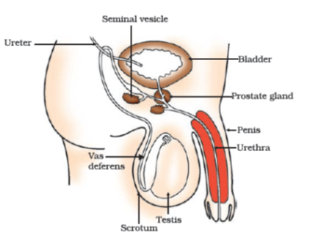

Figure 8.10 Human–male reproductive system

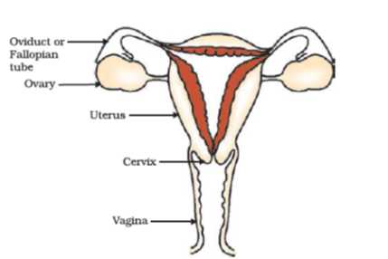

Figure 8.11 Human–female reproductive system

When a girl is born, the ovaries already contain thousands of immature eggs. On reaching puberty, some of these start maturing. One egg is produced every month by one of the ovaries. The egg is carried from the ovary to the womb through a thin oviduct or fallopian tube. The two oviducts unite into an elastic bag-like structure known as the uterus. The uterus opens into the vagina through the cervix.

The sperms enter through the vaginal passage during sexual intercourse. They travel upwards and reach the oviduct where they may encounter the egg. The fertilised egg (zygote) starts dividing and form a ball of cells or embryo. The embryo is implanted in the lining of the uterus where they continue to grow and develop organs to become foetus. We have seen in earlier sections that the mother’s body is designed to undertake the development of the child. Hence the uterus prepares itself every month to receive and nurture the growing embryo. The lining thickens and is richly supplied with blood to nourish the growing embryo.

The embryo gets nutrition from the mother’s blood with the help of a special tissue called placenta. This is a disc which is embedded in the uterine wall. It contains villi on the embryo’s side of the tissue. On the mother’s side are blood spaces, which surround the villi. This provides a large surface area for glucose and oxygen to pass from the mother to the embryo. The developing embryo will also generate waste substances which can be removed by transferring them into the mother’s blood through the placenta. The development of the child inside the mother’s body takes approximately nine months. The child is born as a result of rhythmic contractions of the muscles in the uterus.

#### 8.3.3 (c) - What happens when the Egg is not Fertilised?

If the egg is not fertilised, it lives for about one day. Since the ovary releases one egg every month, the uterus also prepares itself every month to receive a fertilised egg. Thus its lining becomes thick and spongy. This would be required for nourishing the embryo if fertilisation had taken place. Now, however, this lining is not needed any longer. So, the lining slowly breaks and comes out through the vagina as blood and mucous. This cycle takes place roughly every month and is known as menstruation. It usually lasts for about two to eight days.

#### 8.3.3 (d) - Reproductive Health

As we have seen, the process of sexual maturation is gradual, and takes place while general body growth is still going on. Therefore, some degree of sexual maturation does not necessarily mean that the body or the mind is ready for sexual acts or for having and bringing up children. How do we decide if the body or the mind is ready for this major responsibility? All of us are under many different kinds of pressures about these issues. There can be pressure from our friends for participating in many activities, whether we really want to or not. There can be pressure from families to get married and start having children. There can be pressure from government agencies to avoid having children. In this situation, making choices can become very difficult.

We must also consider the possible health consequences of having sex. We have discussed in Class IX that diseases can be transmitted from person to person in a variety of ways. Since the sexual act is a very intimate connection of bodies, it is not surprising that many diseases can be sexually transmitted. These include bacterial infections such as gonorrhoea and syphilis, and viral infections such as warts and HIV-AIDS. Is it possible to prevent the transmission of such diseases during the sexual act? Using a covering, called a condom, for the penis during sex helps to prevent transmission of many of these infections to some extent.

The sexual act always has the potential to lead to pregnancy. Pregnancy will make major demands on the body and the mind of the woman, and if she is not ready for it, her health will be adversely affected. Therefore, many ways have been devised to avoid pregnancy. These contraceptive methods fall in a number of categories. One category is the creation of a mechanical barrier so that sperm does not reach the egg. Condoms on the penis or similar coverings worn in the vagina can serve this purpose. Another category of contraceptives acts by changing the hormonal balance of the body so that eggs are not released and fertilisation cannot occur. These drugs commonly need to be taken orally as pills. However, since they change hormonal balances, they can cause side-effects too. Other contraceptive devices such as the loop or the copper-T are placed in the uterus to prevent pregnancy. Again, they can cause side effects due to irritation of the uterus. If the vas deferens in the male is blocked, sperm transfer will be prevented. If the fallopian tube in the female is blocked, the egg will not be able to reach the uterus. In both cases fertilisation will not take place. Surgical methods can be used to create such blocks. While surgical methods are safe in the long run, surgery itself can cause infections and other problems if not performed properly. Surgery can also be used for removal of unwanted pregnancies. These may be misused by people who do not want a particular child, as happens in illegal sex-selective abortion of female foetuses. For a healthy society, the female-male sex ratio must be maintained. Because of reckless female foeticides, child sex ratio is declining at an alarming rate in some sections of our society, although prenatal sex determination has been prohibited by law.

We have noted earlier that reproduction is the process by which organisms increase their populations. The rates of birth and death in a given population will determine its size. The size of the human population is a cause for concern for many people. This is because an expanding population makes it harder to improve everybody’s standard of living. However, if inequality in society is the main reason for poor standards of living for many people, the size of the population is relatively unimportant. If we look around us, what can we identify as the most important reason(s) for poor living standards?

#### Questions

How is the process of pollination different from fertilisation?

What is the role of the seminal vesicles and the prostate gland?

What are the changes seen in girls at the time of puberty?

How does the embryo get nourishment inside the mother’s body?

If a woman is using a copper-T, will it help in protecting her from sexually transmitted diseases?

### What you have learnt

Reproduction, unlike other life processes, is not essential to maintain the life of an individual organism.

Reproduction involves creation of a DNA copy and additional cellular apparatus by the cell involved in the process.

Various organisms use different modes of reproduction depending on their body design.

In fission, many bacteria and protozoa simply divide into two or more daughter cells.

Organisms such as hydra can regenerate if they are broken into pieces. They can also give out buds which mature into new individuals.

Roots, stems and leaves of some plants develop into new plants through vegetative propagation.

These are examples of asexual reproduction where new generations are created from a single individual.

Sexual reproduction involves two individuals for the creation of a new individual.

DNA copying mechanisms creates variations which are useful for ensuring the survival of the species. Modes of sexual reproduction allow for greater variation to be generated.

Reproduction in flowering plants involves transfer of pollen grains from the anther to the stigma which is referred to as pollination. This is followed by fertilisation.

Changes in the body at puberty, such as increase in breast size in girls and new facial hair growth in boys, are signs of sexual maturation.

The male reproductive system in human beings consists of testes which produce sperms, vas deferens, seminal vesicles, prostate gland, urethra and penis.

The female reproductive system in human beings consists of ovaries, fallopian tubes, uterus and vagina.

Sexual reproduction in human beings involves the introduction of sperm in the vagina of the female. Fertilisation occurs in the fallopian tube.

Contraception to avoid pregnancy can be achieved by the use of condoms, oral pills, copper-T and other methods.

### Exercises

Asexual reproduction takes place through budding in

*amoeba.*

yeast.

*Plasmodium.*

*leishmania.*

Which of the following is not a part of the female reproductive system in human beings?

Ovary

Uterus

Vas deferens

Fallopian tube

The anther contains

sepals.

ovules.

pistil.

pollen grains.

What are the advantages of sexual reproduction over asexual reproduction?

What are the functions performed by the testis in human beings?

Why does menstruation occur?

Draw a labelled diagram of the longitudinal section of a flower.

What are the different methods of contraception?

How are the modes for reproduction different in unicellular and multicellular organisms?

How does reproduction help in providing stability to populations of species?

What could be the reasons for adopting contraceptive methods?

## Chapter 9 – Heredity and Evolution



1064CH09

We have seen that reproductive processes give rise to new individuals that are similar, but subtly different. We have discussed how some amount of variation is produced even during asexual reproduction. And the number of successful variations are maximised by the process of sexual reproduction. If we observe a field of sugarcane we find very little variations among the individual plants. But in a number of animals including human beings, which reproduce sexually, quite distinct variations are visible among different individuals. In this chapter, we shall be studying the mechanism by which variations are created and inherited. The long-term consequences of the accumulation of variations are also an interesting point to be considered. We shall be studying this under evolution.

### 9.1 - Accumulation of Variation During Reproduction

Inheritance from the previous generation provides both a common basic body design, and subtle changes in it, for the next generation. Now think about what would happen when this new generation, in its turn, reproduces. The second generation will have differences that they inherit from the first generation, as well as newly created differences (Fig. 9.1).

Figure 9.1 would represent the situation if a single individual reproduces, as happens in asexual reproduction. If one bacterium divides, and then the resultant two bacteria divide again, the four individual bacteria generated would be very similar. There would be only very minor differences between them, generated due to small inaccuracies in DNA copying. However, if sexual reproduction is involved, even greater diversity will be generated, as we will see when we discuss the rules of inheritance.

Do all these variations in a species have equal chances of surviving in the environment in which they find themselves? Obviously not. Depending on the nature of variations, different individuals would have different kinds of advantages. Bacteria that can withstand heat will survive better in a heat wave, as we have discussed earlier. Selection of variants by environmental factors forms the basis for evolutionary processes, as we will discuss in later sections.

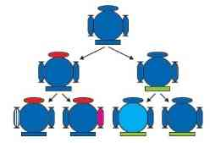

Figure 9.1 Creation of diversity over succeeding generations. The original organism at the top will give rise to, say, two individuals, similar in body design, but with subtle differences. Each of them, in turn, will give rise to two individuals in the next generation. Each of the four individuals in the bottom row will be different from each other. While some of these differences will be unique, others will be inherited from their respective parents, who were different from each other.

#### Questions

If a trait A exists in 10% of a population of an asexually reproducing species and a trait B exists in 60% of the same population, which trait is likely to have arisen earlier?

How does the creation of variations in a species promote survival?

### 9.2 - Heredity

The most obvious outcome of the reproductive process still remains the generation of individuals of similar design. The rules of heredity determine the process by which traits and characteristics are reliably inherited. Let us take a closer look at these rules.

#### 9.2.1 - Inherited Traits

What exactly do we mean by similarities and differences? We know that a child bears all the basic features of a human being. However, it does not look exactly like its parents, and human populations show a great deal of variation.

##### Activity 9.1

Observe the ears of all the students in the class. Prepare a list of students having free or attached earlobes and calculate the percentage of students having each (Fig. 9.2). Find out about the earlobes of the parents of each student in the class. Correlate the earlobe type of each student with that of their parents. Based on this evidence, suggest a possible rule for the inheritance of earlobe types.

#### 9.2.2 - Rules for the Inheritance of Traits – Mendel’s Contributions

The rules for inheritance of such traits in human beings are related to the fact that both the father and the mother contribute practically equal amounts of genetic material to the child. This means that each trait can be influenced by both paternal and maternal DNA. Thus, for each trait there will be two versions in each child. What will, then, the trait seen in the child be? Mendel (see box) worked out the main rules of such inheritance, and it is interesting to look at some of his experiments from more than a century ago.

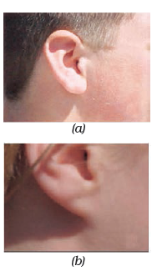

Figure 9.2 (a) Free and (b) attached earlobes. The lowest part of the ear, called the earlobe, is closely attached to the side of the head in some of us, and not in others. Free and attached earlobes are two variants found in human populations.

**Gregor Johann Mendel (1822–1884)**

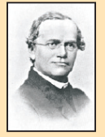

Mendel was educated in a monastery and went on to study science and mathematics at the University of Vienna. Failure in the examinations for a teaching certificate did not suppress his zeal for scientific quest. He went back to his monastery and started growing peas. Many others had studied the inheritance of traits in peas and other organisms earlier, but Mendel blended his knowledge of science and mathematics and was the first one to keep count of individuals exhibiting a particular trait in each generation. This helped him to arrive at the laws of inheritance.

Mendel used a number of contrasting visible characters of garden peas – round/wrinkled seeds, tall/short plants, white/violet flowers and so on. He took pea plants with different characteristics – a tall plant and a short plant, produced progeny by crossing them, and calculated the percentages of tall or short progeny.

In the first place, there were no halfway characteristics in this first-generation, or F1 progeny – no ‘medium-height’ plants. All plants were tall. This meant that only one of the parental traits was seen, not some mixture of the two. So the next question was, were the tall plants in the F1 generation exactly the same as the tall plants of the parent generation? Mendelian experiments test this by getting both the parental plants and these F1 tall plants to reproduce by self-pollination. The progeny of the parental plants are, of course, all tall. However, the second-generation, or F2, progeny of the F1 tall plants are not all tall. Instead, one quarter of them are short. This indicates that both the tallness and shortness traits were inherited in the F1 plants, but only the tallness trait was expressed. This led Mendel to propose that two copies of factor (now called genes) controlling traits are present in sexually reproducing organism. These two may be identical, or may be different, depending on the parentage. A pattern of inheritance can be worked out with this assumption, as shown in Fig. 9.3.

##### Activity 9.2

In Fig. 9.3, what experiment would we do to confirm that the F2 generation did in fact have a 1:2:1 ratio of TT, Tt and tt trait combinations?

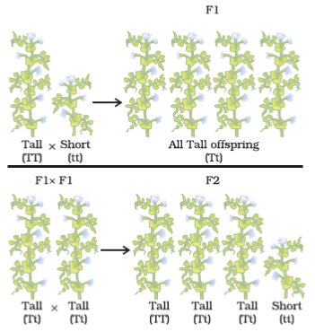

Figure 9.3 Inheritance of traits over two generations

In this explanation, both TT and Tt are tall plants, while only tt is a short plant. In other words, a single copy of ‘T’ is enough to make the plant tall, while both copies have to be ‘t’ for the plant to be short. Traits like ‘T’ are called dominant traits, while those that behave like ‘t’ are called recessive traits. Work out which trait would be considered dominant and which one recessive in Fig. 9.4.

What happens when pea plants showing two different characteristics, rather than just one, are bred with each other? What do the progeny of a tall plant with round seeds and a short plant with wrinkled-seeds look like? They are all tall and have round seeds. Tallness and round seeds are thus dominant traits. But what happens when these F1 progeny are used to generate F2 progeny by self-pollination? A Mendelian experiment will find that some F2 progeny are tall plants with round seeds, and some were short plants with wrinkled seeds. However, there would also be some F2 progeny that showed new combinations. Some of them would be tall, but have wrinkled seeds, while others would be short, but have round seeds. You can see as to how new combinations of traits are formed in F2 offspring when factors controlling for seed shape and seed colour recombine to form zygote leading to form F2 offspring (Fig. 9.5). Thus, the tall/short trait and the round seed/wrinkled seed trait are independently inherited.

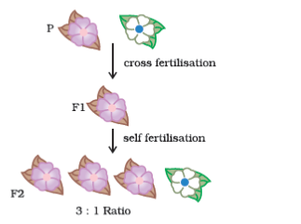

Figure 9.4

#### 9.2.3 - How do these Traits get Expressed?

How does the mechanism of heredity work? Cellular DNA is the information source for making proteins in the cell. A section of DNA that provides information for one protein is called the gene for that protein. How do proteins control the characteristics that we are discussing here? Let us take the example of tallness as a characteristic. We know that plants have hormones that can trigger growth. Plant height can thus depend on the amount of a particular plant hormone. The amount of the plant hormone made will depend on the efficiency of the process for making it. Consider now an enzyme that is important for this process. If this enzyme works efficiently, a lot of hormone will be made, and the plant will be tall. If the gene for that enzyme has an alteration that makes the enzyme less efficient, the amount of hormone will be less, and the plant will be short. Thus, genes control characteristics, or traits.

If the interpretations of Mendelian experiments we have been discussing are correct, then both parents must be contributing equally to the DNA of the progeny during sexual reproduction. We have discussed this issue in the previous Chapter. If both parents can help determine the trait in the progeny, both parents must be contributing a copy of the same gene. This means that each pea plant must have two sets of all genes, one inherited from each parent. For this mechanism to work, each germ cell must have only one gene set.

How do germ-cells make a single set of genes from the normal two copies that all other cells in the body have? If progeny plants inherited a single whole gene set from each parent, then the experiment explained in Fig. 9.5 cannot work. This is because the two characteristics ‘R’ and ‘y’ would then be linked to each other and cannot be independently inherited. This is explained by the fact that each gene set is present, not as a single long thread of DNA, but as separate independent pieces, each called a chromosome. Thus, each cell will have two copies of each chromosome, one each from the male and female parents. Every germ-cell will take one chromosome from each pair and these may be of either maternal or paternal origin. When two germ cells combine, they will restore the normal number of chromosomes in the progeny, ensuring the stability of the DNA of the species. Such a mechanism of inheritance explains the results of the Mendel experiments, and is used by all sexually reproducing organisms. But asexually reproducing organisms also follow similar rules of inheritance. Can we work out how their inheritance might work?

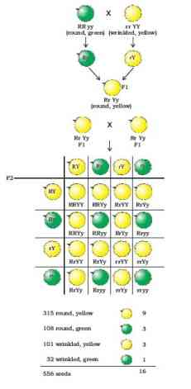

Figure 9.5 Independent inheritance of two separate traits, shape and colour of seeds

#### 9.2.4 - Sex Determination

We have discussed the idea that the two sexes participating in sexual reproduction must be somewhat different from each other for a number of reasons. How is the sex of a newborn individual determined? Different species use very different strategies for this. Some rely entirely on environmental cues. Thus, in some animals like a few reptiles, the temperature at which fertilised eggs are kept determines whether the animals developing in the eggs will be male or female. In other animals, such as snails, individuals can change sex, indicating that sex is not genetically determined. However, in human beings, the sex of the individual is largely genetically determined. In other words, the genes inherited from our parents decide whether we will be boys or girls. But so far, we have assumed that similar gene sets are inherited from both parents. If that is the case, how can genetic inheritance determine sex?

The explanation lies in the fact that all human chromosomes are not paired. Most human chromosomes have a maternal and a paternal copy, and we have 22 such pairs. But one pair, called the sex chromosomes, is odd in not always being a perfect pair. Women have a perfect pair of sex chromosomes, both called X. But men have a mismatched pair in which one is a normal-sized X while the other is a short one called Y. So women are XX, while men are XY. Now, can we work out what the inheritance pattern of X and Y will be?

As Fig. 9.6 shows, half the children will be boys and half will be girls. All children will inherit an X chromosome from their mother regardless of whether they are boys or girls. Thus, the sex of the children will be determined by what they inherit from their father. A child who inherits an X chromosome from her father will be a girl, and one who inherits a Y chromosome from him will be a boy.

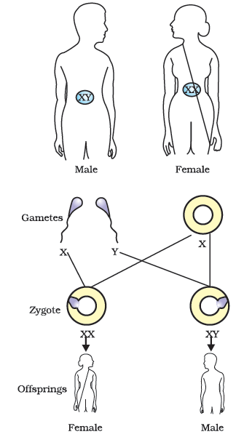

Figure 9.6 Sex determination in human beings

#### Questions

How do Mendel’s experiments show that traits may be dominant or recessive?

How do Mendel’s experiments show that traits are inherited independently?

A man with blood group A marries a woman with blood group O and their daughter has blood group O. Is this information enough to tell you which of the traits – blood group A or O – is dominant? Why or why not?

How is the sex of the child determined in human beings?

### 9.3 - Evolution

We have noted that there is an inbuilt tendency to variation during reproduction, both because of errors in DNA copying, and as a result of sexual reproduction. Let us now look at some consequences of this tendency.

#### 9.3.1 - An Illustration

Consider a group of twelve red beetles. They live, let us assume, in some bushes with green leaves. Their population will grow by sexual reproduction, and therefore, can generate variations. Let us imagine also that crows eat these beetles. The more beetles the crows eat, the fewer beetles are available to reproduce. Now, let us think about some different situations (Fig. 9.7) that can develop in this beetle population.

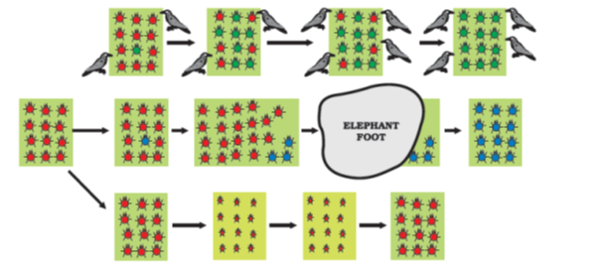

Figure 9.7 Variations in a population – inherited and otherwise

In the first situation, a colour variation arises during reproduction, so that there is one beetle that is green in colour instead of red. This beetle, moreover, can pass the colour on to its progeny, so that all its progeny beetles are green. Crows cannot see green-coloured beetles on the green leaves of the bushes, and therefore cannot eat them. What happens then? The progeny of green beetles is not eaten, while the progeny of red beetles continues to be eaten. As a result, there are more and more green beetles than red ones in the beetle population.

In a second situation, again, a colour variation arises during reproduction, but now it results in a beetle that is blue in colour instead of red. This beetle can also pass the colour on to its progeny, so that all its progeny beetles are blue. Crows can see blue-coloured beetles in the green leaves of the bushes as well as they can see red ones, and therefore can eat them. What happens initially? In the population, as it expands, there are a few blue beetles, but most are red. But at this point, an elephant comes by, and stamps on the bushes where the beetles live. This kills most of the beetles. By chance, the few beetles that have survived are mostly blue. The beetle population slowly expands again, but now, the beetles in the population are mostly blue.

It is obvious that in both situations, what started out as a rare variation came to be a common characteristic in the population. In other words, the frequency of an inherited trait changed over generations. Since genes control traits, we can say that the frequency of certain genes in a population changed over generations. This is the essence of the idea of evolution.

But there are interesting differences, too, in the two situations. In the first case, the variation became common because it gave a survival advantage. In other words, it was naturally selected. We can see that the natural selection is exerted by the crows. The more crows there are, the more red beetles would be eaten, and the more the proportion of green beetles in the population would be. Thus, natural selection is directing evolution in the beetle population. It results in adaptations in the beetle population to fit their environment better.

In the second situation, the colour change gave no survival advantage. Instead, it was simply a matter of accidental survival of beetles of one colour that changed the common characteristic of the resultant population. The elephant would not have caused such major havoc in the beetle population if the beetle population had been very large. So, accidents in small populations can change the frequency of some genes in a population, even if they give no survival advantage. This is the notion of genetic drift, which provides diversity without any adaptations.

Now consider a third situation. In this, as the beetle population begins to expand, the bushes start suffering from a plant disease. The amount of leaf material for the beetles is reduced. The beetles are poorly nourished as a result. The average weight of adult beetles decreases from what it used to be when leaves were plentiful, but there is no genetic change occurring. After a few years and a few beetle generations of such scarcity, the plant disease is eliminated. There is a lot of leaf food. At this time, what would we expect the weight of the beetles to be?

#### 9.3.2 - Acquired and Inherited Traits

We discussed the idea that the germ cells of sexually reproducing populations are made in specialised reproductive tissue. If the weight of the beetle is reduced because of starvation, that will not change the DNA of the germ cells. Therefore, low weight is not a trait that can be inherited by the progeny of a starving beetle. Therefore, even if some generations of beetles are low in weight because of starvation, that is not an example of evolution, since the change is not inherited over generations. Change in non-reproductive tissues cannot be passed on to the DNA of the germ cells. Therefore the experiences of an individual during its lifetime cannot be passed on to its progeny, and cannot direct evolution.

Consider another example of how an individual cannot pass on to its progeny the experiences of its lifetime. If we breed a group of mice, all their progeny will have tails, as expected. Now, if the tails of these mice are removed by surgery in each generation, do these tailless mice have tailless progeny? The answer is no, and it makes sense because removal of the tail cannot change the genes of the germ cells of the mice.

This is the reason why the ideas of heredity and genetics that we have discussed earlier are so essential for understanding evolution. Even Charles Darwin, who came up with the idea of evolution of species by natural selection in the nineteenth century, could not work out the mechanism. It is ironic that he could have done so if he had seen the significance of the experiments his Austrian contemporary, Gregor Mendel, was doing. But then, Mendel too did not notice Darwin’s work as relevant to his!

**Charles Robert Darwin (1809–1882)**

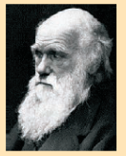

Charles Darwin set out on a voyage when he was 22 years old. The five-year voyage took him to South America and the islands off its coast. The studies that he conducted during this voyage were to change forever the way we look at the variety of life on earth. Interestingly, after he got back to England, he never left its shores again. He stayed at home and conducted various experiments that led him to formulate his hypothesis that evolution took place due to natural selection. He did not know the mechanism whereby variations arose in the species. He would have been enlightened by Mendel’s experiments, but these two gentlemen did not know of each other or their work!

We often associate Darwin solely with the theory of evolution. But he was an accomplished naturalist, and one of the studies he conducted was to do with the role of earthworms in soil fertility.

##### Do you Know?

**Origin of life on earth**

Darwin’s theory of evolution tells us how life evolved from simple to more complex forms and Mendel’s experiments give us the mechanism for the inheritance of traits from one generation to the next. But neither tells us anything about how life began on earth in the first place.

J.B.S. Haldane, a British scientist (who became a citizen of India later), suggested in 1929 that life must have developed from the simple inorganic molecules which were present on earth soon after it was formed. He speculated that the conditions on earth at that time, which were far from the conditions we see today, could have given rise to more complex organic molecules that were necessary for life. The first primitive organisms would arise from further chemical synthesis.

How did these organic molecules arise? An answer was suggested by the experiment conducted by Stanley L. Miller and Harold C. Urey in 1953. They assembled an atmosphere similar to that thought to exist on early earth (this had molecules like ammonia, methane and hydrogen sulphide, but no oxygen) over water. This was maintained at a temperature just below 100°C and sparks were passed through the mixture of gases to simulate lightning. At the end of a week, 15% of the carbon (from methane) had been converted to simple compounds of carbon including amino acids which make up protein molecules. So, can life arise afresh on earth even now?

#### Questions

What are the different ways in which individuals with a particular trait may increase in a population?

Why are traits acquired during the life-time of an individual not inherited?

Why are the small numbers of surviving tigers a cause of worry from the point of view of genetics?

### 9.4 - Speciation

What we have seen so far is micro-evolution. That means that the changes are small, even though they are significant. Also, they simply change the common characteristics of a particular species. But this does not properly explain as to how new species come into existence. That can be said to have happened only if this group of beetles we are thinking about, splits into two populations that cannot reproduce with each other. When this happens, they can be called two independent species. So, can we extend the reasoning we have used above to explain such speciation?

Consider what would happen if the bushes the beetles feed on are spread widely over a mountain range. The beetle population becomes very large as a result. But individual beetles feed mostly on a few nearby bushes throughout their lifetime. They do not travel far. So, in this huge population of beetles, there will be sub-populations in neighbourhoods. Since male and female beetles have to meet for reproduction to happen, most reproduction will be within these sub-populations. Of course, an occasional adventurous beetle might go from one site to another. Or a beetle is picked up by a crow from one site and dropped in the other site without being eaten. In either case, the migrant beetle will reproduce with the local population. This will result in the genes of the migrant beetle entering a new population. This kind of gene flow is bound to happen between populations that are partly, but not completely separated. If, however, between two such sub-populations a large river comes into existence, the two populations will be further isolated. The levels of gene flow between them will decrease even further.

Over generations, genetic drift will accumulate different changes in each sub-population. Also, natural selection may also operate differently in these different geographic locations. Thus, for example, in the territory of one sub-population, crows are eliminated by eagles. But this does not happen for the other sub-population, where crow numbers are very high. As a result, the green variation will not be selected at the first site, while it will be strongly selected at the second.

Together, the processes of genetic drift and natural selection will result in these two isolated sub-populations of beetles becoming more and more different from each other. Eventually, members of these two groups will be incapable of reproducing with each other even if they happen to meet.

There can be a number of ways by which this can happen. If the DNA changes are severe enough, such as a change in the number of chromosomes, eventually the germ cells of the two groups cannot fuse with each other. Or a new variation emerges in which green females will not mate with red males, but only with green males. This allows very strong natural selection for greenness. Now, if such a green female beetle meets a red male from the other group, her behaviour will ensure that there is no reproduction between them. Effectively, new species of beetles are being generated.

#### Questions

What factors could lead to the rise of a new species?

Will geographical isolation be a major factor in the speciation of a self-pollinating plant species? Why or why not?

Will geographical isolation be a major factor in the speciation of an organism that reproduces asexually? Why or why not?

### 9.5 - Evolution and Classification

Based on these principles, we can work out the evolutionary relationships of the species we see around us. It is a sort of going backwards in time. We can do this by identifying hierarchies of characteristics between species. In order to understand this process, let us think back to our discussion on the classification of organisms in Class IX.

Similarities among organisms will allow us to group them and then study the groups. For this, which characteristics decide more fundamental differences among organisms, and which ones decide less basic differences? What is meant by ‘characteristics’, anyway? Characteristics are details of appearance or behaviour; in other words, a particular form or a particular function. That we have four limbs is thus a characteristic. That plants can do photosynthesis is also a characteristic.

Some basic characteristics will be shared by most organisms. The cell is the basic unit of life in all organisms. The characteristics in the next level of classification would be shared by most, but not all organisms. A basic characteristic of cell design that differs among different organisms is whether the cell has a nucleus. Bacterial cells do not, while the cells of most other organisms do. Among organisms with nucleated cells, which ones are unicellular and which ones multi-cellular? That property marks a very basic difference in body design, because of specialisation of cell types and tissues. Among multi-cellular organisms, whether they can undertake photosynthesis or not will provide the next level of classification. Among the multi-cellular organisms that cannot do photosynthesis, whether the skeleton is inside the body or around the body will mark another fundamental design difference. We can see that, even in these few questions that we have asked, a hierarchy is developing that allows us to make classification groups.

The more characteristics two species will have in common, the more closely they are related. And the more closely they are related, the more recently they will have had a common ancestor. An example will help. A brother and a sister are closely related. They have common ancestors in the first generation before them, namely, their parents. A girl and her first cousin are also related, but less than the girl and her brother. This is because cousins have common ancestors, their grandparents, in the second generation before them, not in the first one. We can now appreciate that classification of species is in fact a reflection of their evolutionary relationship.

We can thus build up small groups of species with recent common ancestors, then super-groups of these groups with more distant common ancestors, and so on. In theory, we can keep going backwards like this until we come to the notion of a single species at the very beginning of evolutionary time. If that is the case, then at some point in the history of the earth, non-living material must have given rise to life. There are many theories about how this might have happened. It would be interesting to come up with theories of our own!

#### 9.5.1 - Tracing Evolutionary Relationships

When we try to follow evolutionary relationships, how do we identify characteristics as common? These characteristics in different organisms would be similar because they are inherited from a common ancestor. As an example, consider the fact that mammals have four limbs, as do birds, reptiles and amphibians (Fig. 9.8). The basic structure of the limbs is similar though it has been modified to perform different functions in various vertebrates. Such a homologous characteristic helps to identify an evolutionary relationship between apparently different species.

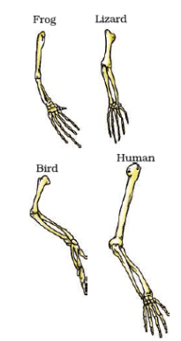

Figure 9.8 Homologous organs

However, all similarities simply in organ shape are not necessarily because of common ancestry. What would we think about the wings of birds and bats, for example (Fig. 9.9)? Birds and bats have wings, but squirrels and lizards do not. So are birds and bats more closely related to each other than to squirrels or lizards?

Before we jump to this conclusion, let us look at the wings of birds and bats more closely. When we do that, we find that the wings of bats are skin folds stretched mainly between elongated fingers. But the wings of birds are a feathery covering all along the arm. The designs of the two wings, their structure and components, are thus very different. They look similar because they have a common use for flying, but their origins are not common. This makes them analogous characteristics, rather than homologous characteristics. It would now be interesting to think about whether bird arms and bat arms should be considered homologous or analogous!

#### 9.5.2 - Fossils

Such studies of organ structure can be done not only on current species, but also on species that are no longer alive. How do we know that these extinct species ever existed? We know this from finding fossils (Fig. 9.10). What are fossils? Usually, when organisms die, their bodies will decompose and be lost. But every once in a while, the body or at least some parts may be in an environment that does not let it decompose completely. If a dead insect gets caught in hot mud, for example, it will not decompose quickly, and the mud will eventually harden and retain the impression of the body parts of the insect. All such preserved traces of living organisms are called fossils.

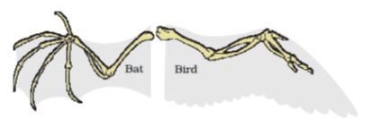

Figure 9.9 Analogous organs – The wing of a bat and the wing of a bird

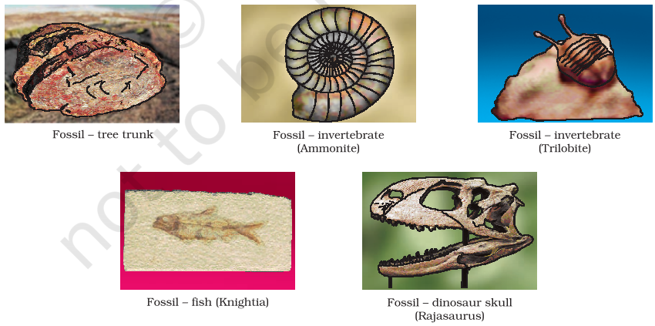

Figure 9.10 Various kind of fossils. Note the different appearances and degrees of detail and preservation. The dinosaur skull fossil shown was found only a few years ago in the Narmada valley.

How do we know how old the fossils are? There are two components to this estimation. One is relative. If we dig into the earth and start finding fossils, it is reasonable to suppose that the fossils we find closer to the surface are more recent than the fossils we find in deeper layers. The second way of dating fossils is by detecting the ratios of different isotopes of the same element in the fossil material. It would be interesting to find out exactly how this method works!

##### Do you know?

**How do fossils form layer by layer?**

Let us start 100 million years ago. Some invertebrates on the sea-bed die, and are buried in the sand. More sand accumulates, and sandstone forms under pressure.



Millions of years later, dinosaurs living in the area die, and their bodies, too, are buried in mud. This mud is also compressed into rock, above the rock containing the earlier invertebrate fossils.

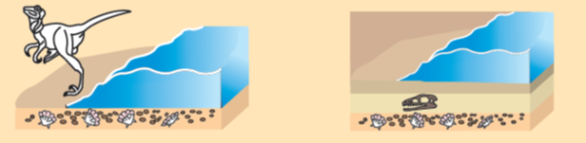

Again millions of years later, the bodies of horse-like creatures dying in the area are fossilised in rocks above these earlier rocks.

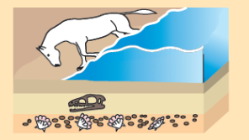

Much later, by erosion or water flow wears away some of the rock and exposes the horse-like fossils. As we dig deeper, we will find older and older fossils.

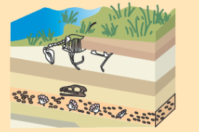

#### 9.5.3 - Evolution by Stages

A question that arises here is – if complicated organs, such as the eye, are selected for the advantage they provide, how can they be generated by a single DNA change? Surely such complex organs will be created bit-by-bit over generations? But how can each intermediate change be selected for? There are a number of possible explanations. Even an intermediate stage (Fig. 9.11), such as a rudimentary eye, can be useful to some extent. This might be enough to give a fitness advantage. In fact, the eye – like the wing – seems to be a very popular adaptation. Insects have them, so does an octopus, and so do vertebrates. And the structure of the eye in each of these organisms is different – enough for them to have separate evolutionary origins.

Also, a change that is useful for one property to start with can become useful later for quite a different function. Feathers, for example, can start out as providing insulation in cold weather (Fig. 9.12). But later, they might become useful for flight. In fact, some dinosaurs had feathers, although they could not fly using the feathers. Birds seem to have later adapted the feathers to flight. This, of course, means that birds are very closely related to reptiles, since dinosaurs were reptiles!

It is all very well to say that very dissimilar-looking structures evolve from a common ancestral design. It is true that analysis of the organ structure in fossils allows us to make estimates of how far back evolutionary relationships go. But those are guesses about what happened in history. Are there any current examples of such a process? The wild cabbage plant is a good example. Humans have, over more than two thousand years, cultivated wild cabbage as a food plant, and generated different vegetables from it by selection (see Fig. 9.13). This is, of course, artificial selection rather than natural selection. So some farmers have wanted to select for very short distances between leaves, and have bred the cabbage we eat. Some have wanted to select for arrested flower development, and have bred broccoli, or for sterile flowers, and have made the cauliflower. Some have selected for swollen parts, and come up with kohlrabi. Some have simply looked for slightly larger leaves, and come up with a leafy vegetable called kale. Would we have thought that all these structures are descended from the same ancestor if we had not done it ourselves?

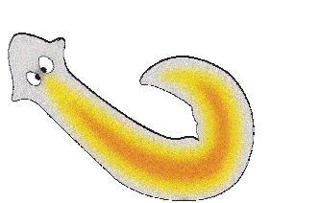

Figure 9.11 A flatworm named Planaria has very simple ‘eyes’ that are really just eye-spots which detect light.

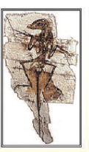

This is a small dinosaur from the Dromaesaur family.

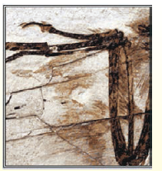

Feather imprints were preserved along this dinosaur’s bones. Here we can see feathers on the forearm.

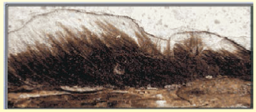

Here’s a close-up of the fossil’s head feathers. This dinosaur could not fly, and it is possible that the evolution of feathers had nothing to do with flight. **Figure 9.12** Dinosaurs and the evolution of feathers

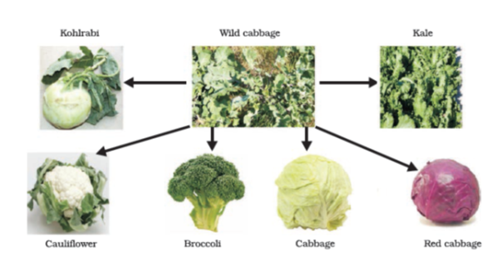

Figure 9.13 Evolution of wild cabbage!

Another way of tracing evolutionary relationships depends on the original idea that we started with. That idea was that changes in DNA during reproduction are the basic events in evolution. If that is the case, then comparing the DNA of different species should give us a direct estimate of how much the DNA has changed during the formation of these species. This method is now extensively used to define evolutionary relationships.

##### More to know!

**Molecular phylogeny**

We have been discussing how changes in the DNA during cell division would lead to changes in the proteins that are made from this new DNA. Another point that has been made is that these changes would accumulate from one generation to the next. Could this be used to trace the changes in DNA backwards in time and find out where each change diverged from the other? Molecular phylogeny does exactly this. This approach is based on the idea that organisms which are more distantly related will accumulate a greater number of differences in their DNA. Such studies trace the evolutionary relationships and it has been highly gratifying to find that the relationships among different organisms shown by molecular phylogeny match the classification scheme that we learnt in Class IX.

#### Questions

Give an example of characteristics being used to determine how close two species are in evolutionary terms.

Can the wing of a butterfly and the wing of a bat be considered homologous organs? Why or why not?

What are fossils? What do they tell us about the process of evolution?

### 9.6 - Evolution Should Not Be Equated With ‘Progress’

In an exercise of tracing the family trees of species, we need to remember certain things. Firstly, there are multiple branches possible at each and every stage of this process. So it is not as if one species is eliminated to give rise to a new one. A new species has emerged. But that does not necessarily mean, like the beetle example we have been thinking about, that the old species will disappear. It will all depend on the environment. Also, it is not as if the newly generated species are in any way ‘better’ than the older one. It is just that natural selection and genetic drift have together led to the formation of a population that cannot reproduce with the original one. So, for example, it is not true that human beings have evolved from chimpanzees. Rather, both human beings and chimpanzees have a common ancestor a long time ago. That common ancestor is likely to have been neither human or chimpanzee. Also, the first step of separation from that ancestor is unlikely to have resulted in modern chimpanzees and human beings. Instead, the two resultant species have probably evolved in their own separate ways to give rise to the current forms.

In fact, there is no real ‘progress’ in the idea of evolution. Evolution is simply the generation of diversity and the shaping of the diversity by environmental selection. The only progressive trend in evolution seems to be that more and more complex body designs have emerged over time. However, again, it is not as if the older designs are inefficient! So many of the older and simpler designs still survive. In fact, one of the simplest life forms – bacteria – inhabit the most inhospitable habitats like hot springs, deep-sea thermal vents and the ice in Antarctica. In other words, human beings are not the pinnacle of evolution, but simply yet another species in the teeming spectrum of evolving life.

#### 9.6.1 - Human Evolution

The same tools for tracing evolutionary relationships–excavating, time-dating and studying fossils, as well as determining DNA sequences – have been used for studying human evolution. There is a great diversity of human forms and features across the planet. So much so that, for a long time, people used to talk about human ‘races’. Skin colour used to be the commonest way of identifying these so-called races. Some were called yellow, some black, white or brown. A major question debated for a long time was, have these apparent groups evolved differently? Over recent years, the evidence has become very clear. The answer is that there is no biological basis to the notion of human races. All humans are a single species.

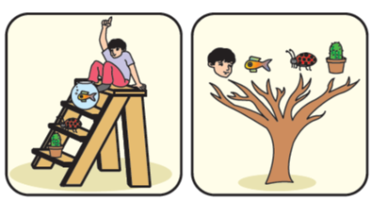

Figure 9.14 Evolution – Ladder versus Tree

Not only that, regardless of where we have lived for the past few thousand years, we all come from Africa. The earliest members of the human species, *Homo sapiens*, can be traced there. Our genetic footprints can be traced back to our African roots. A couple of hundred thousand years ago, some of our ancestors left Africa while others stayed on. While the residents spread across Africa, the migrants slowly spread across the planet – from Africa to West Asia, then to Central Asia, Eurasia, South Asia, East Asia. They travelled down the islands of Indonesia and the Philippines to Australia, and they crossed the Bering land bridge to the Americas. They did not go in a single line, so they were not travelling for the sake of travelling, obviously. They went forwards and backwards, with groups sometimes separating from each other, sometimes coming back to mix with each other, even moving in and out of Africa. Like all other species on the planet, they had come into being as an accident of evolution, and were trying to live their lives the best they could.

#### Questions

Why are human beings who look so different from each other in terms of size, colour and looks said to belong to the same species?

In evolutionary terms, can we say which among bacteria, spiders, fish and chimpanzees have a ‘better’ body design? Why or why not?

### What you have learnt

Variations arising during the process of reproduction can be inherited.

These variations may lead to increased survival of the individuals.

Sexually reproducing individuals have two copies of genes for the same trait. If the copies are not identical, the trait that gets expressed is called the dominant trait and the other is called the recessive trait.

Traits in one individual may be inherited separately, giving rise to new combinations of traits in the offspring of sexual reproduction.

Sex is determined by different factors in various species. In human beings, the sex of the child depends on whether the paternal chromosome is X (for girls) or Y (for boys).

Variations in the species may confer survival advantages or merely contribute to the genetic drift.

Changes in the non-reproductive tissues caused by environmental factors are not inheritable.

Speciation may take place when variation is combined with geographical isolation.

Evolutionary relationships are traced in the classification of organisms.

Tracing common ancestors back in time leads us to the idea that at some point of time, non-living material must have given rise to life.

Evolution can be worked out by the study of not just living species, but also fossils.

Complex organs may have evolved because of the survival advantage of even the intermediate stages.

Organs or features may be adapted to new functions during the course of evolution. For example, feathers are thought to have been initially evolved for warmth and later adapted for flight.

Evolution cannot be said to ‘progress’ from ‘lower’ forms to ‘higher’ forms. Rather, evolution seems to have given rise to more complex body designs even while the simpler body designs continue to flourish.

Study of the evolution of human beings indicates that all of us belong to a single species that evolved in Africa and spread across the world in stages.

### Exercises

A Mendelian experiment consisted of breeding tall pea plants bearing violet flowers with short pea plants bearing white flowers. The progeny all bore violet flowers, but almost half of them were short. This suggests that the genetic make-up of the tall parent can be depicted as

TTWW

TTww

TtWW

TtWw

An example of homologous organs is

our arm and a dog’s fore-leg.

our teeth and an elephant’s tusks.

potato and runners of grass.

all of the above.

In evolutionary terms, we have more in common with

a Chinese school-boy.

a chimpanzee.

a spider.

a bacterium.

A study found that children with light-coloured eyes are likely to have parents with light-coloured eyes. On this basis, can we say anything about whether the light eye colour trait is dominant or recessive? Why or why not?

How are the areas of study – evolution and classification – interlinked?

Explain the terms analogous and homologous organs with examples.

Outline a project which aims to find the dominant coat colour in dogs.

Explain the importance of fossils in deciding evolutionary relationships.

What evidence do we have for the origin of life from inanimate matter?

Explain how sexual reproduction gives rise to more viable variations than asexual reproduction. How does this affect the evolution of those organisms that reproduce sexually?

How is the equal genetic contribution of male and female parents ensured in the progeny?

Only variations that confer an advantage to an individual organism will survive in a population. Do you agree with this statement? Why or why not?

## Chapter 10 – Light – Reflection and Refraction



1064CH10

We see a variety of objects in the world around us. However, we are unable to see anything in a dark room. On lighting up the room, things become visible. What makes things visible? During the day, the sunlight helps us to see objects. An object reflects light that falls on it. This reflected light, when received by our eyes, enables us to see things. We are able to see through a transparent medium as light is transmitted through it. There are a number of common wonderful phenomena associated with light such as image formation by mirrors, the twinkling of stars, the beautiful colours of a rainbow, bending of light by a medium and so on. A study of the properties of light helps us to explore them.

By observing the common optical phenomena around us, we may conclude that light seems to travel in straight lines. The fact that a small source of light casts a *sharp* shadow of an opaque object points to this straight-line path of light, usually indicated as a ray of light.

In this Chapter, we shall study the phenomena of reflection and refraction of light using the straight-line propagation of light. These basic concepts will help us in the study of some of the optical phenomena in nature. We shall try to understand in this Chapter the reflection of light by spherical mirrors and refraction of light and their application in real life situations.

### More to know!

If an opaque object on the path of light becomes *very small*, light has a tendency to bend around it and not walk in a straight line – an effect known as the diffraction of light. Then the straight-line treatment of optics using rays fails. To explain phenomena such as diffraction, light is thought of as a wave, the details of which you will study in higher classes. Again, at the beginning of the 20th century, it became known that the wave theory of light often becomes inadequate for treatment of the interaction of light with matter, and light often behaves somewhat like a *stream of particles*. This confusion about the true nature of light continued for some years till a modern quantum theory of light emerged in which light is neither a ‘wave’ nor a ‘particle’ – the new theory reconciles the particle properties of light with the wave nature.

### 10.1 - Reflection of Light

A highly polished surface, such as a mirror, reflects most of the light falling on it. You are already familiar with the laws of reflection of light.

Let us recall these laws –

The angle of incidence is equal to the angle of reflection, and

The incident ray, the normal to the mirror at the point of incidence and the reflected ray, all lie in the same plane.

These laws of reflection are applicable to all types of reflecting surfaces including spherical surfaces. You are familiar with the formation of image by a plane mirror. What are the properties of the image? Image formed by a plane mirror is always virtual and erect. The size of the image is equal to that of the object. The image formed is as far behind the mirror as the object is in front of it. Further, the image is laterally inverted. How would the images be when the reflecting surfaces are curved? Let us explore.

#### Activity 10.1

Take a large shining spoon. Try to view your face in its curved surface.

Do you get the image? Is it smaller or larger?

Move the spoon slowly away from your face. Observe the image. How does it change?

Reverse the spoon and repeat the Activity. How does the image look like now?

Compare the characteristics of the image on the two surfaces.

The curved surface of a shining spoon could be considered as a curved mirror. The most commonly used type of curved mirror is the spherical mirror. The reflecting surface of such mirrors can be considered to form a part of the surface of a sphere. Such mirrors, whose reflecting surfaces are spherical, are called spherical mirrors. We shall now study about spherical mirrors in some detail.

### 10.2 - Spherical Mirrors

The reflecting surface of a spherical mirror may be curved inwards or outwards. A spherical mirror, whose reflecting surface is curved inwards, that is, faces towards the centre of the sphere, is called a concave mirror. A spherical mirror whose reflecting surface is curved outwards, is called a convex mirror. The schematic representation of these mirrors is shown in Fig. 10.1. You may note in these diagrams that the back of the mirror is shaded.

You may now understand that the surface of the spoon curved inwards can be approximated to a concave mirror and the surface of the spoon bulged outwards can be approximated to a convex mirror.

Before we move further on spherical mirrors, we need to recognise and understand the meaning of a few terms. These terms are commonly used in discussions about spherical mirrors. The centre of the reflecting surface of a spherical mirror is a point called the pole. It lies on the surface of the mirror. The pole is usually represented by the letter P.

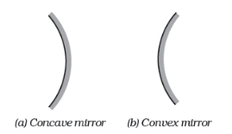

Figure 10.1 Schematic representation of spherical mirrors; the shaded side is non-reflecting.

The reflecting surface of a spherical mirror forms a part of a sphere. This sphere has a centre. This point is called the centre of curvature of the spherical mirror. It is represented by the letter C. Please note that the centre of curvature is not a part of the mirror. It lies outside its reflecting surface. The centre of curvature of a concave mirror lies in front of it. However, it lies behind the mirror in case of a convex mirror. You may note this in Fig. 10.2 (a) and (b). The radius of the sphere of which the reflecting surface of a spherical mirror forms a part, is called the radius of curvature of the mirror. It is represented by the letter *R*. You may note that the distance PC is equal to the radius of curvature. Imagine a straight line passing through the pole and the centre of curvature of a spherical mirror. This line is called the principal axis. Remember that principal axis is normal to the mirror at its pole. Let us understand an important term related to mirrors, through an Activity.

#### Activity 10.2

**CAUTION:** Do not look at the Sun directly or even into a mirror reflecting sunlight. It may damage your eyes.

Hold a concave mirror in your hand and direct its reflecting surface towards the Sun.

Direct the light reflected by the mirror on to a sheet of paper held close to the mirror.

Move the sheet of paper back and forth gradually until you find on the paper sheet a bright, sharp spot of light.

Hold the mirror and the paper in the same position for a few minutes. What do you observe? Why?

The paper at first begins to burn producing smoke. Eventually it may even catch fire. Why does it burn? The light from the Sun is converged at a point, as a sharp, bright spot by the mirror. In fact, this spot of light is the image of the Sun on the sheet of paper. This point is the focus of the concave mirror. The heat produced due to the concentration of sunlight ignites the paper. The distance of this image from the position of the mirror gives the approximate value of focal length of the mirror.

Let us try to understand this observation with the help of a ray diagram.

Observe Fig. 10.2 (a) closely. A number of rays parallel to the principal axis are falling on a concave mirror. Observe the reflected rays. They are all meeting/intersecting at a point on the principal axis of the mirror. This point is called the principal focus of the concave mirror. Similarly, observe Fig. 10.2 (b). How are the rays parallel to the principal axis, reflected by a convex mirror? The reflected rays appear to come from a point on the principal axis. This point is called the principal focus of the convex mirror. The principal focus is represented by the letter F. The distance between the pole and the principal focus of a spherical mirror is called the focal length. It is represented by the letter ƒ.

The reflecting surface of a spherical mirror is by-and-large spherical. The surface, then, has a circular outline. The diameter of the reflecting surface of spherical mirror is called its aperture. In Fig. 10.2, distance MN represents the aperture. We shall consider in our discussion only such spherical mirrors whose aperture is much smaller than its radius of curvature.

Is there a relationship between the radius of curvature *R*, and focal length ƒ, of a spherical mirror? For spherical mirrors of small apertures, the radius of curvature is found to be equal to twice the focal length. We put this as *R = 2*ƒ. This implies that the principal focus of a spherical mirror lies midway between the pole and centre of curvature.

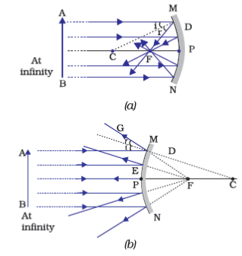

Figure 10.2 (a) Concave mirror (b) Convex mirror

#### 10.2.1 - Image Formation by Spherical Mirrors

You have studied about the image formation by plane mirrors. You also know the nature, position and relative size of the images formed by them. How about the images formed by spherical mirrors? How can we locate the image formed by a concave mirror for different positions of the object? Are the images real or virtual? Are they enlarged, diminished or have the same size? We shall explore this with an Activity.

##### Activity 10.3

You have already learnt a way of determining the focal length of a concave mirror. In Activity 10.2, you have seen that the sharp bright spot of light you got on the paper is, in fact, the image of the Sun. It was a tiny, real, inverted image. You got the approximate focal length of the concave mirror by measuring the distance of the image from the mirror.

Take a concave mirror. Find out its approximate focal length in the way described above. Note down the value of focal length. (You can also find it out by obtaining image of a distant object on a sheet of paper.)

Mark a line on a Table with a chalk. Place the concave mirror on a stand. Place the stand over the line such that its pole lies over the line.

Draw with a chalk two more lines parallel to the previous line such that the distance between any two successive lines is equal to the focal length of the mirror. These lines will now correspond to the positions of the points P, F and C, respectively. *Remember – For a spherical mirror of small aperture, the principal focus* F *lies mid-way between the pole* Ρ *and the centre of curvature* C.

Keep a bright object, say a burning candle, at a position far beyond C. Place a paper screen and move it in front of the mirror till you obtain a sharp bright image of the candle flame on it.

Observe the image carefully. Note down its nature, position and relative size with respect to the object size.

Repeat the activity by placing the candle – (a) just beyond C, (b) at C, (c) between F and C, (d) at F, and (e) between Ρ and F.

In one of the cases, you may not get the image on the screen. Identify the position of the object in such a case. Then, look for its virtual image in the mirror itself.

Note down and tabulate your observations.

You will see in the above Activity that the nature, position and size of the image formed by a concave mirror depends on the position of the object in relation to points P, F and C. The image formed is real for some positions of the object. It is found to be a virtual image for a certain other position. The image is either magnified, reduced or has the same size, depending on the position of the object. A summary of these observations is given for your reference in Table 10.1.

**Table 10.1** Image formation by a concave mirror for different positions of the object

| **Position of the object** | **Position of the image** | **Size of the image** | **Nature of the image** |
| --- | --- | --- | --- |
| At infinity | At the focus F | Highly diminished, point-sized | Real and inverted |
| Beyond C | Between F and C | Diminished | Real and inverted |
| At C | At C | Same size | Real and inverted |
| Between C and F | Beyond C | Enlarged | Real and inverted |
| At F | At infinity | Highly enlarged | Real and inverted |
| Between Ρ and F | Behind the mirror | Enlarged | Virtual and erect |

#### 10.2.2 - Representation of Images Formed by Spherical Mirrors Using Ray Diagrams

We can also study the formation of images by spherical mirrors by drawing ray diagrams. Consider an extended object, of finite size, placed in front of a spherical mirror. Each small portion of the extended object acts like a point source. An infinite number of rays originate from each of these points. To construct the ray diagrams, in order to locate the image of an object, an arbitrarily large number of rays emanating from a point could be considered. However, it is more convenient to consider only two rays, for the sake of clarity of the ray diagram. These rays are so chosen that it is easy to know their directions after reflection from the mirror.

The intersection of at least two reflected rays give the position of image of the point object. Any two of the following rays can be considered for locating the image.

*A ray parallel to the principal axis*, after reflection, will pass through the principal focus in case of a concave mirror or appear to diverge from the principal focus in case of a convex mirror. This is illustrated in Fig. 10.3 (a) and (b).

*A ray passing through the principal focus* of a concave mirror or a *ray which is directed towards the principal focus of* a convex mirror, after reflection, will emerge parallel to the principal axis. This is illustrated in Fig. 10.4 (a) and (b).

*A ray passing through the centre of curvature* of a concave mirror or directed in the direction of the centre of curvature of a convex mirror, after reflection, is reflected back along the same path. This is illustrated in Fig. 10.5 (a) and (b). The light rays come back along the same path because the incident rays fall on the mirror along the normal to the reflecting surface.

*A ray incident obliquely to the principal axis*, towards a point Ρ (pole of the mirror), on the concave mirror [Fig. 10.6 (a)] or a convex mirror [Fig. 10.6 (b)], is reflected obliquely. The incident and reflected rays follow the laws of reflection at the point of incidence (point P), making equal angles with the principal axis

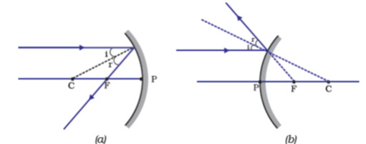

Figure 10.3

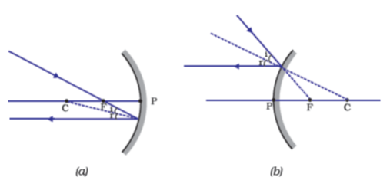

Figure 10.4

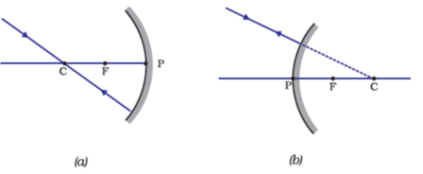

Figure 10.5

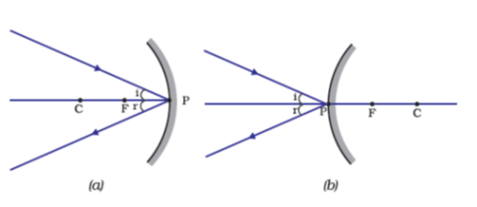

Figure 10.6

Remember that in all the above cases the laws of reflection are followed. At the point of incidence, the incident ray is reflected in such a way that the angle of reflection equals the angle of incidence.

**Image formation by Concave Mirror**

Figure 10.7 illustrates the ray diagrams for the formation of image by a concave mirror for various positions of the object.

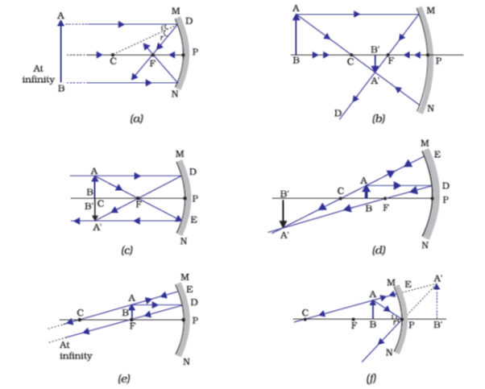

**Figure 10.7** Ray diagrams for the image formation by a concave mirror

**Uses of concave mirrors**

Concave mirrors are commonly used in torches, search-lights and vehicles headlights to get powerful parallel beams of light. They are often used as shaving mirrors to see a larger image of the face. The dentists use concave mirrors to see large images of the teeth of patients. Large concave mirrors are used to concentrate sunlight to produce heat in solar furnaces.

##### Activity 10.4

Draw neat ray diagrams for each position of the object shown in Table 10.1.

You may take any two of the rays mentioned in the previous section for locating the image.

Compare your diagram with those given in Fig. 10.7.

Describe the nature, position and relative size of the image formed in each case.

Tabulate the results in a convenient format.

**Image formation by a Convex Mirror**

We studied the image formation by a concave mirror. Now we shall study the formation of image by a convex mirror.

##### Activity 10.5

Take a convex mirror. Hold it in one hand.

Hold a pencil in the upright position in the other hand.

Observe the image of the pencil in the mirror. Is the image erect or inverted? Is it diminished or enlarged?

Move the pencil away from the mirror slowly. Does the image become smaller or larger?

Repeat this Activity carefully. State whether the image will move closer to or farther away from the focus as the object is moved away from the mirror?

We consider two positions of the object for studying the image formed by a convex mirror. First is when the object is at infinity and the second position is when the object is at a finite distance from the mirror. The ray diagrams for the formation of image by a convex mirror for these two positions of the object are shown in Fig. 10.8 (a) and (b), respectively. The results are summarised in Table 10.2.

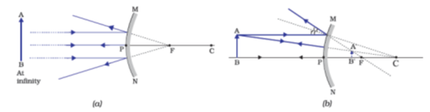

**Figure 10.8** Formation of image by a convex mirror

**Table 10.2** Nature, position and relative size of the image formed by a convex mirror

| **Position of the object** | **Position of the image** | **Size of the image** | **Nature of the image** |
| --- | --- | --- | --- |
| At infinity | At the focus F, behind the mirror | Highly diminished, point-sized | Virtual and erect |
| Between infinity and the pole Ρ of the mirror | Between Ρ and F, behind the mirror | Diminished | Virtual and erect |

You have so far studied the image formation by a plane mirror, a concave mirror and a convex mirror. Which of these mirrors will give the full image of a large object? Let us explore through an Activity.

##### Activity 10.6

Observe the image of a distant object, say a distant tree, in a plane mirror.

Could you see a full-length image?

Try with plane mirrors of different sizes. Did you see the entire object in the image?

Repeat this Activity with a concave mirror. Did the mirror show full length image of the object?

Now try using a convex mirror. Did you succeed? Explain your observations with reason.

You can see a full-length image of a tall building/tree in a small convex mirror. One such mirror is fitted in a wall of Agra Fort facing Taj Mahal. If you visit the Agra Fort, try to observe the full image of Taj Mahal. To view distinctly, you should stand suitably at the terrace adjoining the wall.

**Uses of convex mirrors**

Convex mirrors are commonly used as rear-view (wing) mirrors in vehicles. These mirrors are fitted on the sides of the vehicle, enabling the driver to see traffic behind him/her to facilitate safe driving. Convex mirrors are preferred because they always give an erect, though diminished, image. Also, they have a wider field of view as they are curved outwards. Thus, convex mirrors enable the driver to view much larger area than would be possible with a plane mirror.

#### Questions

Define the principal focus of a concave mirror.

The radius of curvature of a spherical mirror is 20 cm. What is its focal length?

Name a mirror that can give an erect and enlarged image of an object.

Why do we prefer a convex mirror as a rear-view mirror in vehicles?

#### 10.2.3 - Sign Convention for Reflection by Spherical Mirrors

While dealing with the reflection of light by spherical mirrors, we shall follow a set of sign conventions called the *New Cartesian Sign Convention*. In this convention, the pole (P) of the mirror is taken as the origin (Fig. 10.9). The principal axis of the mirror is taken as the x-axis (X’X) of the coordinate system. The conventions are as follows—

The object is always placed to the left of the mirror. This implies that the light from the object falls on the mirror from the left-hand side.

All distances parallel to the principal axis are measured from the pole of the mirror.

All the distances measured to the right of the origin (along + x-axis\text{along\ +\ x-axis}

) are taken as positive while those measured to the left of the origin (along–x-axis\text{along}\text{–}\text{x-axis}

) are taken as negative.

Distances measured perpendicular to and above the principal axis (along + y-axis\text{along\ +\ y-axis}

) are taken as positive.

Distances measured perpendicular to and below the principal axis (along–y-axis\text{along}\text{–}\text{y-axis}

) are taken as negative.

The New Cartesian Sign Convention described above is illustrated in Fig. 10.9 for your reference. These sign conventions are applied to obtain the mirror formula and solve related numerical problems.

#### 10.2.4 - Mirror Formula and Magnification

In a spherical mirror, the distance of the object from its pole is called the object distance (u). The distance of the image from the pole of the mirror is called the image distance (v). You already know that the distance of the principal focus from the pole is called the focal length (ƒ). There is a relationship between these three quantities given by the *mirror formula* which is expressed as

1v+1u=1f\frac{1}{v} + \frac{1}{u} = \frac{1}{f}

…(10.1)

This formula is valid in all situations for all spherical mirrors for all positions of the object. You must use the New Cartesian Sign Convention while substituting numerical values for u, v, ƒ, and *R* in the mirror formula for solving problems.

**Magnification**

Magnification produced by a spherical mirror gives the relative extent to which the image of an object is magnified with respect to the object size. It is expressed as the ratio of the height of the image to the height of the object. It is usually represented by the letter m.

If *h* is the height of the object and *h*′ is the height of the image, then the magnification *m* produced by a spherical mirror is given by

m=Hightofthe image(h′)Hightof the image(h)m = \frac{\text{Hig}h\text{toft}h\text{e\ image}\left( h^{'} \right)}{\text{Hig}h\text{tof\ t}h\text{e\ image}\left( h \right)}

m=h′hm = \frac{h^{'}}{h}

……(10.2)

The magnification *m* is also related to the object distance (*u*) and image distance (*v*). It can be expressed as:

Magnification(m)=h′h=−υu\text{Magnification}\left( m \right) = \frac{h^{'}}{h} = - \frac{\upsilon}{u}

…(10.3)

You may note that the height of the object is taken to be positive as the object is usually placed above the principal axis. The height of the image should be taken as positive for virtual images. However, it is to be taken as negative for real images. A negative sign in the value of the magnification indicates that the image is real. A positive sign in the value of the magnification indicates that the image is virtual.

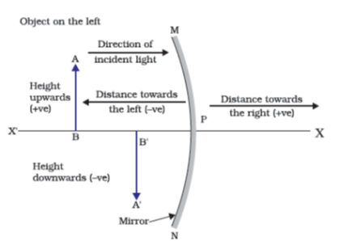

Figure 10.9 The New Cartesian Sign Convention for spherical mirrors

**Example 10.1**

A convex mirror used for rear-view on an automobile has a radius of curvature of 3.00 m. If a bus is located at 5.00 m from this mirror, find the position, nature and size of the image.

**Solution**

Radius of curvature, R=+3.00mR\ = \ + \ 3.00\ m

;

Object-distance,u= – 5.00 mu\ = \text{\ }\text{–}\text{\ }5.00\text{\ m}

;

Image-distance, v=v\ =

?

Height of the image, h′=?h^{'} = ?

Focal length, f=R2=+3.00m2=+1.50mf = \frac{R}{2} = + \frac{3.00m}{2} = + 1.50m

(as the principal focus of a convex mirror is behind the mirror)

Since 1v+1u=1f\frac{1}{v} + \frac{1}{u} = \frac{1}{f}

or, 1v=1f−1u=+11.50−1(–5.00)=11.50+15.00\frac{1}{v} = \frac{1}{f} - \frac{1}{u} = + \frac{1}{1.50} - \frac{1}{\left( –5.00 \right)} = \frac{1}{1.50} + \frac{1}{5.00}

=5.00+1.507.50= \frac{5.00 + 1.50}{7.50}

v=+7.506.50=+1.15mv = \frac{+ 7.50}{6.50} = + 1.15m

The image is 1.15 m at the back of the mirror.

Magnification, m=h′h=−vu=−1.15m–5.00mm = \frac{h^{'}}{h} = - \frac{v}{u} = - \frac{1.15m}{\text{–}\text{5.00}m}

=+0.23= + 0.23

The image is virtual, erect and smaller in size by a factor of 0.23.

**Example 10.2**

An object, 4.0 cm in size, is placed at 25.0 cm in front of a concave mirror of focal length 15.0 cm. At what distance from the mirror should a screen be placed in order to obtain a sharp image? Find the nature and the size of the image.

**Solution**

Object-size, h=+4.0 cmh\ = \ + \ 4.0\text{\ cm}

;

Object-distance, u= – 25.0 cm;u\ = \text{\ }\text{–}\text{\ 25.0\ cm;}

Focal length, f=−15.0cmf\ = \ - 15.0\ cm

;

Image-distance, v=v\ =

?

Image-size, h′=h'\ =

?

From Eq. (10.1):

1v+1u=1f\frac{1}{v} + \frac{1}{u} = \frac{1}{f}

or, 1v=1f−1u=1−15.0−1−25.0=−115.0+125.0\frac{1}{v} = \frac{1}{f} - \frac{1}{u} = \frac{1}{- 15.0} - \frac{1}{- 25.0} = - \frac{1}{15.0} + \frac{1}{25.0}

or, 1v=–5.0+3.075.0=–2.075.0\frac{1}{v} = \frac{–5.0 + 3.0}{75.0} = \frac{–2.0}{75.0}

or v=−37.5cmv = - 37.5\text{cm}

The screen should be placed at 37.5 cm in front of the mirror. The image is real.

Also, magnification, m=h′h=−vum = \frac{h^{'}}{h} = - \frac{v}{u}

or, h′=−vhu=−(–37.5cm)(+4.0cm)(–25.0cm)h^{'} = - \frac{vh}{u} = - \frac{\left( –37.5\text{cm} \right)\left( + 4.0\text{cm} \right)}{\left( –25.0\text{cm} \right)}

Height of the image, h′=−6.0cmh'\ = \ - \ 6.0\ cm

The image is inverted and enlarged.

#### Questions

Find the focal length of a convex mirror whose radius of curvature is 32 cm.

A concave mirror produces three times magnified (enlarged) real image of an object placed at 10 cm in front of it. Where is the image located?

### 10.3 - Refraction of Light

Light seems to travel along straight-line paths in a transparent medium. What happens when light enters from one transparent medium to another? Does it still move along a straight-line path or change its direction? We shall recall some of our day-to-day experiences.

You might have observed that the bottom of a tank or a pond containing water appears to be raised. Similarly, when a thick glass slab is placed over some printed matter, the letters appear raised when viewed through the glass slab. Why does it happen? Have you seen a pencil partly immersed in water in a glass tumbler? It appears to be displaced at the interface of air and water. You might have observed that a lemon kept in water in a glass tumbler appears to be bigger than its actual size, when viewed from the sides. How can you account for such experiences?

Let us consider the case of the apparent displacement of a pencil, partly immersed in water. The light reaching you from the portion of the pencil inside water seems to come from a different direction, compared to the part above water. This makes the pencil appear to be displaced at the interface. For similar reasons, the letters appear to be raised, when seen through a glass slab placed over it.

Does a pencil appear to be displaced to the same extent, if instead of water, we use liquids like kerosene or turpentine? Will the letters appear to rise to the same height if we replace a glass slab with a transparent plastic slab? You will find that the extent of the effect is different for different pair of media. These observations indicate that light does not travel in the same direction in all media. It appears that when travelling obliquely from one medium to another, the direction of propagation of light in the second medium changes. This phenomenon is known as refraction of light. Let us understand this phenomenon further by doing a few activities.

#### Activity 10.7

Place a coin at the bottom of a bucket filled with water.

With your eye to a side above water, try to pick up the coin in one go. Did you succeed in picking up the coin?

Repeat the Activity. Why did you not succeed in doing it in one go?

Ask your friends to do this. Compare your experience with theirs.

#### Activity 10.8

Place a large shallow bowl on a Table and put a coin in it.

Move away slowly from the bowl. Stop when the coin just disappears from your sight.

Ask a friend to pour water gently into the bowl without disturbing the coin.

Keep looking for the coin from your position. Does the coin becomes visible again from your position? How could this happen?

The coin becomes visible again on pouring water into the bowl. The coin appears slightly raised above its actual position due to refraction of light.

#### Activity 10.9

Draw a thick straight line in ink, over a sheet of white paper placed on a Table.

Place a glass slab over the line in such a way that one of its edges makes an angle with the line.

Look at the portion of the line under the slab from the sides. What do you observe? Does the line under the glass slab appear to be bent at the edges?

Next, place the glass slab such that it is normal to the line. What do you observe now? Does the part of the line under the glass slab appear bent?

Look at the line from the top of the glass slab. Does the part of the line, beneath the slab, appear to be raised? Why does this happen?

#### 10.3.1 - Refraction through a Rectangular Glass Slab

To understand the phenomenon of refraction of light through a glass slab, let us do an Activity.

##### Activity 10.10

Fix a sheet of white paper on a drawing board using drawing pins.

Place a rectangular glass slab over the sheet in the middle.

Draw the outline of the slab with a pencil. Let us name the outline as ABCD.

Take four identical pins.

Fix two pins, say E and F, vertically such that the line joining the pins is inclined to the edge AB.

Look for the images of the pins E and F through the opposite edge. Fix two other pins, say G and H, such that these pins and the images of E and F lie on a straight line.

Remove the pins and the slab.

Join the positions of tip of the pins E and F and produce the line up to AB. Let EF meet AB at O. Similarly, join the positions of tip of the pins G and H and produce it up to the edge CD. Let HG meet CD at O′.

Join O and O′. Also produce EF up to P, as shown by a dotted line in Fig. 10.10.

In this Activity, you will note, the light ray has changed its direction at points O and O′. Note that both the points O and O′ lie on surfaces separating two transparent media. Draw a perpendicular NN’ to AB at O and another perpendicular MM′ to CD at O′ The light ray at point O has entered from a rarer medium to a denser medium, that is, from air to glass. Note that the light ray has bent towards the normal. At O′, the light ray has entered from glass to air, that is, from a denser medium to a rarer medium. The light here has bent away from the normal. Compare the angle of incidence with the angle of refraction at both refracting surfaces AB and CD.

In Fig. 10.10, a ray EO is obliquely incident on surface AB, called incident ray. OO′ is the refracted ray and O′ H is the emergent ray. You may observe that the emergent ray is parallel to the direction of the incident ray. Why does it happen so? The extent of bending of the ray of light at the opposite parallel faces AB (air-glass interface) and CD (glass-air interface) of the rectangular glass slab is equal and opposite. This is why the ray emerges parallel to the incident ray. However, the light ray is shifted sideward slightly. What happens when a light ray is incident normally to the interface of two media? Try and find out.

Now you are familiar with the refraction of light. Refraction is due to change in the speed of light as it enters from one transparent medium to another. Experiments show that refraction of light occurs according to certain laws.

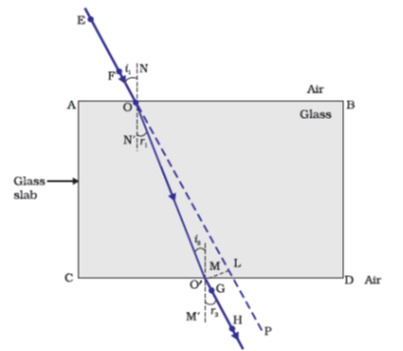

Figure 10.10 Refraction of light through a rectangular glass slab

The following are the *laws of refraction of light.*

*The incident ray, the refracted ray and the normal to the interface of two transparent media at the point of incidence, all lie in the same plane.*

*The ratio of sine of angle of incidence to the sine of angle of refraction is a constant, for the light of a given colour and for the given pair of media.* This law is also known as Snell’s law of refraction. (This is true for angle 0 < *i* < 90°)

If *i* is the angle of incidence and *r* is the angle of refraction, then,

sinisinr=constant\frac{\sin i}{\sin r} = constant

…(10.4)

This constant value is called the refractive index of the second medium with respect to the first. Let us study about refractive index in some detail.

#### 10.3.2 - The Refractive Index

You have already studied that a ray of light that travels obliquely from one transparent medium into another will change its direction in the second medium. The extent of the change in direction that takes place in a given pair of media may be expressed in terms of the refractive index, the “constant” appearing on the right-hand side of Eq.(10.4).

The refractive index can be linked to an important physical quantity, the relative speed of propagation of light in different media. It turns out that light propagates with different speeds in different media. Light travels fastest in vacuum with speed of 3×108ms−13 \times 10^{8}ms^{- 1}

. In air, the speed of light is only marginally less, compared to that in vacuum. It reduces considerably in glass or water. The value of the refractive index for a given pair of media depends upon the speed of light in the two media, as given below.

Consider a ray of light travelling from medium 1 into medium 2, as shown in Fig. 10.11. Let v1v_{1}

be the speed of light in medium 1 and v2v_{2}

be the speed of light in medium 2. The refractive index of medium 2 with respect to medium 1 is given by the ratio of the speed of light in medium 1 and the speed of light in medium 2. This is usually represented by the symbol n21n_{\text{21}}

. This can be expressed in an equation form as

n21=Speed of lightinmedium1Speed of lightinmedium2=υ1υ2n_{21} = \frac{\text{Speed\ of\ lig}ht\ in\ medium\ 1}{\text{Speed\ of\ lig}ht\ in\ medium\ 2} = \frac{\upsilon_{1}}{\upsilon_{2}}

…(10.5)

By the same argument, the refractive index of medium 1 with respect to medium 2 is represented asn12n_{\text{12}}

. It is given by

n12=Speed of lightinmedium2Speed of lightinmedium1=υ2v1n_{12} = \frac{\text{Speed\ of\ lig}ht\ in\ medium\ 2}{\text{Speed\ of\ lig}ht\ in\ medium\ 1} = \frac{\upsilon_{2}}{v_{1}}

…(10.6)

If medium 1 is vacuum or air, then the refractive index of medium 2 is considered with respect to vacuum. This is called the absolute refractive index of the medium. It is simply represented as n2n_{2}

. If *c* is the speed of light in air and *v* is the speed of light in the medium, then, the refractive index of the medium nmn_{m}

is given by

nm=Speed of light in airSpeed of light in the medium=cυn_{m} = \frac{\text{Speed\ of\ lig}h\text{t\ in\ air}}{\text{Speed\ of\ lig}h\text{t\ in\ t}h\text{e\ medium}} = \frac{c}{\upsilon}

…(10.7)

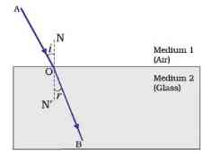

Figure 10.11

The absolute refractive index of a medium is simply called its refractive index. The refractive index of several media is given in Table 10.3. From the Table you can know that the refractive index of water, nw = 1.33n_{w}\text{\ =\ 1.33}

. This means that the ratio of the speed of light in air and the speed of light in water is equal to 1.33. Similarly, the refractive index of crown glass, ng = 1.52n_{g}\text{\ =\ 1.52}

. Such data are helpful in many places. However, you need not memorise the data.

**Table 10.3** Absolute refractive index of some material media

| **Material medium** | **Refractive index** | **Material medium** | **Refractive index** |
| --- | --- | --- | --- |
| Air | 1.0003 | Canada Balsam | 1.53 |
| Ice | 1.31 | Rock salt | 1.54 |
| Water | 1.33 | Carbon disulphide | 1.63 |
| Alcohol | 1.36 | Dense flint glass | 1.65 |
| Kerosene | 1.44 | Ruby | 1.71 |
| Fused quartz | 1.46 | Sapphire | 1.77 |
| Turpentine oil | 1.47 | Diamond | 2.42 |
| Benzene | 1.50 |  |  |
| Crown glass | 1.52 |  |  |

Note from Table 10.3 that an optically denser medium may not possess greater mass density. For example, kerosene having higher refractive index, is optically denser than water, although its mass density is less than water.

##### More to know!

The ability of a medium to refract light is also expressed in terms of its optical density. Optical density has a definite connotation. It is not the same as mass density. We have been using the terms ‘rarer medium’ and ‘denser medium’ in this Chapter. It actually means ‘optically rarer medium’ and ‘optically denser medium’, respectively. When can we say that a medium is optically denser than the other? In comparing two media, the one with the larger refractive index is optically denser medium than the other. The other medium of lower refractive index is optically rarer. The speed of light is higher in a rarer medium than a denser medium. Thus, a ray of light travelling from a rarer medium to a denser medium slows down and bends towards the normal. When it travels from a denser medium to a rarer medium, it speeds up and bends away from the normal.

#### Questions

A ray of light travelling in air enters obliquely into water. Does the light ray bend towards the normal or away from the normal? Why?

Light enters from air to glass having refractive index 1.50. What is the speed of light in the glass? The speed of light in vacuum is 3×108ms−13 \times 10^{8}ms^{- 1}

.

Find out, from Table 10.3, the medium having highest optical density. Also find the medium with lowest optical density.

You are given kerosene, turpentine and water. In which of these does the light travel fastest? Use the information given in Table 10.3.

The refractive index of diamond is 2.42. What is the meaning of this statement?

#### 10.3.3 - Refraction by Spherical Lenses

You might have seen watchmakers using a small magnifying glass to see tiny parts. Have you ever touched the surface of a magnifying glass with your hand? Is it plane surface or curved? Is it thicker in the middle or at the edges? The glasses used in spectacles and that by a watchmaker are examples of lenses. What is a lens? How does it bend light rays? We shall discuss these in this section.

A transparent material bound by two surfaces, of which one or both surfaces are spherical, forms a lens. This means that a lens is bound by at least one spherical surface. In such lenses, the other surface would be plane. A lens may have two spherical surfaces, bulging outwards. Such a lens is called a double convex lens. It is simply called a convex lens. It is thicker at the middle as compared to the edges. Convex lens converges light rays as shown in Fig. 10.12 (a). Hence convex lenses are also called converging lenses. Similarly, a double concave lens is bounded by two spherical surfaces, curved inwards. It is thicker at the edges than at the middle. Such lenses diverge light rays as shown in Fig. 10.12 (b). Such lenses are also called diverging lenses. A double concave lens is simply called a concave lens.

A lens, either a convex lens or a concave lens, has two spherical surfaces. Each of these surfaces forms a part of a sphere. The centres of these spheres are called centres of curvature of the lens. The centre of curvature of a lens is usually represented by the letter C. Since there are two centres of curvature, we may represent them as C1C_{1}

andC2C_{2}

. An imaginary straight line passing through the two centres of curvature of a lens is called its principal axis. The central point of a lens is its optical centre. It is usually represented by the letter O. A ray of light through the optical centre of a lens passes without suffering any deviation. The effective diameter of the circular outline of a spherical lens is called its aperture. We shall confine our discussion in this Chapter to such lenses whose aperture is much less than its radius of curvature and the two centres of curvatures are equidistant from the optical centre O. Such lenses are called thin lenses with small apertures. What happens when parallel rays of light are incident on a lens? Let us do an Activity to understand this.

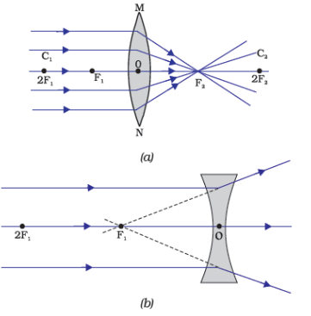

**Figure 10.12** (a) Converging action of a convex lens, (b) diverging action of a concave lens

##### Activity 10.11

**CAUTION:** Do not look at the Sun directly or through a lens while doing this Activity or otherwise. You may damage your eyes if you do so.

Hold a convex lens in your hand. Direct it towards the Sun.

Focus the light from the Sun on a sheet of paper. Obtain a sharp bright image of the Sun.

Hold the paper and the lens in the same position for a while. Keep observing the paper. What happened? Why? Recall your experience in Activity 10.2.

The paper begins to burn producing smoke. It may even catch fire after a while. Why does this happen? The light from the Sun constitutes parallel rays of light. These rays were converged by the lens at the sharp bright spot formed on the paper. In fact, the bright spot you got on the paper is a real image of the Sun. The concentration of the sunlight at a point generated heat. This caused the paper to burn.

Now, we shall consider rays of light parallel to the principal axis of a lens. What happens when you pass such rays of light through a lens? This is illustrated for a convex lens in Fig. 10.12 (a) and for a concave lens in Fig. 10.12 (b).

Observe Fig. 10.12 (a) carefully. Several rays of light parallel to the principal axis are falling on a convex lens. These rays, after refraction from the lens, are converging to a point on the principal axis. This point on the principal axis is called the principal focus of the lens. Let us see now the action of a concave lens.

Observe Fig. 10.12 (b) carefully. Several rays of light parallel to the principal axis are falling on a concave lens. These rays, after refraction from the lens, are appearing to diverge from a point on the principal axis. This point on the principal axis is called the principal focus of the concave lens.

If you pass parallel rays from the opposite surface of the lens, you get another principal focus on the opposite side. Letter F is usually used to represent principal focus. However, a lens has two principal foci. They are represented by F1F_{1}

andF2F_{2}

. The distance of the principal focus from the optical centre of a lens is called its focal length. The letter ƒ is used to represent the focal length. How can you find the focal length of a convex lens? Recall the Activity 10.11. In this Activity, the distance between the position of the lens and the position of the image of the Sun gives the approximate focal length of the lens.

#### 10.3.4 - Image Formation by Lenses

Lenses form images by refracting light. How do lenses form images? What is their nature? Let us study this for a convex lens first.

##### Activity 10.12

Take a convex lens. Find its approximate focal length in a way described in Activity 10.11.

Draw five parallel straight lines, using chalk, on a long Table such that the distance between the successive lines is equal to the focal length of the lens.

Place the lens on a lens stand. Place it on the central line such that the optical centre of the lens lies just over the line.

The two lines on either side of the lens correspond to F and 2F of the lens respectively. Mark them with appropriate letters such as 2F1\text{2}F_{1}

, F1F_{1}

, F2F_{2}

and 2F2\text{2}F_{2}

, respectively.

Place a burning candle, far beyond 2F1\text{2}\text{F}_{1}

to the left. Obtain a clear sharp image on a screen on the opposite side of the lens.

Note down the nature, position and relative size of the image.

Repeat this Activity by placing object just behind 2F1\text{2}F_{1}

, between F1F_{1}

and 2F1\text{2}F_{1}

atF1\ F_{1}

, between F1F_{1}

and O. Note down and tabulate your observations.

The nature, position and relative size of the image formed by convex lens for various positions of the object is summarised in Table 10.4.

**Table 10.4** Nature, position and relative size of the image formed by a convex lens for various positions of the object

| **Position of the object** | **Position of the image** | **Relative size of the image** | **Nature of the image** |
| --- | --- | --- | --- |
| At infinity | At focusF2F_{2} | Highly diminished, point-sized | Real and inverted |
| Beyond2F1\text{2}\text{F}_{1} | BetweenF2F_{2}  and2F2\text{2}F_{2} | Diminished | Real and inverted |
| At2F1\text{2}F_{1} | At2F2\text{2}F_{2} | Same size | Real and inverted |
| BetweenF1F_{1}  and2F1\text{2}F_{1} | Beyond2F22F_{2} | Enlarged | Real and inverted |
| At focusF1F_{1} | At infinity | Infinitely large or highly enlarged | Real and inverted |
| Between focusF1F_{1}  and optical centre O | On the same side of the lens as the object | Enlarged | Virtual and erect |

Let us now do an Activity to study the nature, position and relative size of the image formed by a concave lens.

##### Activity 10.13

Take a concave lens. Place it on a lens stand.

Place a burning candle on one side of the lens.

Look through the lens from the other side and observe the image. Try to get the image on a screen, if possible. If not, observe the image directly through the lens.

Note down the nature, relative size and approximate position of the image.

Move the candle away from the lens. Note the change in the size of the image. What happens to the size of the image when the candle is placed too far away from the lens.

The summary of the above Activity is given in Table 10.5 below.

**Table 10.5** Nature, position and relative size of the image formed by a concave lens for various positions of the object

| **Position of the object** | **Position of the image** | **Relative size of the image** | **Nature of the image** |
| --- | --- | --- | --- |
| At infinity | At focusF1F_{1} | Highly diminished, point-sized | Virtual and erect |
| Between infinity and optical centre O of the lens | Between focusF1F_{1}  and optical centre O | Diminished | Virtual and erect |

What conclusion can you draw from this Activity? A concave lens will always give a virtual, erect and diminished image, irrespective of the position of the object.

#### 10.3.5 - Image Formation in Lenses Using Ray Diagrams

We can represent image formation by lenses using ray diagrams. Ray diagrams will also help us to study the nature, position and relative size of the image formed by lenses. For drawing ray diagrams in lenses, alike of spherical mirrors, we consider any two of the following rays –

A ray of light from the object, parallel to the principal axis, after refraction from a convex lens, passes through the principal focus on the other side of the lens, as shown in Fig. 10.13 (a). In case of a concave lens, the ray appears to diverge from the principal focus located on the same side of the lens, as shown in Fig. 10.13 (b).

A ray of light passing through a principal focus, after refraction from a convex lens, will emerge parallel to the principal axis. This is shown in Fig. 10.14 (a). A ray of light appearing to meet at the principal focus of a concave lens, after refraction, will emerge parallel to the principal axis. This is shown in Fig. 10.14 (b).

A ray of light passing through the optical centre of a lens will emerge without any deviation. This is illustrated in Fig. 10.15(a) and Fig. 10.15 (b).

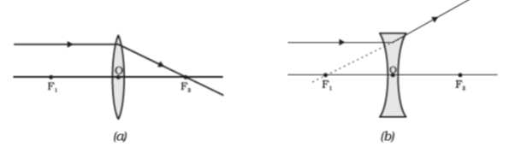

Figure 10.13

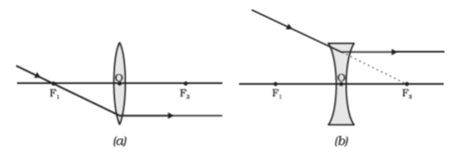

Figure 10.14

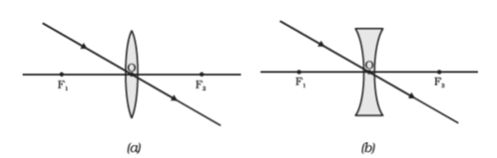

Figure 10.15

The ray diagrams for the image formation in a convex lens for a few positions of the object are shown in Fig. 10.16. The ray diagrams representing the image formation in a concave lens for various positions of the object are shown in Fig. 10.17.

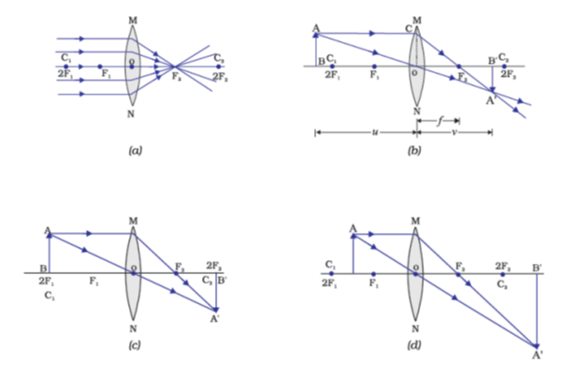

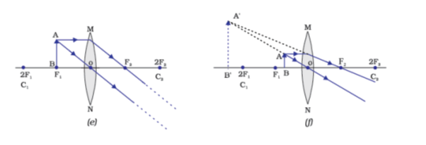

**Figure 10.16** The position, size and the nature of the image formed by a convex lens for various positions of the object

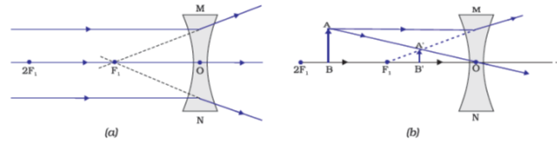

**Figure 10.17** Nature, position and relative size of the image formed by a concave lens

#### 10.3.6 - Sign Convention for Spherical Lenses

For lenses, we follow sign convention, similar to the one used for spherical mirrors. We apply the rules for signs of distances, except that all measurements are taken from the optical centre of the lens. According to the convention, the focal length of a convex lens is positive and that of a concave lens is negative. You must take care to apply appropriate signs for the values of *u, v*, ƒ, object height *h* and image height *h′*.

#### 10.3.7 Lens Formula and Magnification

As we have a formula for spherical mirrors, we also have formula for spherical lenses. This formula gives the relationship between object-distance (*u*), image-distance (*v*) and the focal length (ƒ). The lens formula is expressed as

1v−1u=1f\frac{1}{v} - \frac{1}{u} = \frac{1}{f}

…(10.8)

The lens formula given above is general and is valid in all situations for any spherical lens. Take proper care of the signs of different quantities, while putting numerical values for solving problems relating to lenses.

**Magnification**

The magnification produced by a lens, similar to that for spherical mirrors, is defined as the ratio of the height of the image and the height of the object. Magnification is represented by the letter *m*. If *h* is the height of the object and *h′* is the height of the image given by a lens, then the magnification produced by the lens is given by,

m=Height of the ImageHeight of the object=h′hm = \frac{\text{Heig}h\text{t\ of\ t}h\text{e\ Image}}{\text{Heig}h\text{t\ of\ t}h\text{e\ object}} = \frac{h^{'}}{h}

…(10.9)

Magnification produced by a lens is also related to the object-distance *u*, and the image-distance *v*. This relationship is given by

Magnification(h′h=υu)\text{Magnification}\left( \frac{h^{'}}{h} = \frac{\upsilon}{u} \right)

…(10.10)

**Example 10.3**

A concave lens has focal length of 15 cm. At what distance should the object from the lens be placed so that it forms an image at 10 cm from the lens? Also, find the magnification produced by the lens.

**Solution**

A concave lens always forms a virtual, erect image on the same side of the object.

Image-distance v=−10 cmv\ = \ - 10\text{\ cm}

;

Focal length ƒ=−15cm= - 15\text{cm}

;

Object-distance u=u\ =

?

Since 1v−1u=1f\frac{1}{v} - \frac{1}{u} = \frac{1}{f}

or, 1u=1υ−1f\frac{1}{u} = \frac{1}{\upsilon} - \frac{1}{f}

1u=1−10−1(−15)=−110+115\frac{1}{u} = \frac{1}{- 10} - \frac{1}{\left( - 15 \right)} = - \frac{1}{10} + \frac{1}{15}

1u=−3+230=1−30\frac{1}{u} = \frac{- 3 + 2}{30} = \frac{1}{- 30}

or, u=−30 cmu\ = \ - \ 30\text{\ cm}

Thus, the object-distance is 30 cm.

Magnification m =vu\text{m\ } = \frac{v}{u}

m=−10cm−30cm=13m = \frac{- 10\text{cm}}{- 30\text{cm}} = \frac{1}{3}

≃+0.33

The positive sign shows that the image is erect and virtual. The image is one-third of the size of the object.

**Example 10.4**

A 2.0 cm tall object is placed perpendicular to the principal axis of a convex lens of focal length 10 cm. The distance of the object from the lens is 15 cm. Find the nature, position and size of the image. Also find its magnification.

**Solution**

Height of the object h=+2.0cmh\ = \ + \ 2.0\ cm

;

Focal length f=+10cmf\ = \ + \ 10\ cm

;

object-distance u=−15cmu\ = \ - 15\ cm

;

Image-distance v=v\ =

?

Height of the image h′=?h^{'} = ?

Since 1υ−1u=1f\frac{1}{\upsilon} - \frac{1}{u} = \frac{1}{f}

or, 1υ=1u+1f\frac{1}{\upsilon} = \frac{1}{u} + \frac{1}{f}

1υ=1(−15)+110=−115+110\frac{1}{\upsilon} = \frac{1}{\left( - 15 \right)} + \frac{1}{10} = - \frac{1}{15} + \frac{1}{10}

1υ=−2+330=130\frac{1}{\upsilon} = \frac{- 2 + 3}{30} = \frac{1}{30}

or, v=+30 cmv\ = \ + \ 30\text{\ cm}

The positive sign of *v* shows that the image is formed at a distance of 30 cm on the other side of the optical centre. The image is real and inverted.

Magnification m=h′h=υum = \frac{h^{'}}{h} = \frac{\upsilon}{u}

or, h′=h(vu)h'\ = \ h\ \left( \frac{v}{u} \right)

Height of the image, h′=(2.0)(+30−15)=−4.0 cmh'\ = \ \left( 2.0 \right)\left( + \frac{30}{- 15} \right)\ = \ - 4.0\text{\ cm}

Magnification m=vum\ = \frac{v}{u}

or, m=+30cm−15cm=−2m = \frac{+ 30\text{cm}}{- 15\text{cm}} = - 2

The negative signs of m and *h′* show that the image is inverted and real. It is formed below the principal axis. Thus, a real, inverted image, 4 cm tall, is formed at a distance of 30 cm on the other side of the lens. The image is two times enlarged.

#### 10.3.8 - Power of a Lens

You have already learnt that the ability of a lens to converge or diverge light rays depends on its focal length. For example, a convex lens of short focal length bends the light rays through large angles, by focussing them closer to the optical centre. Similarly, concave lens of very short focal length causes higher divergence than the one with longer focal length. The degree of convergence or divergence of light rays achieved by a lens is expressed in terms of its power. The power of a lens is defined as the reciprocal of its focal length. It is represented by the letter *P*. The power *Ρ* of a lens of focal length ƒ is given by

p=1fp = \frac{1}{f}

…(10.11)

The SI unit of power of a lens is ‘dioptre’. It is denoted by the letter D. If ƒ is expressed in metres, then, power is expressed in dioptres. Thus, 1 dioptre is the power of a lens whose focal length is 1 metre. 1D=1m−11D = 1m^{- 1}

. You may note that the *power of a convex lens is positive and that of a concave lens is negative.*

Opticians prescribe corrective lenses indicating their powers. Let us say the lens prescribed has power equal to+ 2.0 D\text{+\ 2.0\ D}

. This means the lens prescribed is convex. The focal length of the lens is+ 0.50 m\text{+\ 0.50\ m}

. Similarly, a lens of power −2.5 D- 2.5\text{\ D}

has a focal length of –0.40 m\text{–}\text{0.40\ m}

. The lens is concave.

##### More to know!

Many optical instruments consist of a number of lenses. They are combined to increase the magnification and sharpness of the image. The net power (*P*) of the lenses placed in contact is given by the algebraic sum of the individual powers P1,P2,P3,...P_{1},\ P_{2},\ P_{3},\ ...

as P=P1+P2+P3+...P\ = \ P_{1}\ + \ P_{2}\ + \ P_{3}\ + \ ...

The use of powers, instead of focal lengths, for lenses is quite convenient for opticians. During eye-testing, an optician puts several different combinations of corrective lenses of known power, in contact, inside the testing spectacles’ frame. The optician calculates the power of the lens required by simple algebraic addition. For example, a combination of two lenses of power + 2.0 D and + 0.25 D is equivalent to a single lens of power + 2.25 D. The simple additive property of the powers of lenses can be used to design lens systems to minimise certain defects in images produced by a single lens. Such a lens system, consisting of several lenses, in contact, is commonly used in the design of lenses of camera, microscopes and telescopes.

#### Questions

Define 1 dioptre of power of a lens.

A convex lens forms a real and inverted image of a needle at a distance of 50 cm from it. Where is the needle placed in front of the convex lens if the image is equal to the size of the object? Also, find the power of the lens.

Find the power of a concave lens of focal length 2 m.

### What you learnt

Light seems to travel in straight lines.

Mirrors and lenses form images of objects. Images can be either real or virtual, depending on the position of the object.

The reflecting surfaces, of all types, obey the laws of reflection. The refracting surfaces obey the laws of refraction.

New Cartesian Sign Conventions are followed for spherical mirrors and lenses.

Mirror formula, 1υ+1u=1f\frac{1}{\upsilon} + \frac{1}{u} = \frac{1}{f}

, gives the relationship between the object-distance (*u*), image-distance (*v*), and focal length (ƒ) of a spherical mirror.

The focal length of a spherical mirror is equal to half its radius of curvature.

The magnification produced by a spherical mirror is the ratio of the height of the image to the height of the object.

A light ray travelling obliquely from a denser medium to a rarer medium bends away from the normal. A light ray bends towards the normal when it travels obliquely from a rarer to a denser medium.

Light travels in vacuum with an enormous speed of 3×108ms−13 \times 10^{8}ms^{- 1}

. The speed of light is different in different media.

The refractive index of a transparent medium is the ratio of the speed of light in vacuum to that in the medium.

In case of a rectangular glass slab, the refraction takes place at both air-glass interface and glass-air interface. The emergent ray is parallel to the direction of incident ray.

Lens formula, 1υ−1u=1f\frac{1}{\upsilon} - \frac{1}{u} = \frac{1}{f}

, gives the relationship between the object-distance (*u*), image-distance (*v*), and the focal length (ƒ) of a spherical lens.

Power of a lens is the reciprocal of its focal length. The SI unit of power of a lens is *dioptre*.

### Exercises

Which one of the following materials cannot be used to make a lens?

Water

Glass

Plastics

Clay

The image formed by a concave mirror is observed to be virtual, erect and larger than the object. Where should be the position of the object?

Between the principal focus and the centre of curvature

At the centre of curvature

Beyond the centre of curvature

Between the pole of the mirror and its principal focus.

Where should an object be placed in front of a convex lens to get a real image of the size of the object?

At the principal focus of the lens

At twice the focal length

At infinity

Between the optical centre of the lens and its principal focus.

A spherical mirror and a thin spherical lens have each a focal length of–15 cm\text{–}\text{15\ cm}

. The mirror and the lens are likely to be

both concave.

both convex.

the mirror is concave and the lens is convex.

the mirror is convex, but the lens is concave.

No matter how far you stand from a mirror, your image appears erect. The mirror is likely to be

only plane.

only concave.

only convex.

either plane or convex.

Which of the following lenses would you prefer to use while reading small letters found in a dictionary?

A convex lens of focal length 50 cm.

A concave lens of focal length 50 cm.

A convex lens of focal length 5 cm.

A concave lens of focal length 5 cm.

We wish to obtain an erect image of an object, using a concave mirror of focal length 15 cm. What should be the range of distance of the object from the mirror? What is the nature of the image? Is the image larger or smaller than the object? Draw a ray diagram to show the image formation in this case.

Name the type of mirror used in the following situations.

Headlights of a car.

Side/rear-view mirror of a vehicle.

Solar furnace.

Support your answer with reason.

One-half of a convex lens is covered with a black paper. Will this lens produce a complete image of the object? Verify your answer experimentally. Explain your observations.

An object 5 cm in length is held 25 cm away from a converging lens of focal length 10 cm. Draw the ray diagram and find the position, size and the nature of the image formed.

A concave lens of focal length 15 cm forms an image 10 cm from the lens. How far is the object placed from the lens? Draw the ray diagram.

An object is placed at a distance of 10 cm from a convex mirror of focal length 15 cm. Find the position and nature of the image.

The magnification produced by a plane mirror is+1\text{+1}

. What does this mean?

An object 5.0 cm in length is placed at a distance of 20 cm in front of a convex mirror of radius of curvature 30 cm. Find the position of the image, its nature and size.

An object of size 7.0 cm is placed at 27 cm in front of a concave mirror of focal length 18 cm. At what distance from the mirror should a screen be placed, so that a sharp focused image can be obtained? Find the size and the nature of the image.

Find the focal length of a lens of power −2.0 D- \text{2.0\ D}

. What type of lens is this?

A doctor has prescribed a corrective lens of power +1.5 D\text{+1.5\ D}

. Find the focal length of the lens. Is the prescribed lens diverging or converging?

## Chapter 11 – The Human Eye and the Colourful World



1064CH11

You have studied in the previous chapter about refraction of light by lenses. You also studied the nature, position and relative size of images formed by lenses. How can these ideas help us in the study of the human eye? The human eye uses light and enables us to see objects around us. It has a lens in its structure. What is the function of the lens in a human eye? How do the lenses used in spectacles correct defects of vision? Let us consider these questions in this chapter.

We have learnt in the previous chapter about light and some of its properties. In this chapter, we shall use these ideas to study some of the optical phenomena in nature. We shall also discuss about rainbow formation, splitting of white light and blue colour of the sky.

### 11.1 - The Human Eye

The human eye is one of the most valuable and sensitive sense organs. It enables us to see the wonderful world and the colours around us. On closing the eyes, we can identify objects to some extent by their smell, taste, sound they make or by touch. It is, however, impossible to identify colours while closing the eyes. Thus, of all the sense organs, the human eye is the most significant one as it enables us to see the beautiful, colourful world around us.

The human eye is like a camera. Its lens system forms an image on a light-sensitive screen called the retina. Light enters the eye through a thin membrane called the cornea. It forms the transparent bulge on the front surface of the eyeball as shown in Fig. 11.1. The eyeball is approximately spherical in shape with a diameter of about 2.3 cm. Most of the refraction for the light rays entering the eye occurs at the outer surface of the cornea. The crystalline lens merely provides the finer adjustment of focal length required to focus objects at different distances on the retina. We find a structure called *iris* behind the cornea. Iris is a dark muscular diaphragm that controls the size of the pupil. The pupil regulates and controls the amount of light entering the eye. The eye lens forms an inverted real image of the object on the retina. The retina is a delicate membrane having enormous number of light-sensitive cells. The light-sensitive cells get activated upon illumination and generate electrical signals. These signals are sent to the brain via the optic nerves. The brain interprets these signals, and finally, processes the information so that we perceive objects as they are.

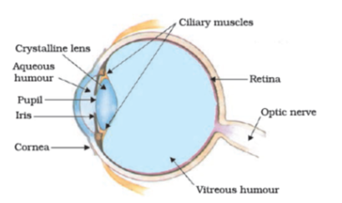

**Figure 11.1** The human eye

#### Do you know?

Damage to or malfunction of any part of the visual system can lead to significant loss of visual functioning. For example, if any of the structures involved in the transmission of light, like the cornea, pupil, eye lens, aqueous humour and vitreous humour or those responsible for conversion of light to electrical impulse, like the retina or even the optic nerve that transmits these impulses to the brain, is damaged, it will result in visual impairment. You might have experienced that you are not able to see objects clearly for some time when you enter from bright light to a room with dim light. After sometime, however, you may be able to see things in the dim-lit room. The pupil of an eye acts like a variable aperture whose size can be varied with the help of the iris. When the light is very bright, the iris contracts the pupil to allow less light to enter the eye. However, in dim light the iris expands the pupil to allow more light to enter the eye. Thus, the pupil opens completely through the relaxation of the iris.

#### 11.1.1 - Power of Accommodation

The eye lens is composed of a fibrous, jelly-like material. Its curvature can be modified to some extent by the ciliary muscles. The change in the curvature of the eye lens can thus change its focal length. When the muscles are relaxed, the lens becomes thin. Thus, its focal length increases. This enables us to see distant objects clearly. When you are looking at objects closer to the eye, the ciliary muscles contract. This increases the curvature of the eye lens. The eye lens then becomes thicker. Consequently, the focal length of the eye lens decreases. This enables us to see nearby objects clearly.

The ability of the eye lens to adjust its focal length is called accommodation. However, the focal length of the eye lens cannot be decreased below a certain minimum limit. Try to read a printed page by holding it very close to your eyes. You may see the image being blurred or feel strain in the eye. To see an object comfortably and distinctly, you must hold it at about 25 cm from the eyes. The minimum distance, at which objects can be seen most distinctly without strain, is called the least distance of distinct vision. It is also called the near point of the eye. For a young adult with normal vision, the near point is about 25 cm. The farthest point upto which the eye can see objects clearly is called the far point of the eye. It is infinity for a normal eye. You may note here a normal eye can see objects clearly that are between 25 cm and infinity.

Sometimes, the crystalline lens of people at old age becomes milky and cloudy. This condition is called cataract. This causes partial or complete loss of vision. It is possible to restore vision through a cataract surgery.

##### Do you know?

**Why do we have two eyes for vision and not just one?**

There are several advantages of our having two eyes instead of one. It gives a wider field of view. A human being has a horizontal field of view of about 150° with one eye and of about 180° with two eyes. The ability to detect faint objects is, of course, enhanced with two detectors instead of one.

Some animals, usually prey animals, have their two eyes positioned on opposite sides of their heads to give the widest possible field of view. But our two eyes are positioned on the front of our heads, and it thus reduces our field of view in favour of what is called stereopsis. Shut one eye and the world looks flat – two-dimensional. Keep both eyes open and the world takes on the third dimension of depth. Because our eyes are separated by a few centimetres, each eye sees a slightly different image. Our brain combines the two images into one, using the extra information to tell us how close or far away things are.

### 11.2 - Defects Of Vision And Their Correction

Sometimes, the eye may gradually lose its power of accommodation. In such conditions, the person cannot see the objects distinctly and comfortably. The vision becomes blurred due to the refractive defects of the eye.

There are mainly three common refractive defects of vision. These are (i) myopia or near-sightedness, (ii) Hypermetropia or far-sightedness, and (iii) Presbyopia. These defects can be corrected by the use of suitable spherical lenses. We discuss below these defects and their correction.

**Myopia**

Myopia is also known as near-sightedness. A person with myopia can see nearby objects clearly but cannot see distant objects distinctly. A person with this defect has the far point nearer than infinity. Such a person may see clearly upto a distance of a few metres. In a myopic eye, the image of a distant object is formed in front of the retina [Fig. 11.2 (b)] and not at the retina itself. This defect may arise due to (i) excessive curvature of the eye lens, or (ii) elongation of the eyeball. This defect can be corrected by using a concave lens of suitable power. This is illustrated in Fig. 11.2 (c). A concave lens of suitable power will bring the image back on to the retina and thus the defect is corrected.

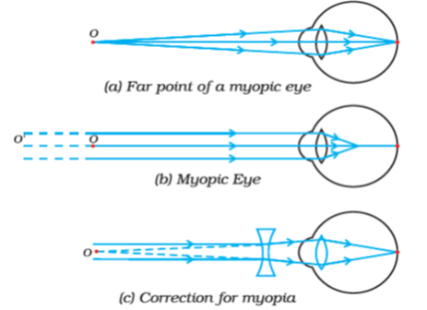

**Figure 11.2** (a), (b) The myopic eye, and (c) correction for myopia with a concave lens

**Hypermetropia**

Hypermetropia is also known as far-sightedness. A person with hypermetropia can see distant objects clearly but cannot see nearby objects distinctly. The near point, for the person, is farther away from the normal near point (25 cm). Such a person has to keep a reading material much beyond 25 cm from the eye for comfortable reading. This is because the light rays from a closeby object are focussed at a point behind the retina as shown in Fig. 11.3 (b). This defect arises either because (i) the focal length of the eye lens is too long, or (ii) the eyeball has become too small. This defect can be corrected by using a convex lens of appropriate power. This is illustrated in Fig. 11.3 (c). Eye-glasses with converging lenses provide the additional focussing power required for forming the image on the retina.

**Presbyopia**

The power of accommodation of the eye usually decreases with ageing. For most people, the near point gradually recedes away. They find it difficult to see nearby objects comfortably and distinctly without corrective eye-glasses. This defect is called Presbyopia. It arises due to the gradual weakening of the ciliary muscles and diminishing flexibility of the eye lens. Sometimes, a person may suffer from both myopia and hypermetropia. Such people often require bi-focal lenses. A common type of bi-focal lenses consists of both concave and convex lenses. The upper portion consists of a concave lens. It facilitates distant vision. The lower part is a convex lens. It facilitates near vision.

These days, it is possible to correct the refractive defects with contact lenses or through surgical interventions.

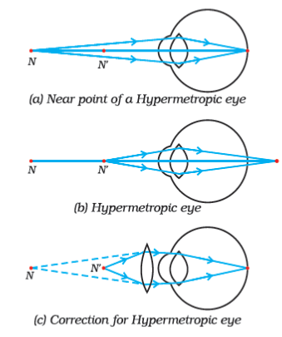

**Figure 11.3** (a), (b) The hypermetropic eye, and (c) correction for hypermetropia N = Near point of hypermetropic eye. N’ = Near point of a normal eye.

#### Questions

What is meant by power of accommodation of the eye?

A person with a myopic eye cannot see objects beyond 1.2 m distinctly. What should be the type of the corrective lens used to restore proper vision?

What is the far point and near point of the human eye with normal vision?

A student has difficulty reading the blackboard while sitting in the last row. What could be the defect the child is suffering from? How can it be corrected?

#### Think it over

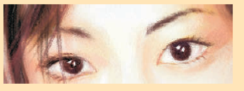

*You talk of wondrous things you see,*

*You say the sun shines bright;*

*I feel him warm, but how can he*

*Or make it day or night?*

– C. Cibber

Do you know that our eyes can live even after our death? By donating our eyes after we die, we can light the life of a blind person.

About 35 million people in the developing world are blind and most of them can be cured. About 4.5 million people with corneal blindness can be cured through corneal transplantation of donated eyes. Out of these 4.5 million, 60% are children below the age of 12. So, if we have got the gift of vision, why not pass it on to somebody who does not have it? What do we have to keep in mind when eyes have to be donated?

Eye donors can belong to any age group or sex. People who use spectacles, or those operated for cataract, can still donate the eyes. People who are diabetic, have hypertension, asthma patients and those without communicable diseases can also donate eyes.

Eyes must be removed within 4-6 hours after death. Inform the nearest eye bank immediately.

The eye bank team will remove the eyes at the home of the deceased or at a hospital.

Eye removal takes only 10-15 minutes. It is a simple process and does not lead to any disfigurement.

Persons who were infected with or died because of AIDS, Hepatitis B or C, rabies, acute leukaemia, tetanus, cholera, meningitis or encephalitis cannot donate eyes.

An eye bank collects, evaluates and distributes the donated eyes. All eyes donated are evaluated using strict medical standards. Those donated eyes found unsuitable for transplantation are used for valuable research and medical education. The identities of both the donor and the recipient remain confidential.

One pair of eyes gives vision to up to FOUR CORNEAL BLIND PEOPLE.

### 11.3 - Refraction of Light Through A Prism

You have learnt how light gets refracted through a rectangular glass slab. For parallel refracting surfaces, as in a glass slab, the emergent ray is parallel to the incident ray. However, it is slightly displaced laterally. How would light get refracted through a transparent prism? Consider a triangular glass prism. It has two triangular bases and three rectangular lateral surfaces. These surfaces are inclined to each other. The angle between its two lateral faces is called the angle of the prism. Let us now do an activity to study the refraction of light through a triangular glass prism.

#### Activity 11.1

Fix a sheet of white paper on a drawing board using drawing pins.

Place a glass prism on it in such a way that it rests on its triangular base. Trace the outline of the prism using a pencil.

Draw a straight line PE inclined to one of the refracting surfaces, say AB, of the prism.

Fix two pins, say at points Ρ and Q, on the line PE as shown in Fig. 11.4.

Look for the images of the pins, fixed at Ρ and Q, through the other face AC.

Fix two more pins, at points R and S, such that the pins at R and S and the images of the pins at Ρ and Q lie on the same straight line.

Remove the pins and the glass prism.

The line PE meets the boundary of the prism at point E (see Fig. 11.4). Similarly, join and produce the points R and S. Let these lines meet the boundary of the prism at E and F, respectively. Join E and F.

Draw perpendiculars to the refracting surfaces AB and AC of the prism at points E and F, respectively.

Mark the angle of incidence(∠i)\left( \angle i \right)

, the angle of refraction (∠r)\left( \angle r \right)

and the angle of emergence (∠e)\left( \angle e \right)

as shown in Fig. 11.4.

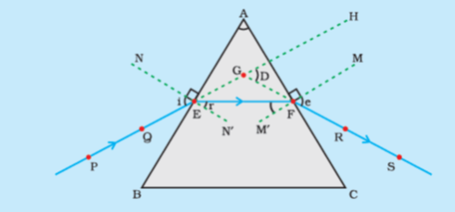

Figure 11.4 Refraction of light through a triangular glass prism

PE – Incident ray

EF – Refracted ray

FS – Emergent ray

∠A\angle A

– Angle of prism

∠i\angle i

– Angle of incidence

∠r\angle r

– Angle of refraction

∠e\angle e

– Angle of emergence

∠D\angle D

– Angle of deviation

Here PE is the incident ray, EF is the refracted ray and FS is the emergent ray. You may note that a ray of light is entering from air to glass at the first surface AB. The light ray on refraction has bent towards the normal. At the second surface AC, the light ray has entered from glass to air. Hence it has bent away from normal. Compare the angle of incidence and the angle of refraction at each refracting surface of the prism. Is this similar to the kind of bending that occurs in a glass slab? The peculiar shape of the prism makes the emergent ray bend at an angle to the direction of the incident ray. This angle is called the angle of deviation. In this case ∠D\angle D

is the angle of deviation. Mark the angle of deviation in the above activity and measure it.

### 11.4 - Dispersion of White Light By A Glass Prism

You must have seen and appreciated the spectacular colours in a rainbow. How could the white light of the Sun give us various colours of the rainbow? Before we take up this question, we shall first go back to the refraction of light through a prism. The inclined refracting surfaces of a glass prism show exciting phenomenon. Let us find it out through an activity.

#### Activity 11.2

Take a thick sheet of cardboard and make a small hole or narrow slit in its middle.

Allow sunlight to fall on the narrow slit. This gives a narrow beam of white light.

Now, take a glass prism and allow the light from the slit to fall on one of its faces as shown in Fig. 11.5.

Turn the prism slowly until the light that comes out of it appears on a nearby screen.

What do you observe? You will find a beautiful band of colours. Why does this happen?

The prism has probably split the incident white light into a band of colours. Note the colours that appear at the two ends of the colour band. What is the sequence of colours that you see on the screen? The various colours seen are Violet, Indigo, Blue, Green, Yellow, Orange and Red, as shown in Fig. 11.5. The acronym VIBGYOR will help you to remember the sequence of colours. The band of the coloured components of a light beam is called its spectrum. You might not be able to see all the colours separately. Yet something makes each colour distinct from the other. The splitting of light into its component colours is called dispersion.

You have seen that white light is dispersed into its seven-colour components by a prism. Why do we get these colours? Different colours of light bend through different angles with respect to the incident ray, as they pass through a prism. The red light bends the least while the violet the most. Thus the rays of each colour emerge along different paths and thus become distinct. It is the band of distinct colours that we see in a spectrum.

Isaac Newton was the first to use a glass prism to obtain the spectrum of sunlight. He tried to split the colours of the spectrum of white light further by using another similar prism. However, he could not get any more colours. He then placed a second identical prism in an inverted position with respect to the first prism, as shown in Fig. 11.6. This allowed all the colours of the spectrum to pass through the second prism. He found a beam of white light emerging from the other side of the second prism. This observation gave Newton the idea that the sunlight is made up of seven colours.

Any light that gives a spectrum similar to that of sunlight is often referred to as white light.

A rainbow is a natural spectrum appearing in the sky after a rain shower (Fig. 11.7). It is caused by dispersion of sunlight by tiny water droplets, present in the atmosphere. A rainbow is always formed in a direction opposite to that of the Sun. The water droplets act like small prisms. They refract and disperse the incident sunlight, then reflect it internally, and finally refract it again when it comes out of the raindrop (Fig. 11.8). Due to the dispersion of light and internal reflection, different colours reach the observer’s eye.

You can also see a rainbow on a sunny day when you look at the sky through a waterfall or through a water fountain, with the Sun behind you.

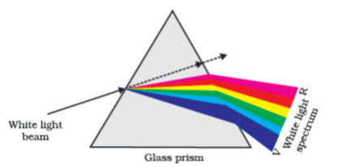

**Figure 11.5** Dispersion of white light by the glass prism

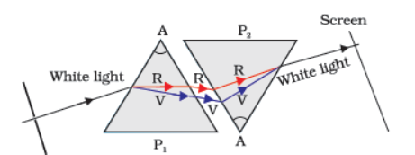

**Figure 11.6** Recombination of the spectrum of white light

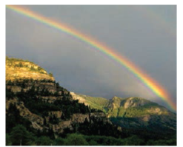

**Figure 11.7** Rainbow in the sky

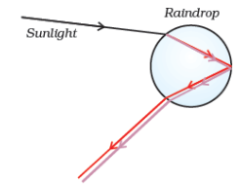

**Figure 11.8** Rainbow formation

### 11.5 - Atmospheric Refraction

You might have observed the apparent random wavering or flickering of objects seen through a turbulent stream of hot air rising above a fire or a radiator. The air just above the fire becomes hotter than the air further up. The hotter air is lighter (less dense) than the cooler air above it, and has a refractive index slightly less than that of the cooler air. Since the physical conditions of the refracting medium (air) are not stationary, the apparent position of the object, as seen through the hot air, fluctuates. This wavering is thus an effect of atmospheric refraction (refraction of light by the earth’s atmosphere) on a small scale in our local environment. The twinkling of stars is a similar phenomenon on a much larger scale. Let us see how we can explain it.

#### Twinkling of stars

The twinkling of a star is due to atmospheric refraction of starlight. The starlight, on entering the earth’s atmosphere, undergoes refraction continuously before it reaches the earth. The atmospheric refraction occurs in a medium of gradually changing refractive index. Since the atmosphere bends starlight towards the normal, the apparent position of the star is slightly different from its actual position. The star appears slightly higher (above) than its actual position when viewed near the horizon (Fig. 11.9). Further, this apparent position of the star is not stationary, but keeps on changing slightly, since the physical conditions of the earth’s atmosphere are not stationary, as was the case in the previous paragraph. Since the stars are very distant, they approximate point-sized sources of light. As the path of rays of light coming from the star goes on varying slightly, the apparent position of the star fluctuates and the amount of starlight entering the eye flickers – the star sometimes appears brighter, and at some other time, fainter, which is the twinkling effect.

Why don’t the planets twinkle? The planets are much closer to the earth, and are thus seen as extended sources. If we consider a planet as a collection of a large number of point-sized sources of light, the total variation in the amount of light entering our eye from all the individual point-sized sources will average out to zero, thereby nullifying the twinkling effect.

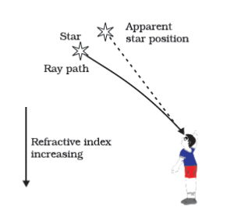

**Figure 11.9** Apparent star position due to atmospheric refraction

#### Advance sunrise and delayed sunset

The Sun is visible to us about 2 minutes before the actual sunrise, and about 2 minutes after the actual sunset because of atmospheric refraction. By actual sunrise, we mean the actual crossing of the horizon by the Sun. Fig. 11.10 shows the actual and apparent positions of the Sun with respect to the horizon. The time difference between actual sunset and the apparent sunset is about 2 minutes. The apparent flattening of the Sun’s disc at sunrise and sunset is also due to the same phenomenon.

### 11.6 - Scattering of Light

The interplay of light with objects around us gives rise to several spectacular phenomena in nature. The blue colour of the sky, colour of water in deep sea, the reddening of the sun at sunrise and the sunset are some of the wonderful phenomena we are familiar with. In the previous class, you have learnt about the scattering of light by colloidal particles. The path of a beam of light passing through a true solution is not visible. However, its path becomes visible through a colloidal solution where the size of the particles is relatively larger.

#### 11.6.1 - Tyndall Effect

The earth’s atmosphere is a heterogeneous mixture of minute particles. These particles include smoke, tiny water droplets, suspended particles of dust and molecules of air. When a beam of light strikes such fine particles, the path of the beam becomes visible. The light reaches us, after being reflected diffusely by these particles. The phenomenon of scattering of light by the colloidal particles gives rise to Tyndall effect which you have studied in Class IX. This phenomenon is seen when a fine beam of sunlight enters a smoke-filled room through a small hole. Thus, scattering of light makes the particles visible. Tyndall effect can also be observed when sunlight passes through a canopy of a dense forest. Here, tiny water droplets in the mist scatter light.

The colour of the scattered light depends on the size of the scattering particles. Very fine particles scatter mainly blue light while particles of larger size scatter light of longer wavelengths. If the size of the scattering particles is large enough, then, the scattered light may even appear white.

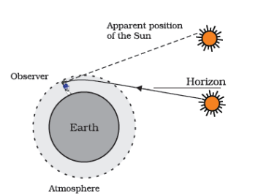

**Figure 11.10** Atmospheric refraction effects at sunrise and sunset

#### 11.6.2 - Why is the colour of the clear Sky Blue?

The molecules of air and other fine particles in the atmosphere have size smaller than the wavelength of visible light. These are more effective in scattering light of shorter wavelengths at the blue end than light of longer wavelengths at the red end. The red light has a wavelength about 1.8 times greater than blue light. Thus, when sunlight passes through the atmosphere, the fine particles in air scatter the blue colour (shorter wavelengths) more strongly than red. The scattered blue light enters our eyes. If the earth had no atmosphere, there would not have been any scattering. Then, the sky would have looked dark. The sky appears dark to passengers flying at very high altitudes, as scattering is not prominent at such heights.

You might have observed that ‘danger’ signal lights are red in colour. Do you know why? The red is least scattered by fog or smoke. Therefore, it can be seen in the same colour at a distance.

#### 11.6.3 - Colour of the Sun at Sunrise and Sunset

Have you seen the sky and the Sun at sunset or sunrise? Have you wondered as to why the Sun and the surrounding sky appear red? Let us do an activity to understand the blue colour of the sky and the reddish appearance of the Sun at the sunrise or sunset.

##### Activity 11.3

Place a strong source (S) of white light at the focus of a converging lens (L1L_{1}

). This lens provides a parallel beam of light.

Allow the light beam to pass through a transparent glass tank (T) containing clear water.

Allow the beam of light to pass through a circular hole (c) made in a cardboard. Obtain a sharp image of the circular hole on a screen (MN) using a second converging lens (L2L_{2}

), as shown in Fig. 11.11.

Dissolve about 200 g of sodium thiosulphate (hypo) in about 2 L of clean water taken in the tank. Add about 1 to 2 mL of concentrated sulphuric acid to the water. What do you observe?

You will find fine microscopic sulphur particles precipitating in about 2 to 3 minutes. As the sulphur particles begin to form, you can observe the blue light from the three sides of the glass tank. This is due to scattering of short wavelengths by minute colloidal sulphur particles. Observe the colour of the transmitted light from the fourth side of the glass tank facing the circular hole. It is interesting to observe at first the orange red colour and then bright crimson red colour on the screen.

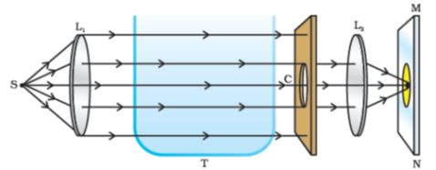

**Figure 11.11** An arrangement for observing scattering of light in colloidal solution

This activity demonstrates the scattering of light that helps you to understand the bluish colour of the sky and the reddish appearance of the Sun at the sunrise or the sunset.

Light from the Sun near the horizon passes through thicker layers of air and larger distance in the earth’s atmosphere before reaching our eyes (Fig. 11.12).

However, light from the Sun overhead would travel relatively shorter distance. At noon, the Sun appears white as only a little of the blue and violet colours are scattered. Near the horizon, most of the blue light and shorter wavelengths are scattered away by the particles. Therefore, the light that reaches our eyes is of longer wavelengths. This gives rise to the reddish appearance of the Sun.

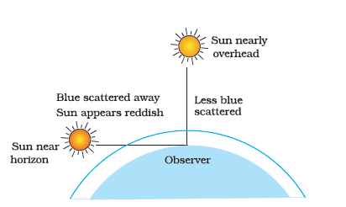

**Figure 11.12** Reddening of the Sun at sunrise and sunset

### What you have learnt

The ability of the eye to focus on both near and distant objects, by adjusting its focal length, is called the accommodation of the eye.

The smallest distance, at which the eye can see objects clearly without strain, is called the near point of the eye or the least distance of distinct vision. For a young adult with normal vision, it is about 25 cm.

The common refractive defects of vision include myopia, hypermetropia and presbyopia. Myopia (short-sightedness – the image of distant objects is focussed before the retina) is corrected by using a concave lens of suitable power. Hypermetropia (far-sightedness – the image of nearby objects is focussed beyond the retina) is corrected by using a convex lens of suitable power. The eye loses its power of accommodation at old age.

The splitting of white light into its component colours is called dispersion.

Scattering of light causes the blue colour of sky and the reddening of the Sun at sunrise and sunset.

### Exercises

The human eye can focus on objects at different distances by adjusting the focal length of the eye lens. This is due to

presbyopia.

accommodation.

near-sightedness.

far-sightedness.

The human eye forms the image of an object at its

cornea.

iris.

pupil.

retina.

The least distance of distinct vision for a young adult with normal vision is about

25 m.

2.5 cm.

25 cm.

2.5 m.

The change in focal length of an eye lens is caused by the action of the

pupil.

retina.

ciliary muscles.

iris.

A person needs a lens of power −5.5- 5.5

dioptres for correcting his distant vision. For correcting his near vision he needs a lens of power +1.5 dioptre. What is the focal length of the lens required for correcting (i) distant vision, and (ii) near vision?

The far point of a myopic person is 80 cm in front of the eye. What is the nature and power of the lens required to correct the problem?

Make a diagram to show how hypermetropia is corrected. The near point of a hypermetropic eye is 1 m. What is the power of the lens required to correct this defect? Assume that the near point of the normal eye is 25 cm.

Why is a normal eye not able to see clearly the objects placed closer than 25 cm?

What happens to the image distance in the eye when we increase the distance of an object from the eye?

Why do stars twinkle?

Explain why the planets do not twinkle.

Why does the Sun appear reddish early in the morning?

Why does the sky appear dark instead of blue to an astronaut?

## Chapter 12 – Electricity



1064CH12

Electricity has an important place in modern society. It is a controllable and convenient form of energy for a variety of uses in homes, schools, hospitals, industries and so on. What constitutes electricity? How does it flow in an electric circuit? What are the factors that control or regulate the current through an electric circuit? In this Chapter, we shall attempt to answer such questions. We shall also discuss the heating effect of electric current and its applications.

### 12.1 - Electric Current and Circuit

We are familiar with air current and water current. We know that flowing water constitute water current in rivers. Similarly, if the electric charge flows through a conductor (for example, through a metallic wire), we say that there is an electric current in the conductor. In a torch, we know that the cells (or a battery, when placed in proper order) provide flow of charges or an electric current through the torch bulb to glow. We have also seen that the torch gives light only when its switch is *on*. What does a switch do? A switch makes a conducting link between the cell and the bulb. A continuous and closed path of an electric current is called an electric circuit. Now, if the circuit is broken anywhere (or the switch of the torch is turned *off*), the current stops flowing and the bulb does not glow.

How do we express electric current? Electric current is expressed by the amount of charge flowing through a particular area in unit time. In other words, it is the rate of flow of electric charges. In circuits using metallic wires, electrons constitute the flow of charges. However, electrons were not known at the time when the phenomenon of electricity was first observed. So, electric current was considered to be the flow of positive charges and the direction of flow of positive charges was taken to be the direction of electric current. Conventionally, in an electric circuit the direction of electric current is taken as opposite to the direction of the flow of electrons, which are negative charges.

If a net charge Q, flows across any cross-section of a conductor in time *t*, then the current *I*, through the cross-section is

I=QtI = \frac{Q}{t}

…(12.1)

The SI unit of electric charge is coulomb (C), which is equivalent to the charge contained in nearly 6×10186 \times 10^{18}

electrons. (We know that an electron possesses a negative charge of 1.6×10−19C1.6 \times 10^{- 19}C

.) The electric current is expressed by a unit called ampere (A), named after the French scientist, Andre-Marie Ampere (1775–1836). One ampere is constituted by the flow of one coulomb of charge per second, that is, 1A=1C1s1A = \frac{1C}{1s}

. Small quantities of current are expressed in milliampere (1mA=10−3A)\left( 1mA = 10^{- 3}A \right)

or in microampere(1μA=10−6A)\left( 1\mu A = 10^{- 6}A \right)

. An instrument called ammeter measures electric current in a circuit. It is always connected in series in a circuit through which the current is to be measured. Figure 12.1 shows the schematic diagram of a typical electric circuit comprising a cell, an electric bulb, an ammeter and a plug key. Note that the electric current flows in the circuit from the positive terminal of the cell to the negative terminal of the cell through the bulb and ammeter.

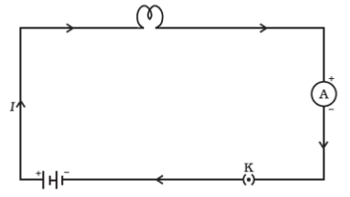

**Figure 12.1** A schematic diagram of an electric circuit comprising – cell, electric bulb, ammeter and plug key

**Example 12.1**

A current of 0.5 A is drawn by a filament of an electric bulb for 10 minutes. Find the amount of electric charge that flows through the circuit.

**Solution**

We are given, I=0.5AI\ = \ 0.5\ A

; t=10min=600st\ = \ 10\ min\ = \ 600\ s

.

From Eq. (12.1), we have

Q=ItQ\ = \ It

=0.5A×600s= \ 0.5\ A\ \times \ 600\ s

=300C= \ 300\ C

#### More to know!

**‘Flow’ of charges inside a wire**

How does a metal conduct electricity? You would think that a low-energy electron would have great difficulty passing through a solid conductor. Inside the solid, the atoms are packed together with very little spacing between them. But it turns out that the electrons are able to ‘travel’ through a perfect solid crystal smoothly and easily, almost as if they were in a vacuum. The ‘motion’ of electrons in a conductor, however, is very different from that of charges in empty space. When a steady current flows through a conductor, the electrons in it move with a certain average ‘drift speed’. One can calculate this drift speed of electrons for a typical copper wire carrying a small current, and it is found to be actually very small, of the order of 1 mms−1s^{- 1}

. How is it then that an electric bulb lights up as soon as we turn the switch *on*? It cannot be that a current starts only when an electron from one terminal of the electric supply physically reaches the other terminal through the bulb, because the physical drift of electrons in the conducting wires is a very slow process. The exact mechanism of the current flow, which takes place with a speed close to the speed of light, is fascinating, but it is beyond the scope of this book. Do you feel like probing this question at an advanced level?

#### Questions

What does an electric circuit mean?

Define the unit of current.

Calculate the number of electrons constituting one coulomb of charge.

### 12.2 - Electric Potential and Potential Difference

What makes the electric charge to flow? Let us consider the analogy of flow of water. Charges do not flow in a copper wire by themselves, just as water in a perfectly horizontal tube does not flow. If one end of the tube is connected to a tank of water kept at a higher level, such that there is a pressure difference between the two ends of the tube, water flows out of the other end of the tube. For flow of charges in a conducting metallic wire, the gravity, of course, has no role to play; the electrons move only if there is a difference of electric pressure – called the *potential difference* – along the conductor. This difference of potential may be produced by a battery, consisting of one or more electric cells. The chemical action within a cell generates the potential difference across the terminals of the cell, even when no current is drawn from it. When the cell is connected to a conducting circuit element, the potential difference sets the charges in motion in the conductor and produces an electric current. In order to maintain the current in a given electric circuit, the cell has to expend its chemical energy stored in it.

We define the electric potential difference between two points in an electric circuit carrying some current as the work done to move a unit charge from one point to the other –

Potential difference (V)betweentwopoints=Workdone(W)Charge (Q)\text{Potential\ difference\ }\left( V \right)between\ two\ points\ = \ \frac{Work\ done\ (W)}{Ch\text{arge\ }\left( Q \right)}

V=WQV\ = \frac{W}{Q}

…(12.2)

The SI unit of electric potential difference is volt (V), named after Alessandro Volta (1745–1827), an Italian physicist. One volt is the potential difference between two points in a current carrying conductor when 1 joule of work is done to move a charge of 1 coulomb from one point to the other.

Therefore, 1volt=1joule1coulomb1\text{volt} = \frac{1\text{joule}}{1\text{coulomb}}

(12.3)

1V=1JC−11V = 1JC^{- 1}

The potential difference is measured by means of an instrument called the voltmeter. The voltmeter is always connected in parallel across the points between which the potential difference is to be measured.

**Example 12.2**

How much work is done in moving a charge of 2C across two points having a potential difference 12V?

**Solution**

The amount of charge Q, that flows between two points at potential difference V(= 12 V)V\ (\text{=\ 12\ V})

is 2C. Thus, the amount of work W, done in moving the charge [from Eq. (12.2)] is

W=VQW\ = \ VQ

=12V×2C= \ 12\ V\ \times \ 2\ C

=24J= \ 24\ J

.

#### Questions

Name a device that helps to maintain a potential difference across a conductor.

What is meant by saying that the potential difference between two points is 1 V?

How much energy is given to each coulomb of charge passing through a 6 V battery?

### 12.3 - Circuit Diagram

We know that an electric circuit, as shown in Fig. 12.1, comprises a cell (or a battery), a plug key, electrical component(s), and connecting wires. It is often convenient to draw a schematic diagram, in which different components of the circuit are represented by the symbols conveniently used. Conventional symbols used to represent some of the most commonly used electrical components are given in Table 12.1.

**Table 12.1** Symbols of some commonly used components in circuit diagrams

| **Sl. No.** | **Components** | **Symbols** |
| --- | --- | --- |
|  | An electric cell | symbol for an electric cell |
|  | A battery or a combination of cells | symbol for a battery |
|  | Plug key or switch (open) | symbol for a open key |
|  | Plug key or switch (closed) | symbol for a closed key |
|  | A wire joint | symbol for a joint in a wire |
|  | Wires crossing without joining | symbol for a two wires crossing each other without joining to each other |
|  | Electric bulb | symbol for a bulb  Or  symbol for a bulb |
|  | A resistor of resistance *R* | symbol for a resistor |
|  | Variable resistance or rheostat | symbol for a variable resistor  Or  symbol for a variable resistor |
|  | Ammeter | symbol for a ammeter |
|  | Voltmeter | symbol for a voltmeter |

### 12.4 - Ohm’s Law

Is there a relationship between the potential difference across a conductor and the current through it? Let us explore with an Activity.

#### Activity 12.1

Set up a circuit as shown in Fig. 12.2, consisting of a nichrome wire XY of length, say 0.5 m, an ammeter, a voltmeter and four cells of 1.5 V each. (Nichrome is an alloy of nickel, chromium, manganese, and iron metals.)

First use only one cell as the source in the circuit. Note the reading in the ammeter *I*, for the current and reading of the voltmeter *V* for the potential difference across the nichrome wire XY in the circuit. Tabulate them in the Table given.

Next connect two cells in the circuit and note the respective readings of the ammeter and voltmeter for the values of current through the nichrome wire and potential difference across the nichrome wire.

Repeat the above steps using three cells and then four cells in the circuit separately.

Calculate the ratio of *V* to *l* for each pair of potential difference *V* and current *I*.

| **Sr. No.** | **Number of cells used in the circuit** | Current through the nichrome wire, *I* (ampere) | Potential difference across the nichrome wire, *V* (volt) | *V/I* (volt/ampere) |
| --- | --- | --- | --- | --- |
| 1 | 1 |  |  |  |
| 2 | 2 |  |  |  |
| 3 | 3 |  |  |  |
| 4 | 4 |  |  |  |

Plot a graph between *V* and *I*, and observe the nature of the graph.

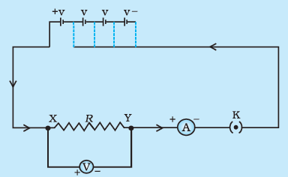

**Figure 12.2** Electric circuit for studying Ohm’s law.

In this Activity, you will find that approximately the same value for VI\frac{V}{I}

is obtained in each case. Thus the V−IV - I

graph is a straight line that passes through the origin of the graph, as shown in Fig. 12.3. Thus, VI\frac{V}{I}

is a constant ratio.

In 1827, a German physicist Georg Simon Ohm (1787–1854) found out the relationship between the current *I*, flowing in a metallic wire and the potential difference across its terminals. The potential difference, *V*, across the ends of a given metallic wire in an electric circuit is directly proportional to the current flowing through it, provided its temperature remains the same. This is called Ohm’s law. In other words –

V∝IV \propto I

…(12.4)

*Or* VI=constant\frac{V}{I} = constant

VI=R\frac{V}{I} = R

V=IRV = IR

…(12.5)

In Eq. (12.4), *R* is a constant for the given metallic wire at a given temperature and is called its resistance. It is the property of a conductor to resist the flow of charges through it. Its SI unit is ohm, represented by the Greek letter Ω. According to Ohm’s law,

R=VIR\ = \frac{V}{I}

…(12.6)

If the potential difference across the two ends of a conductor is 1 V and the current through it is 1A, then the resistance *R*, of the conductor

1 volt is 1 Ω. That is, 1ohm=1volt1ampere1ohm = \frac{1volt}{1ampere}

Also from Eq. (12.5) we get

I=VRI\ = \frac{V}{R}

…(12.7)

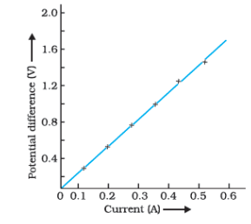

**Figure 12.3**V−IV - I

graph for a nichrome wire. A straight line plot shows that as the current through a wire increases, the potential difference across the wire increases linearly – this is Ohm’s law.

It is obvious from Eq. (12.7) that the current through a resistor is inversely proportional to its resistance. If the resistance is doubled the current gets halved. In many practical cases it is necessary to increase or decrease the current in an electric circuit. A component used to regulate current without changing the voltage source is called variable resistance. In an electric circuit, a device called rheostat is often used to change the resistance in the circuit. We will now study about electrical resistance of a conductor with the help of following Activity.

#### Activity 12.2

Take a nichrome wire, a torch bulb, a 10 W bulb and an ammeter, 0-5A range a plug key and some connecting wires.

Set up the circuit by connecting four dry cells of 1.5V each in series with the ammeter leaving a gap XY in the circuit, as shown in Fig. 12.4.

Complete the circuit by connecting the nichrome wire in the gap XY. Plug the key. Note down the ammeter reading. Take out the key from the plug. [Note: *Always take out the key from the plug after measuring the current through the circuit*]

Replace the nichrome wire with the torch bulb in the circuit and find the current through it by measuring the reading of the ammeter.

Now repeat the above step with the 10W bulb in the gap XY.

Are the ammeter readings different for different components connected in the gap XY? What do the above observations indicate?

You may repeat this Activity by keeping any material component in the gap. Observe the ammeter readings in each case. Analyse the observations.

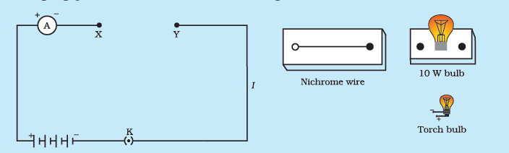

Figure 12.4

In this Activity we observe that the current is different for different components. Why do they differ? Certain components offer an easy path for the flow of electric current while the others resist the flow. We know that motion of electrons in an electric circuit constitutes an electric current. The electrons, however, are not completely free to move within a conductor. They are restrained by the attraction of the atoms among which they move. Thus, motion of electrons through a conductor is retarded by its resistance. A component of a given size that offers a low resistance is a good conductor. A conductor having some appreciable resistance is called a resistor. A component of identical size that offers a higher resistance is a poor conductor. An insulator of the same size offers even higher resistance.

### 12.5 - Factors On Which The Resistance Of A Conductor Depends

#### Activity 12.3

Complete an electric circuit consisting of a cell, an ammeter, a nichrome wire of length *l* [say, marked (1)] and a plug key, as shown in Fig. 12.5.

Now, plug the key. Note the current in the ammeter.

Replace the nichrome wire by another nichrome wire of same thickness but twice the length, that is 2*l* [marked (2) in the Fig. 12.5].

Note the ammeter reading.

Now replace the wire by a thicker nichrome wire, of the same length *l* [marked (3)]. A thicker wire has a larger cross-sectional area. Again note down the current through the circuit.

Instead of taking a nichrome wire, connect a copper wire [marked (4) in Fig. 12.5] in the circuit.

Let the wire be of the same length and same area of cross-section as that of the first nichrome wire [marked (1)]. Note the value of the current.

Notice the difference in the current in all cases.

Does the current depend on the length of the conductor?

Does the current depend on the area of cross-section of the wire used?

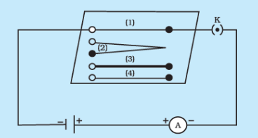

**Figure 12.5** Electric circuit to study the factors on which the resistance of conducting wires depends

It is observed that the ammeter reading decreases to one-half when the length of the wire is doubled. The ammeter reading is increased when a thicker wire of the same material and of the same length is used in the circuit. A change in ammeter reading is observed when a wire of different material of the same length and the same area of cross-section is used. On applying Ohm’s law [Eqs. (12.5) – (12.7)], we observe that the resistance of the conductor depends (i) on its length, (ii) on its area of cross-section, and (iii) on the nature of its material. Precise measurements have shown that resistance of a uniform metallic conductor is directly proportional to its length (*l*) and inversely proportional to the area of cross-section (*A*). That is,

R∝lR \propto l

(12.8)

and R∝1AR \propto \frac{1}{A}

…(12.9)

Combining Eqs. (12.8) and (12.9) we get

R∝lAR \propto \frac{l}{A}

or, R=ρtAR = \rho\frac{t}{A}

…(12.10)

where ρ (rho) is a constant of proportionality and is called the electrical resistivity of the material of the conductor. The SI unit of resistivity is Ω m. It is a characteristic property of the material. The metals and alloys have very low resistivity in the range of 10−8Ωm10^{- 8}\text{Ωm}

to10−6Ωm10^{- 6}\text{Ωm}

. They are good conductors of electricity. Insulators like rubber and glass have resistivity of the order of 101210^{12}

to1017Ωm10^{17}\text{Ωm}

. Both the resistance and resistivity of a material vary with temperature.

Table 12.2 reveals that the resistivity of an alloy is generally higher than that of its constituent metals. Alloys do not oxidise (burn) readily at high temperatures. For this reason, they are commonly used in electrical heating devices, like electric iron, toasters etc. Tungsten is used almost exclusively for filaments of electric bulbs, whereas copper and aluminium are generally used for electrical transmission lines.

**Table 12.2** Electrical resistivity* of some substances at 20°C

|  | **Material** | **Resistivity (Ω m)** |
| --- | --- | --- |
| **Conductors** | Silver | 1.60×10−81.60 \times 10^{- 8} |
|  | Copper | 1.62×10−81.62 \times 10^{- 8} |
|  | Aluminum | 2.63×10−82.63 \times 10^{- 8} |
|  | Tungsten | 5.20×10−85.20 \times 10^{- 8} |
|  | Nickel | 6.84×10−86.84 \times 10^{- 8} |
|  | Iron | 10.0×10−810.0 \times 10^{- 8} |
|  | Chromium | 12.9×10−812.9 \times 10^{- 8} |
|  | Mercury | 94.0×10−894.0 \times 10^{- 8} |
|  | Manganese | 1.84×10−61.84 \times 10^{- 6} |
| **Alloys** | Constantan (alloy of Cu and Ni) | 49×10−649 \times 10^{- 6} |
|  | Manganin (alloy of Cu, Mn and Ni) | 44×10−644 \times 10^{- 6} |
|  | Nichrome (alloy of Ni, Cr, Mn and Fe) | 100×10−6100 \times 10^{- 6} |
| **Insulators** | Glass | 1010to101410^{10}\ to\ 10^{14} |
|  | Hard rubber | 1013to101610^{13}\ to\ 10^{16} |
|  | Ebonite | 1015to101710^{15}\ to\ 10^{17} |
|  | Diamond | 1012to101310^{12}\ to\ 10^{13} |
|  | Paper (dry) | 101210^{12} |
| * You need not memorise these values. You can use these values for solving numerical problems. |  |  |

**Example 12.3**

How much current will an electric bulb draw from a 220V source, if the resistance of the bulb filament is 1200Ω? (b) How much current will an electric heater coil draw from a 220V source, if the resistance of the heater coil is 100Ω?

**Solution**

We are given V = 220 V; R = 1200 ΩV\text{\ =\ 220\ V;\ }R\text{\ =\ 1200\ }\Omega

.

From Eq. (12.6), we have the current I = 220 V/1200 Ω = 0.18 AI\text{\ =\ 220\ V/1200\ }\Omega\text{\ =\ 0.18\ A}

.

We are given, V = 220 V, R = 100 ΩV\text{\ =\ 220\ V,\ }R\text{\ =\ 100\ }\Omega

.

From Eq. (12.6), we have the current I = 220 V/100 Ω = 2.2 AI\text{\ =\ 220\ V/100\ }\Omega\text{\ =\ 2.2\ A}

.

Note the difference of current drawn by an electric bulb and electric heater from the same 220 V source!

**Example 12.4**

The potential difference between the terminals of an electric heater is 60V when it draws a current of 4A from the source. What current will the heater draw if the potential difference is increased to 120V?

**Solution**

We are given, potential difference V = 60 VV\text{\ =\ 60\ V}

, current I=4AI\ = \ 4\ A

.

According to Ohm’s law, R=VI=60V4A=15ΩR = \frac{V}{I} = \frac{60V}{4A} = 15\Omega

.

When the potential difference is increased to 120V the current is given by

current=VR=120V15Ω=8A= \frac{V}{R} = \frac{120V}{15\Omega} = 8A

.

The current through the heater becomes 8A.

**Example 12.5**

Resistance of a metal wire of length 1 m is 26Ω at 20°C. If the diameter of the wire is 0.3 mm, what will be the resistivity of the metal at that temperature? Using Table 12.2, predict the material of the wire.

**Solution**

We are given the resistance *R* of the wire*= 26 Ω*, the diameter d=0.3mm=3×10−4md = 0.3mm = 3 \times 10^{- 4}m

, and the length *l* of the wire = 1m.

Therefore, from Eq. (12.10), the resistivity of the given metallic wire is

ρ=(RAl)=(Rπd24l)\rho\ = \ \left( \frac{\text{RA}}{l} \right)\ = \ \left( \frac{\text{Rπ}d^{2}}{4l} \right)

Substitution of values in this gives

ρ=1.84×10−6Ωm\rho = 1.84 \times 10^{- 6}\text{Ωm}

The resistivity of the metal at 20∘C20{^\circ}C

is 184×10−6Ωm184 \times 10^{- 6}\text{Ωm}

. From Table 12.2, we see that this is the resistivity of manganese.

**Example 12.6**

A wire of given material having length *l* and area of cross-section *A* has a resistance of 4 Ω. What would be the resistance of another wire of the same material having length l2\frac{l}{2}

and area of cross-section 2*A*?

**Solution**

For first wire

R1=ρlA=4ΩR_{1} = \rho\frac{l}{A} = 4\Omega

Now for second wire

R2=ρl/22A=14ρlAR_{2} = \rho\frac{l/2}{2A} = \frac{1}{4}\rho\frac{l}{A}

R2=14R1R_{2} = \frac{1}{4}R_{1}

R2=1ΩR_{2} = 1\Omega

The resistance of the new wire is 1Ω.

#### Questions

On what factors does the resistance of a conductor depend?

Will current flow more easily through a thick wire or a thin wire of the same material, when connected to the same source? Why?

Let the resistance of an electrical component remains constant while the potential difference across the two ends of the component decreases to half of its former value. What change will occur in the current through it?

Why are coils of electric toasters and electric irons made of an alloy rather than a pure metal?

Use the data in Table 12.2 to answer the following –

Which among iron and mercury is a better conductor?

Which material is the best conductor?

### 12.6 - Resistance Of A System Of Resistors

In preceding sections, we learnt about some simple electric circuits. We have noticed how the current through a conductor depends upon its resistance and the potential difference across its ends. In various electrical gadgets, we often use resistors in various combinations. We now therefore intend to see how Ohm’s law can be applied to combinations of resistors.

There are two methods of joining the resistors together. Figure 12.6 shows an electric circuit in which three resistors having resistances R1,R2R_{1},\ R_{2}

andR3R_{3}

, respectively, are joined end to end. Here the resistors are said to be connected in series.

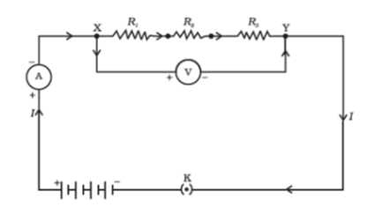

**Figure 12.6** Resistors in series

Figure 12.7 shows a combination of resistors in which three resistors are connected together between points X and Y. Here, the resistors are said to be connected in parallel.

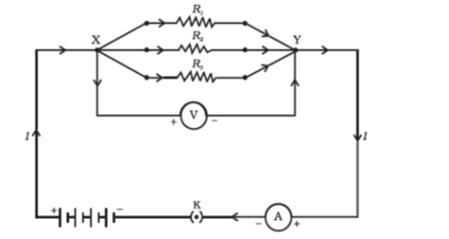

**Figure 12.7** Resistors in parallel

#### 12.6.1 - Resistors in Series

What happens to the value of current when a number of resistors are connected in series in a circuit? What would be their equivalent resistance? Let us try to understand these with the help of the following activities.

##### Activity 12.4

Join three resistors of different values in series. Connect them with a battery, an ammeter and a plug key, as shown in Fig. 12.6. You may use the resistors of values like 1Ω, 2Ω, 3Ω etc., and a battery of 6 V for performing this Activity.

Plug the key. Note the ammeter reading.

Change the position of ammeter to anywhere in between the resistors. Note the ammeter reading each time.

Do you find any change in the value of current through the ammeter?

You will observe that the value of the current in the ammeter is the same, independent of its position in the electric circuit. It means that in a series combination of resistors the current is the same in every part of the circuit or the same current through each resistor.

##### Activity 12.5

In Activity 12.4, insert a voltmeter across the ends X and Y of the series combination of three resistors, as shown in Fig. 12.6.

Plug the key in the circuit and note the voltmeter reading. It gives the potential difference across the series combination of resistors. Let it be V. Now measure the potential difference across the two terminals of the battery. Compare the two values.

Take out the plug key and disconnect the voltmeter. Now insert the voltmeter across the ends X and Ρ of the first resistor, as shown in Fig. 12.8.

Plug the key and measure the potential difference across the first resistor. Let it be V1V_{1}

.

Similarly, measure the potential difference across the other two resistors, separately. Let these values be V2V_{2}

and V3V_{3}

, respectively.

Deduce a relationship between V,V1,V2V,\ V_{1},\ V_{2}

and V3V_{3}

.

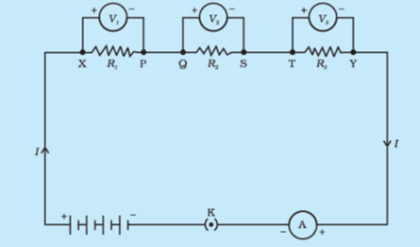

Figure 12.8

You will observe that the potential difference VV

is equal to the sum of potential differencesV1,V2V_{1},\ V_{2}

, andV3V_{3}

. That is the total potential difference across a combination of resistors in series is equal to the sum of potential difference across the individual resistors. That is,

V=V1+V2+V3V\ = \ V_{1}\ + \ V_{2}\ + \ V_{3}

…(12.11)

In the electric circuit shown in Fig. 12.8, let *I* be the current through the circuit. The current through each resistor is also *I*. It is possible to replace the three resistors joined in series by an equivalent single resistor of resistance *R*, such that the potential difference *V* across it, and the current *I* through the circuit remains the same. Applying the Ohm’s law to the entire circuit, we have

V=IRV\ = \ I\ R

…(12.12)

On applying Ohm’s law to the three resistors separately, we further have

V1=IR1V_{1}\ = \ I\ R_{1}

…[12. 13(a)]

V2=IR2V_{2}\ = \ I\ R_{2}

…[12. 13(b)]

and V3=IR3V_{3}\ = \ I\ R_{3}

…[12. 13(c)]

From Eq. (12. 11),

IR=IR1+IR2+IR3I\ R\ = \ I\ R_{1}\ + \ I\ R_{2}\ + \ I\ R_{3}

or

Rs+R1+R2+R3R_{s}\ + \ R_{1}\ + \ R_{2}\ + \ R_{3}

…(12.14)

We can conclude that when several resistors are joined in series, the resistance of the combination R3R_{3}

equals the sum of their individual resistances, R1,R2,R3R_{1},\ R_{2},\ R_{3}

, and is thus greater than any individual resistance.

**Example 12.7**

An electric lamp, whose resistance is 20Ω, and a conductor of 4Ω resistance are connected to a 6V battery (Fig. 12.9). Calculate (a) the total resistance of the circuit, (b) the current through the circuit, and (c) the potential difference across the electric lamp and conductor.

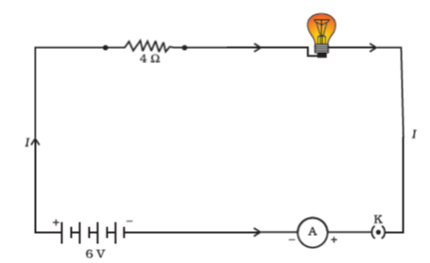

**Figure 12.9** An electric lamp connected in series with a resistor of 4Ω to α 6V battery

**Solution**

The resistance of electric lamp, R1=20ΩR_{1}\ = \ 20\ \Omega

,

The resistance of the conductor connected in series, R2=4ΩR_{2}\ = \ 4\Omega

.

Then the total resistance in the circuit

R=R1+R2R\ = \ R_{1}\ + \ R_{2}

Rs=20Ω+4Ω=24ΩR_{s}\ = \ 20\ \Omega\ + \ 4\ \Omega\ = \ 24\ \Omega

.

The total potential difference across the two terminals of the battery

V=6 VV\ = \ 6\text{\ V}

.

Now by Ohm’s law, the current through the circuit is given by

I=VRsI\ = \frac{V}{R_{s}}

=6 V24Ω= \frac{6\text{\ V}}{24\Omega}

=0.25A= 0.25A

.

Applying Ohm’s law to the electric lamp and conductor separately, we get potential difference across the electric lamp,

V1=20Ω×0.25 AV_{1}\ = \ 20\ \Omega\ \times \ 0.25\text{\ A}

=5 V= \ 5\text{\ V}

;

and,

that across the conductor,V2=4Ω×0.25 AV_{2}\ = \ 4\ \Omega\ \times \ 0.25\text{\ A}

=1 V= \ 1\text{\ V}

.

Suppose that we like to replace the series combination of electric lamp and conductor by a single and equivalent resistor. Its resistance must be such that a potential difference of 6 V across the battery terminals will cause a current of 0.25 A in the circuit. The resistance *R* of this equivalent resistor would be

R=VIR\ = \frac{V}{I}

=6V0.25A= \frac{6V}{0.25A}

= 24 Ω\text{=\ 24\ }\Omega

This is the total resistance of the series circuit; it is equal to the sum of the two resistances.

#### Questions

Draw a schematic diagram of a circuit consisting of a battery of three cells of 2V each, a 5Ω resistor, an 8Ω resistor, and a 12Ω resistor, and a plug key, all connected in series.

Redraw the circuit of Question 1, putting in an ammeter to measure the current through the resistors and a voltmeter to measure the potential difference across the 12Ω resistor. What would be the readings in the ammeter and the voltmeter?

#### 12.6.2 - Resistors in Parallel

Now, let us consider the arrangement of three resistors joined in parallel with a combination of cells (or a battery), as shown in Fig. 12.7.

##### Activity 12.6

Make a parallel combination, XY, of three resistors having resistances R1,R2R_{1},\ R_{2}

, andR3R_{3}

, respectively. Connect it with a battery, a plug key and an ammeter, as shown in Fig. 12.10. Also connect a voltmeter in parallel with the combination of resistors.

Plug the key and note the ammeter reading. Let the current be *I*. Also take the voltmeter reading. It gives the potential difference *V*, across the combination. The potential difference across each resistor is also *V*. This can be checked by connecting the voltmeter across each individual resistor (see Fig. 12.11).

Take out the plug from the key. Remove the ammeter and voltmeter from the circuit. Insert the ammeter in series with the resistor R1R_{1}

as shown in Fig. 12.11. Note the ammeter reading, I1I_{1}

.

Similarly, measure the currents through R2R_{2}

and R3R_{3}

. Let these be I2I_{2}

and I3I_{3}

, respectively. What is the relationship between I,I1,I2I,\ I_{1},\ I_{2}

and I3I_{3}

?

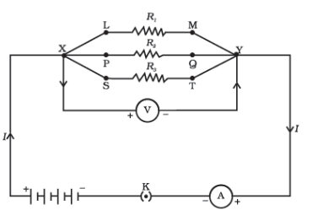

Figure 12.10

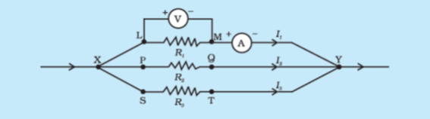

Figure 12.11

It is observed that the total current *I*, is equal to the sum of the separate currents through each branch of the combination.

I=I1+I2+I3I\ = \ I_{1}\ + \ I_{2}\ + \ I_{3}\

…(12.15)

Let RpR_{p}

be the equivalent resistance of the parallel combination of resistors. By applying Ohm’s law to the parallel combination of resistors, we have

I=VRpI\ = \frac{V}{R_{p}}

…(12.16)

On applying Ohm’s law to each resistor, we have

I1=VR1;I2=VR2I_{1}\ = \frac{V}{R_{1}};\ I_{2}\ = \frac{V}{R_{2}}

; and I3=VR3I_{3}\ = \frac{V}{R_{3}}

…(12.17)

From Eqs. (12.15) to (12. 17), we have

VRp=VR1+VR2+VR3\frac{V}{R_{p}}\ = \frac{V}{R_{1}}\ + \frac{V}{R_{2}}\ + \frac{V}{R_{3}}

or

1Rp=1R1+1R2+1R3\frac{1}{R_{p}} = \frac{1}{R_{1}}\ + \frac{1}{R_{2}}\ + \frac{1}{R_{3}}

…(12.18)

Thus, we may conclude that the reciprocal of the equivalent resistance of a group of resistances joined in parallel is equal to the sum of the reciprocals of the individual resistances.

**Example 12.8**

In the circuit diagram given in Fig. 12.10, suppose the resistors R1,R2R_{1},\ R_{2}

and R3R_{3}

have the values 5Ω, 10Ω, 30Ω, respectively, which have been connected to a battery of 12V. Calculate (a) the current through each resistor, (b) the total current in the circuit, and (c) the total circuit resistance.

**Solution**

R1=5Ω,R2=10ΩR_{1}\ = \ 5\ \Omega,\ \ R_{2}\ = \ 10\ \Omega

, and R3=30ΩR_{3}\ = \ 30\ \Omega

.

Potential difference across the battery, V=12 VV = \ 12\text{\ V}

.

This is also the potential difference across each of the individual resistor; therefore, to calculate the current in the resistors, we use Ohm’s law.

The current I1I_{1}

through R1=VR1R_{1}\ = \frac{V}{R_{1}}

I1=12 V5Ω=2.4 AI_{1}\ = \frac{12\text{\ V}}{5\Omega}\ = \ 2.4\text{\ A}

.

The currentI2I_{2}

, through R2=VR2R_{2}\ = \frac{V}{R_{2}}

I2=12 V10Ω=1.2 AI_{2}\ = \frac{12\text{\ V}}{10\Omega}\ = \ 1.2\text{\ A}

.

The currentI3I_{3}

, through R3=VR3R_{3}\ = \frac{V}{R_{3}}

I3=12 V30Ω=0.4 AI_{3}\ = \frac{12\text{\ V}}{30\Omega} = 0.4\text{\ A}

.

The total current in the circuit,

I=I1+I2+I3I\ = \ I_{1}\ + \ I_{2}\ + \ I_{3}

=(2.4+1.2+0.4) A= \ (2.4\ + \ 1.2\ + \ 0.4)\text{\ A}

=4A= \ 4\ A

The total resistance RpR_{p}

, is given by [Eq. (12.18)]

1Rp=15+110+130=13\frac{1}{R_{p}} = \frac{1}{5} + \frac{1}{10} + \frac{1}{30} = \frac{1}{3}

Thus, Rp=3ΩR_{p}\ = \ 3\ \Omega

.

**Example 12.9**

If in Fig. 12.12, R1=10Ω,R2=40Ω,R3=30Ω,R4=20Ω,R5=60ΩR_{1}\ = \ 10\ \Omega,\ R_{2}\ = \ 40\ \Omega,\ R_{3}\ = \ 30\ \Omega,\ R_{4}\ = \ 20\ \Omega,\ R_{5}\ = \ 60\ \Omega

, and a 12V battery is connected to the arrangement. Calculate (a) the total resistance in the circuit, and (b) the total current flowing in the circuit.

**Solution**

Suppose we replace the parallel resistors R1R_{1}

and R2R_{2}

by an equivalent resistor of resistance, R′. Similarly we replace the parallel resistors R3,R4R_{3},\ R_{4}

and R5R_{5}

by an equivalent single resistor of resistanceR″R^{''}

. Then using Eq. (12.18), we have 1R′=110+140=540\frac{1}{R^{'}} = \frac{1}{10}\ + \frac{1}{40}\ = \frac{5}{40}

; that isR’ = 8 ΩR\text{'\ =\ 8\ }\Omega

.

Similarly,$\frac{1}{R"} = \frac{1}{30}\ + \frac{1}{20}\ + \frac{1}{60}\ = \frac{6}{60}$;

that is, $R"\ = \ 10\ \Omega$.

Thus, the total resistance,$R\ = \ R'\ + \ R" = \ 18\ \Omega$.

To calculate the current, we use Ohm’s law, and get

I=VR=12V18Ω=0.67 AI\ = \frac{V}{R}\ = \ \frac{12V}{18\Omega}\ = \ 0.67\text{\ A}

.

We have seen that in a series circuit the current is constant throughout the electric circuit. Thus it is obviously impracticable to connect an electric bulb and an electric heater in series, because they need currents of widely different values to operate properly (see Example 12.3). Another major disadvantage of a series circuit is that when one component fails the circuit is broken and none of the components works. If you have used ‘fairy lights’ to decorate buildings on festivals, on marriage celebrations etc., you might have seen the electrician spending lot of time in trouble-locating and replacing the ‘dead’ bulb – each has to be tested to find which has fused or gone. On the other hand, a parallel circuit divides the current through the electrical gadgets. The total resistance in a parallel circuit is decreased as per Eq. (12.18). This is helpful particularly when each gadget has different resistance and requires different current to operate properly.

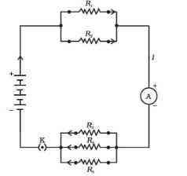

**Figure 12.12** An electric circuit showing the combination of series and parallel resistors

#### Questions

Judge the equivalent resistance when the following are connected in parallel – (a) 1Ω1\Omega

and 106Ω10^{6}\Omega

, (b) 1Ω1\Omega

and 103Ω10^{3}\Omega

, and 106Ω10^{6}\Omega

.

An electric lamp of 100Ω, a toaster of resistance 50Ω, and a water filter of resistance 500Ω are connected in parallel to a 220V source. What is the resistance of an electric iron connected to the same source that takes as much current as all three appliances, and what is the current through it?

What are the advantages of connecting electrical devices in parallel with the battery instead of connecting them in series?

How can three resistors of resistances 2Ω, 3Ω, and 6Ω be connected to give a total resistance of (a) 4Ω, (b) 1Ω?

What is (a) the highest, (b) the lowest total resistance that can be secured by combinations of four coils of resistance 4Ω, 8Ω, 12Ω, 24Ω?

### 12.7 - Heating Effect of Electric Current

We know that a battery or a cell is a source of electrical energy. The chemical reaction within the cell generates the potential difference between its two terminals that sets the electrons in motion to flow the current through a resistor or a system of resistors connected to the battery. We have also seen, in Section 12.2, that to maintain the current, the source has to keep expending its energy. Where does this energy go? A part of the source energy in maintaining the current may be consumed into useful work (like in rotating the blades of an electric fan). Rest of the source energy may be expended in heat to raise the temperature of gadget. We often observe this in our everyday life. For example, an electric fan becomes warm if used continuously for longer time etc. On the other hand, if the electric circuit is purely resistive, that is, a configuration of resistors only connected to a battery; the source energy continually gets dissipated entirely in the form of heat. This is known as the heating effect of electric current. This effect is utilised in devices such as electric heater, electric iron etc.

Consider a current *I* flowing through a resistor of resistance *R*. Let the potential difference across it be *V* (Fig. 12.13). Let *t* be the time during which a charge *Q* flows across. The work done in moving the charge *Q* through a potential difference Vis *VQ*. Therefore, the source must supply energy equal to *VQ* in time *t*. Hence the power input to the circuit by the source is

P=VQt=VIP = V\frac{Q}{t} = VI

…(12.19)

Or the energy supplied to the circuit by the source in time *t* is P × t\text{P\ } \times \text{\ t}

, that is, *VIt*. What happens to this energy expended by the source? This energy gets dissipated in the resistor as heat. Thus for a steady current *I*, the amount of heat *H* produced in time *t* is

H=VItH\ = \ VIt

…(12.20)

Applying Ohm’s law [Eq. (12.5)], we get

H=I2RtH = I^{2}\text{Rt}

…(12.21)

This is known as Joule’s law of heating. The law implies that heat produced in a resistor is (i) directly proportional to the square of current for a given resistance, (ii) directly proportional to resistance for a given current, and (iii) directly proportional to the time for which the current flows through the resistor. In practical situations, when an electric appliance is connected to a known voltage source, Eq. (12.21) is used after calculating the current through it, using the relation I=V/RI\ = \ V/R

.

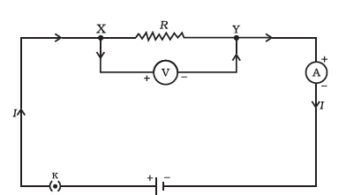

**Figure 12.13** A steady current in a purely resistive electric circuit

**Example 12.10**

An electric iron consumes energy at a rate of 840W when heating is at the maximum rate and 360W when the heating is at the minimum. The voltage is 220V. What are the current and the resistance in each case?

**Solution**

From Eq. (12.19), we know that the power input is

P=VIP\ = \ VI

Thus the current I=PVI\ = \frac{P}{V}

When heating is at the maximum rate,

I =840W220V=3.82AI\text{\ =}\frac{840W}{220V} = \ 3.82\ A

;

and the resistance of the electric iron is

R=VI=220V3.82A=57.60ΩR\ = \frac{V}{I} = \ \frac{220V}{3.82A}\ = \ 57.60\ \Omega

When heating is at the minimum rate,

I=360W220V=1.64AI\ = \ \frac{360W}{220V} = 1.64\ A

;

and the resistance of the electric iron is

R=VI=220V1.64A=134.15ΩR\ = \frac{V}{I}\ = \ \frac{220V}{1.64A}\ = \ 134.15\ \Omega

**Example 12.11**

100J of heat is produced each second in a 4Ω resistance. Find the potential difference across the resistor.

**Solution**

H=100 J,R=4Ω,t=1s,V=?H\ = \ 100\text{\ J},\ R\ = \ 4\ \Omega,\ t\ = \ 1\ s,\ V\ = ?

From Eq. (12.21) we have the current through the resistor as

I=HRtI = \sqrt{\frac{H}{\text{Rt}}}

=100J(4Ω×1s)= \sqrt{\frac{100J}{\left( 4\Omega \times 1s \right)}}

=5A

Thus the potential difference across the resistor, *V* [from Eq. (12.5)] is

V=IR

=5A×4Ω= 5A \times 4\ \Omega

=20Ω= \ 20\Omega

#### Questions

Why does the cord of an electric heater not glow while the heating element does?

Compute the heat generated while transferring 96000 coulomb of charge in one hour through a potential difference of 50V.

An electric iron of resistance 20Ω takes a current of 5A. Calculate the heat developed in 30 s.

#### 12.7.1 - Practical Applications of Heating Effect of Electric Current

The generation of heat in a conductor is an inevitable consequence of electric current. In many cases, it is undesirable as it converts useful electrical energy into heat. In electric circuits, the unavoidable heating can increase the temperature of the components and alter their properties. However, heating effect of electric current has many useful applications. The electric laundry iron, electric toaster, electric oven, electric kettle and electric heater are some of the familiar devices based on Joule’s heating.

The electric heating is also used to produce light, as in an electric bulb. Here, the filament must retain as much of the heat generated as is possible, so that it gets very hot and emits light. It must not melt at such high temperature. A strong metal with high melting point such as tungsten (melting point 3380°C) is used for making bulb filaments. The filament should be thermally isolated as much as possible, using insulating support, etc. The bulbs are usually filled with chemically inactive nitrogen and argon gases to prolong the life of filament. Most of the power consumed by the filament appears as heat, but a small part of it is in the form of light radiated.

Another common application of Joule’s heating is the fuse used in electric circuits. It protects circuits and appliances by stopping the flow of any unduly high electric current. The fuse is placed in series with the device. It consists of a piece of wire made of a metal or an alloy of appropriate melting point, for example aluminium, copper, iron, lead etc. If a current larger than the specified value flows through the circuit, the temperature of the fuse wire increases. This melts the fuse wire and breaks the circuit. The fuse wire is usually encased in a cartridge of porcelain or similar material with metal ends. The fuses used for domestic purposes are rated as 1 A, 2 A, 3 A, 5 A, 10 A, etc. For an electric iron which consumes 1 kW electric power when operated at 220 V, a current of (1000/220) A, that is, 4.54 A will flow in the circuit. In this case, a 5A fuse must be used.

### 12.8 - Electric Power

You have studied in your earlier Class that the rate of doing work is power. This is also the rate of consumption of energy.

Equation (12.21) gives the rate at which electric energy is dissipated or consumed in an electric circuit. This is also termed as electric power. The power *Ρ* is given by

P=VIP = VI

Or P=I2R=V2RP = I^{2}R = \frac{V^{2}}{R}

…(12.22)

The SI unit of electric power is watt (W). It is the power consumed by a device that carries 1 A of current when operated at a potential difference of 1 V. Thus,

1W=1volt×1ampere=1VA1\ W\ = \ 1\ volt\ \times \ 1\ ampere\ = \ 1\ VA

…(12.23)

The unit ‘watt’ is very small. Therefore, in actual practice we use a much larger unit called ‘kilowatt’. It is equal to 1000 watts. Since electrical energy is the product of power and time, the unit of electric energy is, therefore, watt hour (W h). One watt hour is the energy consumed when 1 watt of power is used for 1 hour. The commercial unit of electric energy is kilowatt hour (kW h), commonly known as ‘unit’.

1kWh=1000watt×3600 second1\ kW\ h\ = \ 1000\ watt\ \times \ 3600\text{\ second}

=3.6×106= 3.6 \times 10^{6}

watt second

=3.6×106= 3.6 \times 10^{6}

joule (J)

#### More to know!

Many people think that electrons are consumed in an electric circuit. This is wrong! We pay the electricity board or electric company to provide energy to move electrons through the electric gadgets like electric bulb, fan and engines. We pay for the energy that we use.

**Example 12.12**

An electric bulb is connected to a 220 V generator. The current is 0.50 A. What is the power of the bulb?

**Solution**

P=VIP\ = \ VI

=220V×0.50A= \ 220\ V\ \times \ 0.50\ A

=110J/s= \ 110\ J/s

= 110 W\text{=\ 110\ W}

.

**Example 12.13**

An electric refrigerator rated 400 W operates 8 hour/day. What is the cost of the energy to operate it for 30 days at Rs 3.00 per kW h?

**Solution**

The total energy consumed by the refrigerator in 30 days would be

400W×8.0hour/day×30days=96000Wh400\ W\ \times \ 8.0\ hour/day\ \ \times \ 30\ days\ \ = \ 96000\ W\ h

= 96 kW h\text{=\ 96\ kW\ h}

Thus the cost of energy to operate the refrigerator for 30 days is

96kWh×Rs3.00perkWh=Rs288.0096\ kW\ h\ \times \ Rs\ 3.00\ per\ kWh = Rs\ 288.00

#### Questions

What determines the rate at which energy is delivered by a current?

An electric motor takes 5 A from a 220 V line. Determine the power of the motor and the energy consumed in 2 h.

### What you have learnt

A stream of electrons moving through a conductor constitutes an electric current. Conventionally, the direction of current is taken opposite to the direction of flow of electrons.

The SI unit of electric current is ampere.

To set the electrons in motion in an electric circuit, we use a cell or a battery. A cell generates a potential difference across its terminals. It is measured in volts (V).

Resistance is a property that resists the flow of electrons in a conductor. It controls the magnitude of the current. The SI unit of resistance is ohm (Ω).

Ohm’s law: The potential difference across the ends of a resistor is directly proportional to the current through it, provided its temperature remains the same.

The resistance of a conductor depends directly on its length, inversely on its area of cross-section, and also on the material of the conductor.

The equivalent resistance of several resistors in series is equal to the sum of their individual resistances.

A set of resistors connected in parallel has an equivalent resistance RpR_{p}

given by

1Rp=1R1+1R2+1R3+...\frac{1}{R_{p}} = \frac{1}{R_{1}} + \frac{1}{R_{2}} + \frac{1}{R_{3}} + ...

The electrical energy dissipated in a resistor is given by

W=V×I×tW = V \times I \times t

The unit of power is watt (W). One watt of power is consumed when 1 A of current flows at a potential difference of 1 V.

The commercial unit of electrical energy is kilowatt hour (kWh). 1kWh=3,600,000J=3.6×106 J1\ kW\ h = 3,600,000\ J = 3.6\ \times \ 10^{6}\text{\ J}

.

### Exercises

A piece of wire of resistance R is cut into five equal parts. These parts are then connected in parallel. If the equivalent resistance of this combination is *R*′, then the ratio *R/R′* is –

1/251/25

1/51/5

5

25

Which of the following terms does not represent electrical power in a circuit?

I2RI^{2}R

IR2IR^{2}

VI\text{VI}

V2/RV^{2}/R\

An electric bulb is rated 220 V and 100 W. When it is operated on 110 V, the power consumed will be –

100 W

75 W

50 W

25 W

Two conducting wires of the same material and of equal lengths and equal diameters are first connected in series and then parallel in a circuit across the same potential difference. The ratio of heat produced in series and parallel combinations would be –

1:2

2:1

1:4

4:1

How is a voltmeter connected in the circuit to measure the potential difference between two points?

A copper wire has diameter 0.5 mm and resistivity of 1.6×10−8Ωm1.6 \times 10^{- 8}\text{Ωm}

. What will be the length of this wire to make its resistance 10 Ω? How much does the resistance change if the diameter is doubled?

The values of current *I* flowing in a given resistor for the corresponding values of potential difference *V* across the resistor are given below–

| *I* (amperes) | 0.5 | 1.0 | 2.0 | 3.0 | 4.0 |
| --- | --- | --- | --- | --- | --- |
| *V* (volts) | 1.6 | 3.4 | 6.7 | 10.2 | 13.2 |

Plot a graph between *V* and *I* and calculate the resistance of that resistor.

When a 12 V battery is connected across an unknown resistor, there is a current of 2.5 mA in the circuit. Find the value of the resistance of the resistor.

A battery of 9 V is connected in series with resistors of 0.2 Ω, 0.3 Ω, 0.4 Ω, 0.5 Ω and 12 Ω, respectively. How much current would flow through the 12 Ω resistor?

How many 176 Ω resistors (in parallel) are required to carry 5 A on a 220 V line?

Show how you would connect three resistors, each of resistance 6 Ω, so that the combination has a resistance of (i) 9 Ω, (ii) 4 Ω.

Several electric bulbs designed to be used on a 220 V electric supply line, are rated 10 W. How many lamps can be connected in parallel with each other across the two wires of 220 V line if the maximum allowable current is 5 A?

A hot plate of an electric oven connected to a 220 V line has two resistance coils A and B, each of 24 Ω resistance, which may be used separately, in series, or in parallel. What are the currents in the three cases?

Compare the power used in the 2 Ω resistor in each of the following circuits: (i) a 6 V battery in series with 1 Ω and 2 Ω resistors, and (ii) a 4 V battery in parallel with 12 Ω and 2 Ω resistors.

Two lamps, one rated 100 W at 220 V, and the other 60 W at 220 V, are connected in parallel to electric mains supply. What current is drawn from the line if the supply voltage is 220 V?

Which uses more energy, a 250 W TV set in 1 hr, or a 1200 W toaster in 10 minutes?

An electric heater of resistance 8 Ω draws 15 A from the service mains 2 hours. Calculate the rate at which heat is developed in the heater.

Explain the following.

Why is the tungsten used almost exclusively for filament of electric lamps?

Why are the conductors of electric heating devices, such as bread-toasters and electric irons, made of an alloy rather than a pure metal?

Why is the series arrangement not used for domestic circuits?

How does the resistance of a wire vary with its area of cross-section?

Why are copper and aluminium wires usually employed for electricity transmission?

## Chapter 13 – Magnetic Effects of Electric Current



1064CH13

in the previous Chapter on ‘Electricity’ we learnt about the heating effects of electric current. What could be the other effects of electric current? We know that an electric current-carrying wire behaves like a magnet. Let us perform the following Activity to reinforce it.

### Activity 13.1

Take a straight thick copper wire and place it between the points X and Y in an electric circuit, as shown in Fig. 13.1. The wire XY is kept perpendicular to the plane of paper.

Horizontally place a small compass near to this copper wire. See the position of its needle.

Pass the current through the circuit by inserting the key into the plug.

Observe the change in the position of the compass needle.

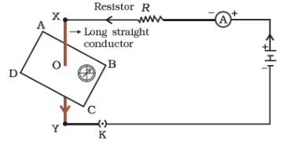

**Figure 13.1** Compass needle is deflected on passing an electric current through a metallic conductor

We see that the needle is deflected. What does it mean? It means that the electric current through the copper wire has produced a magnetic effect. Thus we can say that electricity and magnetism are linked to each other. Then, what about the reverse possibility of an electric effect of moving magnets? In this Chapter we will study magnetic fields and such electromagnetic effects. We shall also study about electromagnets and electric motors which involve the magnetic effect of electric current, and electric generators which involve the electric effect of moving magnets.

**Hans Christian Oersted (1777–1851)**

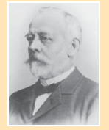

Hans Christian Oersted, one of the leading scientists of the 19th19^{\text{th}}

century, played a crucial role in understanding *electromagnetism*. In 1820 he accidentally discovered that a compass needle got deflected when an electric current passed through a metallic wire placed nearby. Through this observation Oersted showed that electricity and magnetism were related phenomena. His research later created technologies such as the radio, television and fiber optics. The unit of magnetic field strength is named the oersted in his honor.

### 13.1 - Magnetic Field and Field Lines

We are familiar with the fact that a compass needle gets deflected when brought near a bar magnet. A compass needle is, in fact, a small bar magnet. The ends of the compass needle point approximately towards north and south directions. The end pointing towards north is called *north seeking* or north pole. The other end that points towards south is called *south seeking* or south pole. Through various activities we have observed that like poles repel, while unlike poles of magnets attract each other.

#### Questions

Why does a compass needle get deflected when brought near a bar magnet?

#### Activity 13.2

Fix a sheet of white paper on a drawing board using some adhesive material.

Place a bar magnet in the centre of it.

Sprinkle some iron filings uniformly around the bar magnet (Fig. 13.2). A salt-sprinkler may be used for this purpose.

Now tap the board gently.

What do you observe?

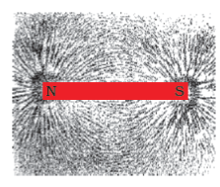

**Figure 13.2** Iron filings near the bar magnet align themselves along the field lines.

The iron filings arrange themselves in a pattern as shown Fig. 13.2. Why do the iron filings arrange in such a pattern? What does this pattern demonstrate? The magnet exerts its influence in the region surrounding it. Therefore the iron filings experience a force. The force thus exerted makes iron filings to arrange in a pattern. The region surrounding a magnet, in which the force of the magnet can be detected, is said to have a magnetic field. The lines along which the iron filings align themselves represent magnetic field lines.

Are there other ways of obtaining magnetic field lines around a bar magnet? Yes, you can yourself draw the field lines of a bar magnet.

#### Activity 13.3

Take a small compass and a bar magnet.

Place the magnet on a sheet of white paper fixed on a drawing board, using some adhesive material.

Mark the boundary of the magnet.

Place the compass near the north pole of the magnet. How does it behave? The south pole of the needle points towards the north pole of the magnet. The north pole of the compass is directed away from the north pole of the magnet.

Mark the position of two ends of the needle.

Now move the needle to a new position such that its south pole occupies the position previously occupied by its north pole.

In this way, proceed step by step till you reach the south pole of the magnet as shown in Fig. 13.3.

Join the points marked on the paper by a smooth curve. This curve represents a field line.

Repeat the above procedure and draw as many lines as you can. You will get a pattern shown in Fig. 13.4. These lines represent the magnetic field around the magnet. These are known as magnetic field lines.

Observe the deflection in the compass needle as you move it along a field line. The deflection increases as the needle is moved towards the poles.

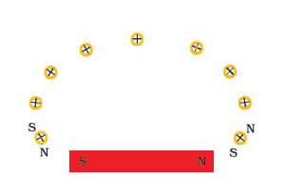

**Figure 13.4** Field lines around a bar magnet

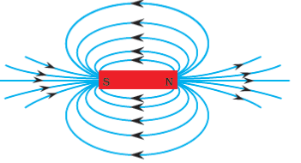

Figure 13.4 Field lines around a bar magnet

Magnetic field is a quantity that has both direction and magnitude. The direction of the magnetic field is taken to be the direction in which a north pole of the compass needle moves inside it. Therefore it is taken by convention that the field lines emerge from north pole and merge at the south pole (note the arrows marked on the field lines in Fig. 13.4). Inside the magnet, the direction of field lines is from its south pole to its north pole. Thus the magnetic field lines are closed curves.

The relative strength of the magnetic field is shown by the degree of closeness of the field lines. The field is stronger, that is, the force acting on the pole of another magnet placed is greater where the field lines are crowded (see Fig. 13.4).

No two field-lines are found to cross each other. If they did, it would mean that at the point of intersection, the compass needle would point towards two directions, which is not possible.

### 13.2 - Magnetic Field Due To A Current-Carrying Conductor

In Activity 13.1, we have seen that an electric current through a metallic conductor produces a magnetic field around it. In order to find the direction of the field produced let us repeat the activity in the following way –

#### Activity 13.4

Take a long straight copper wire, two or three cells of 1.5 V each, and a plug key. Connect all of them in series as shown in Fig. 13.5 (a).

Place the straight wire parallel to and over a compass needle.

Plug the key in the circuit.

Observe the direction of deflection of the north pole of the needle. If the current flows from north to south, as shown in Fig. 13.5 (a), the north pole of the compass needle would move towards the east.

Replace the cell connections in the circuit as shown in Fig. 13.5 (b). This would result in the change of the direction of current through the copper wire, that is, from south to north.

Observe the change in the direction of deflection of the needle. You will see that now the needle moves in opposite direction, that is, towards the west [Fig. 13.5 (b)]. It means that the direction of magnetic field produced by the electric current is also reversed.

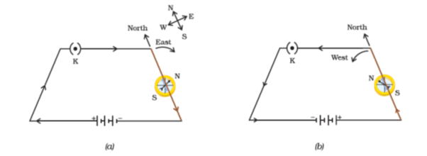

**Figure 13.5** A simple electric circuit in which a straight copper wire is placed parallel to and over a compass needle. The deflection in the needle becomes opposite when the direction of the current is reversed.

#### 13.2.1 - Magnetic Field due to a Current through a Straight Conductor

What determines the pattern of the magnetic field generated by a current through a conductor? Does the pattern depend on the shape of the conductor? We shall investigate this with an activity.

We shall first consider the pattern of the magnetic field around a straight conductor carrying current.

##### Activity 13.5

Take a battery (12 V), a variable resistance (or a rheostat), an ammeter (0-5A), a plug key, connecting wires and a long straight thick copper wire.

Insert the thick wire through the centre, normal to the plane of a rectangular cardboard. Take care that the cardboard is fixed and does not slide up or down.

Connect the copper wire vertically between the points X and Y, as shown in Fig. 13.6 (a), in series with the battery, a plug and key.

Sprinkle some iron filings uniformly on the cardboard. (You may use a salt sprinkler for this purpose.)

Keep the variable of the rheostat at a fixed position and note the current through the ammeter.

Close the key so that a current flows through the wire. Ensure that the copper wire placed between the points X and Y remains vertically straight.

Gently tap the cardboard a few times. Observe the pattern of the iron filings. You would find that the iron filings align themselves showing a pattern of concentric circles around the copper wire (Fig. 13.6).

What do these concentric circles represent? They represent the magnetic field lines.

How can the direction of the magnetic field be found? Place a compass at a point (say P) over a circle. Observe the direction of the needle. The direction of the north pole of the compass needle would give the direction of the field lines produced by the electric current through the straight wire at point P. Show the direction by an arrow.

Does the direction of magnetic field lines get reversed if the direction of current through the straight copper wire is reversed? Check it.

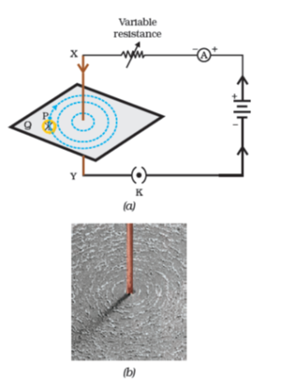

**Figure 13.6** (a) A pattern of concentric circles indicating the field lines of a magnetic field around a straight conducting wire. The arrows in the circles show the direction of the field lines. (b) A close up of the pattern obtained.

What happens to the deflection of the compass needle placed at a given point if the current in the copper wire is changed? To see this, vary the current in the wire. We find that the deflection in the needle also changes. In fact, if the current is increased, the deflection also increases. It indicates that the magnitude of the magnetic field produced at a given point increases as the current through the wire increases.

What happens to the deflection of the needle if the compass is moved away from the copper wire but the current through the wire remains the same? To see this, now place the compass at a farther point from the conducting wire (say at point Q). What change do you observe? We see that the deflection in the needle decreases. Thus the magnetic field produced by a given current in the conductor decreases as the distance from it increases. From Fig. 13.6, it can be noticed that the concentric circles representing the magnetic field around a current-carrying straight wire become larger and larger as we move away from it.

#### 13.2.2 - Right-Hand Thumb Rule

A convenient way of finding the direction of magnetic field associated with a current-carrying conductor is given in Fig. 13.7.

Imagine that you are holding a current-carrying straight conductor in your right hand such that the thumb points towards the direction of current. Then your fingers will wrap around the conductor in the direction of the field lines of the magnetic field, as shown in Fig. 13.7. This is known as the right-hand thumb rule*.

**Example 13.1**

A current through a horizontal power line flows in east to west direction. What is the direction of magnetic field at a point directly below it and at a point directly above it?

**Solution**

The current is in the east-west direction. Applying the right-hand thumb rule, we get that the magnetic field (at any point below or above the wire) turns clockwise in a plane perpendicular to the wire, when viewed from the east end, and anti-clockwise, when viewed from the west end.

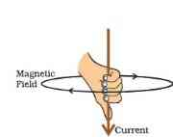

**Figure 13.7** Right-hand thumb rule

#### Questions

Draw magnetic field lines around a bar magnet.

List the properties of magnetic field lines.

Why don’t two magnetic field lines intersect each other?

#### 13.2.3 - Magnetic Field due to a Current through a Circular Loop

We have so far observed the pattern of the magnetic field lines produced around a current-carrying straight wire. Suppose this straight wire is bent in the form of a circular loop and a current is passed through it. How would the magnetic field lines look like? We know that the magnetic field produced by a current-carrying straight wire depends inversely on the distance from it. Similarly at every point of a current-carrying circular loop, the concentric circles representing the magnetic field around it would become larger and larger as we move away from the wire (Fig. 13.8). By the time we reach at the centre of the circular loop, the arcs of these *big* circles would appear as straight lines. Every point on the wire carrying current would give rise to the magnetic field appearing as straight lines at the center of the loop. By applying the right hand rule, it is easy to check that every section of the wire contributes to the magnetic field lines in the same direction within the loop.

We know that the magnetic field produced by a current-carrying wire at a given point depends directly on the current passing through it. Therefore, if there is a circular coil having n turns, the field produced is n times as large as that produced by a single turn. This is because the current in each circular turn has the same direction, and the field due to each turn then just adds up.

*\*This rule is also called Maxwell’s corkscrew rule. If we consider ourselves driving a corkscrew in the direction of the current, then the direction of the rotation of corkscrew is the direction of the magnetic field.*

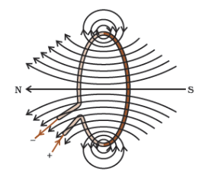

**Figure 13.8** Circular loopagnetic field lines of the field produced by a current-carrying circular loop.

##### Activity 13.6

Take a rectangular cardboard having two holes. Insert a circular coil having large number of turns through them, normal to the plane of the cardboard.

Connect the ends of the coil in series with a battery, a key and a rheostat, as shown in Fig. 13.9.

Sprinkle iron filings uniformly on the cardboard.

Plug the key.

Tap the cardboard gently a few times. Note the pattern of the iron filings that emerges on the cardboard.

#### 13.2.4 - Magnetic Field due to a Current in a Solenoid

A coil of many circular turns of insulated copper wire wrapped closely in the shape of a cylinder is called a solenoid. The pattern of the magnetic field lines around a current-carrying solenoid is shown in Fig. 13.10. Compare the pattern of the field with the magnetic field around a bar magnet (Fig. 13.4). Do they look similar? Yes, they are similar. In fact, one end of the solenoid behaves as a magnetic north pole, while the other behaves as the south pole. The field lines inside the solenoid are in the form of parallel straight lines. This indicates that the magnetic field is the same at all points inside the solenoid. That is, the field is uniform inside the solenoid.

A strong magnetic field produced inside a solenoid can be used to magnetise a piece of magnetic material, like soft iron, when placed inside the coil (Fig. 13.11). The magnet so formed is called an electromagnet.

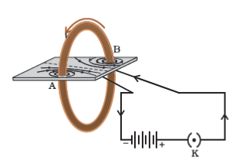

**Figure 13.9** Magnetic field produced by a current-carrying circular coil.

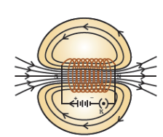

**Figure 13.10** Field lines of the magnetic field through and around a current carrying solenoid.

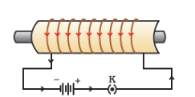

**Figure 13.11** A current-carrying solenoid coil is used to magnetise steel rod inside it – an electromagnet.

#### Questions

Consider a circular loop of wire lying in the plane of the table. Let the current pass through the loop clockwise. Apply the right-hand rule to find out the direction of the magnetic field inside and outside the loop.

The magnetic field in a given region is uniform. Draw a diagram to represent it.

Choose the correct option.

The magnetic field inside a long straight solenoid-carrying current

is zero.

decreases as we move towards its end.

increases as we move towards its end.

is the same at all points.

### 13.3 - Force On A Current-Carrying Conductor In A Magnetic Field

We have learnt that an electric current flowing through a conductor produces a magnetic field. The field so produced exerts a force on a magnet placed in the vicinity of the conductor. French scientist Andre Marie Ampere (1775–1836) suggested that the magnet must also exert an equal and opposite force on the current-carrying conductor. The force due to a magnetic field acting on a current-carrying conductor can be demonstrated through the following activity.

#### Activity 13.7

Take a small aluminium rod AB (of about 5 cm). Using two connecting wires suspend it horizontally from a stand, as shown in Fig. 13.12.

Place a strong horse-shoe magnet in such a way that the rod lies between the two poles with the magnetic field directed upwards. For this put the north pole of the magnet vertically below and south pole vertically above the aluminium rod (Fig. 13.12).

Connect the aluminium rod in series with a battery, a key and a rheostat.

Now pass a current through the aluminium rod from end B to end A.

What do you observe? It is observed that the rod is displaced towards the left. You will notice that the rod gets displaced.

Reverse the direction of current flowing through the rod and observe the direction of its displacement. It is now towards the right.

Why does the rod get displaced?

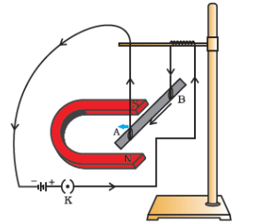

**Figure 13.12** A current-carrying rod, AB, experiences a force perpendicular to its length and the magnetic field. Support for the magnet is not shown here, for simplicity.

The displacement of the rod in the above activity suggests that a force is exerted on the current-carrying aluminium rod when it is placed in a magnetic field. It also suggests that the direction of force is also reversed when the direction of current through the conductor is reversed. Now change the direction of field to vertically downwards by interchanging the two poles of the magnet. It is once again observed that the direction of force acting on the current-carrying rod gets reversed. It shows that the direction of the force on the conductor depends upon the direction of current and the direction of the magnetic field. Experiments have shown that the displacement of the rod is largest (or the magnitude of the force is the highest) when the direction of current is at right angles to the direction of the magnetic field. In such a condition we can use a simple rule to find the direction of the force on the conductor.

In Activity 13.7, we considered the direction of the current and that of the magnetic field perpendicular to each other and found that the force is perpendicular to both of them. The three directions can be illustrated through a simple rule, called Fleming’s left-hand rule. According to this rule, stretch the thumb, forefinger and middle finger of your left hand such that they are mutually perpendicular (Fig. 13.13). If the first finger points in the direction of magnetic field and the second finger in the direction of current, then the thumb will point in the direction of motion or the force acting on the conductor.

Devices that use current-carrying conductors and magnetic fields include electric motor, electric generator, loudspeakers, microphones and measuring instruments. In the next few sections we shall study about electric motors and generators.

**Example 13.2**

An electron enters a magnetic field at right angles to it, as shown in Fig. 13.14. The direction of force acting on the electron will be

to the right.

to the left.

out of the page.

into the page.

**Solution**

Answer is option (d). The direction of force is perpendicular to the direction of magnetic field and current as given by Fleming’s left hand rule. Recall that the direction of current is taken opposite to the direction of motion of electrons. The force is therefore directed into the page.

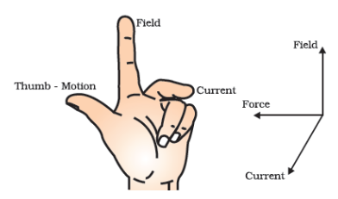

**Figure 13.13** Fleming’s left-hand rule

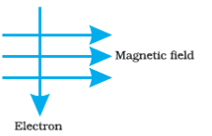

Figure 13.14

#### Questions

Which of the following property of a proton can change while it moves freely in a magnetic field? (There may be more than one correct answer.)

mass

speed

velocity

momentum

In Activity 13.7, how do we think the displacement of rod AB will be affected if (i) current in rod AB is increased; (ii) a stronger horse-shoe magnet is used; and (iii) length of the rod AB is increased?

A positively-charged particle (alpha-particle) projected towards west is deflected towards north by a magnetic field. The direction of magnetic field is

towards south

towards east

downward

upward

#### More to know!

**Magnetism in medicine**

An electric current always produces a magnetic field. Even weak ion currents that travel along the nerve cells in our body produce magnetic fields. When we touch something, our nerves carry an electric impulse to the muscles we need to use. This impulse produces a temporary magnetic field. These fields are very weak and are about one-billionth of the earth’s magnetic field. Two main organs in the human body where the magnetic field produced is significant, are the heart and the brain. The magnetic field inside the body forms the basis of obtaining the images of different body parts. This is done using a technique called Magnetic Resonance Imaging (MRI). Analysis of these images helps in medical diagnosis. Magnetism has, thus, got important uses in medicine.

### 13.4 - Electric Motor

An electric motor is a rotating device that converts electrical energy to mechanical energy. Electric motor is used as an important component in electric fans, refrigerators, mixers, washing machines, computers, MP3 players etc. Do you know how an electric motor works?

An electric motor, as shown in Fig. 13.15, consists of a rectangular coil ABCD of insulated copper wire. The coil is placed between the two poles of a magnetic field such that the arm AB and CD are perpendicular to the direction of the magnetic field. The ends of the coil are connected to the two halves Ρ and Q of a split ring. The inner sides of these halves are insulated and attached to an axle. The external conducting edges of Ρ and Q touch two conducting stationary brushes X and Y, respectively, as shown in the Fig. 13.15.

Current in the coil ABCD enters from the source battery through conducting brush X and flows back to the battery through brush Y. Notice that the current in arm AB of the coil flows from A to B. In arm CD it flows from C to D, that is, opposite to the direction of current through arm AB. On applying Fleming’s left hand rule for the direction of force on a current-carrying conductor in a magnetic field (see Fig. 13.13). We find that the force acting on arm AB pushes it downwards while the force acting on arm CD pushes it upwards. Thus the coil and the axle O, mounted free to turn about an axis, rotate anti-clockwise. At half rotation, Q makes contact with the brush X and Ρ with brush Y. Therefore the current in the coil gets reversed and flows along the path DCBA. A device that reverses the direction of flow of current through a circuit is called a commutator. In electric motors, the split ring acts as a commutator. The reversal of current also reverses the direction of force acting on the two arms AB and CD. Thus the arm AB of the coil that was earlier pushed down is now pushed up and the arm CD previously pushed up is now pushed down. Therefore the coil and the axle rotate half a turn more in the same direction. The reversing of the current is repeated at each half rotation, giving rise to a continuous rotation of the coil and to the axle.

The commercial motors use (i) an electromagnet in place of permanent magnet; (ii) large number of turns of the conducting wire in the current-carrying coil; and (iii) a soft iron core on which the coil is wound. The soft iron core, on which the coil is wound, plus the coils, is called an armature. This enhances the power of the motor.

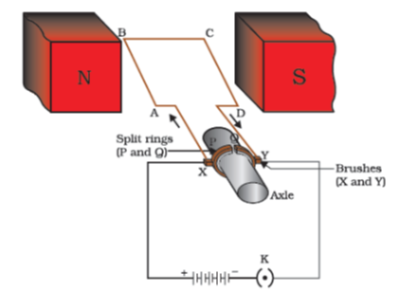

**Figure 13.15** A simple electric motor

#### Questions

State Fleming’s left-hand rule.

What is the principle of an electric motor?

What is the role of the split ring in an electric motor?

### 13.5 - Electromagnetic Induction

We have studied that when a current-carrying conductor is placed in a magnetic field such that the direction of current is perpendicular to the magnetic field, it experiences a force. This force causes the conductor to move. Now let us imagine a situation in which a conductor is moving inside a magnetic field or a magnetic field is changing around a fixed conductor. What will happen? This was first studied by English physicist Michael Faraday. In 1831, Faraday made an important breakthrough by discovering how a moving magnet can be used to generate electric currents. To observe this effect, let us perform the following activity.

#### Activity 13.8

Take a coil of wire AB having a large number of turns.

Connect the ends of the coil to a galvanometer as shown in Fig. 13.16.

Take a strong bar magnet and move its north pole towards the end B of the coil. Do you find any change in the galvanometer needle?

There is a momentary deflection in the needle of the galvanometer, say to the right. This indicates the presence of a current in the coil AB. The deflection becomes zero the moment the motion of the magnet stops.

Now withdraw the north pole of the magnet away from the coil. Now the galvanometer is deflected toward the left, showing that the current is now set up in the direction opposite to the first.

Place the magnet stationary at a point near to the coil, keeping its north pole towards the end B of the coil. We see that the galvanometer needle deflects toward the right when the coil is moved towards the north pole of the magnet. Similarly the needle moves toward left when the coil is moved away.

When the coil is kept stationary with respect to the magnet, the deflection of the galvanometer drops to zero. What do you conclude from this activity?

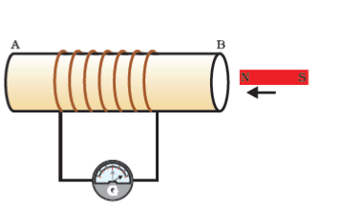

**Figure 13.16** Moving a magnet towards a coil sets up a current in the coil circuit, as indicated by deflection in the galvanometer needle.

A galvanometer is an instrument that can detect the presence of a current in a circuit. The pointer remains at zero (the centre of the scale) for zero current flowing through it. It can deflect either to the left or to the right of the zero mark depending on the direction of current.

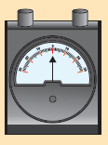

You can also check that if you had moved south pole of the magnet towards the end B of the coil, the deflections in the galvanometer would just be opposite to the previous case. When the coil and the magnet are both stationary, there is no deflection in the galvanometer. It is, thus, clear from this activity that motion of a magnet with respect to the coil produces an induced potential difference, which sets up an induced electric current in the circuit.

**Michael Faraday (1791–1867)**

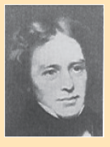

Michael Faraday was an experimental physicist. He had no formal education. He worked in a book-binding shop during his early years. He used to read books that came for binding. This way Faraday developed his interest in science. He got an opportunity to listen to some public lectures by Humphrey Davy of Royal Institute. He made careful notes of Davy’s lectures and sent them to Davy. Soon he was made an assistant in Davy’s laboratory at the Royal Institute. Faraday made several path-breaking discoveries that include electromagnetic induction and the laws of electrolysis. Several universities conferred on him the honorary degrees but he turned down such honours. Faraday loved his science work more than any honour.

Let us now perform a variation of Activity 13.8 in which the moving magnet is replaced by a current-carrying coil and the current in the coil can be varied.

#### Activity 13.9

Take two different coils of copper wire having large number of turns (say 50 and 100 turns respectively). Insert them over a non-conducting cylindrical roll, as shown in Fig. 13.17. (You may use a thick paper roll for this purpose.)

Connect the coil-1, having larger number of turns, in series with a battery and a plug key. Also connect the other coil-2 with a galvanometer as shown.

Plug in the key. Observe the galvanometer. Is there a deflection in its needle? You will observe that the needle of the galvanometer instantly jumps to one side and just as quickly returns to zero, indicating a momentary current in coil-2.

Disconnect coil-1 from the battery. You will observe that the needle momentarily moves, but to the opposite side. It means that now the current flows in the opposite direction in coil-2.

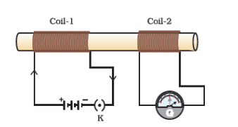

**Figure 13.17** Current is induced in coil-2 when current in coil-1 is changed

In this activity we observe that as soon as the current in coil-1 reaches either a steady value or zero, the galvanometer in coil-2 shows no deflection.

From these observations, we conclude that a potential difference is induced in the coil-2 whenever the electric current through the coil–1 is changing (starting or stopping). Coil-1 is called the primary coil and coil-2 is called the secondary coil. As the current in the first coil changes, the magnetic field associated with it also changes. Thus the magnetic field lines around the secondary coil also change. Hence the change in magnetic field lines associated with the secondary coil is the cause of induced electric current in it. This process, by which a changing magnetic field in a conductor induces a current in another conductor, is called electromagnetic induction. In practice we can induce current in a coil either by moving it in a magnetic field or by changing the magnetic field around it. It is convenient in most situations to move the coil in a magnetic field.

The induced current is found to be the highest when the direction of motion of the coil is at right angles to the magnetic field. In this situation, we can use a simple rule to know the direction of the induced current. Stretch the thumb, forefinger and middle finger of right hand so that they are perpendicular to each other, as shown in Fig. 13.18. If the forefinger indicates the direction of the magnetic field and the thumb shows the direction of motion of conductor, then the middle finger will show the direction of induced current. This simple rule is called Fleming’s right-hand rule.

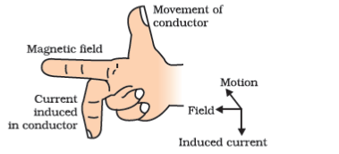

**Figure 13.18** Fleming’s right-hand rule

#### Questions

Explain different ways to induce current in a coil.

### 13.6 - Electric Generator

Based on the phenomenon of electromagnetic induction, the experiments studied above generate induced current, which is usually very small. This principle is also employed to produce large currents for use in homes and industry. In an electric generator, mechanical energy is used to rotate a conductor in a magnetic field to produce electricity.

An electric generator, as shown in Fig. 13.19, consists of a rotating rectangular coil ABCD placed between the two poles of a permanent magnet. The two ends of this coil are connected to the two rings R1R_{1}

and R2R_{2}

. The inner side of these rings are made insulated. The two conducting stationary brushes B1B_{1}

and B2B_{2}

are kept pressed separately on the rings R1R_{1}

and R2R_{2}

, respectively. The two rings R1R_{1}

and R2R_{2}

are internally attached to an axle. The axle may be mechanically rotated from outside to rotate the coil inside the magnetic field. Outer ends of the two brushes are connected to the galvanometer to show the flow of current in the given external circuit.

When the axle attached to the two rings is rotated such that the arm AB moves up (and the arm CD moves down) in the magnetic field produced by the permanent magnet. Let us say the coil ABCD is rotated clockwise in the arrangement shown in Fig. 13.19. By applying Fleming’s right-hand rule, the induced currents are set up in these arms along the directions AB and CD. Thus an induced current flows in the direction ABCD. If there are larger numbers of turns in the coil, the current generated in each turn adds up to give a large current through the coil. This means that the current in the external circuit flows from B2B_{2}

to B1B_{1}

.

After half a rotation, arm CD starts moving up and AB moving down. As a result, the directions of the induced currents in both the arms change, giving rise to the net induced current in the direction DCBA. The current in the external circuit now flows from B1B_{1}

to B2B_{2}

. Thus after every half rotation the polarity of the current in the respective arms changes. Such a current, which changes direction after equal intervals of time, is called an alternating current (abbreviated as AC). This device is called an AC generator.

To get a direct current (DC, which does not change its direction with time), a split-ring type commutator must be used. With this arrangement, one brush is at all times in contact with the arm moving up in the field, while the other is in contact with the arm moving down. We have seen the working of a split ring commutator in the case of an electric motor (see Fig. 13.15). Thus a unidirectional current is produced. The generator is thus called a DC generator.

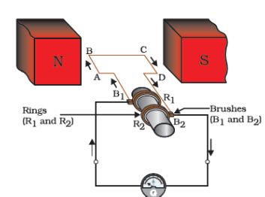

**Figure 13.19** Illustration of the principle of electric generator

The difference between the direct and alternating currents is that the direct current always flows in one direction, whereas the alternating current reverses its direction periodically. Most power stations constructed these days produce AC. In India, the AC changes direction after every 1/1001/100

second, that is, the frequency of AC is 50 Hz. An important advantage of AC over DC is that electric power can be transmitted over long distances without much loss of energy.

#### Questions

State the principle of an electric generator.

Name some sources of direct current.

Which sources produce alternating current?

Choose the correct option.

A rectangular coil of copper wires is rotated in a magnetic field. The direction of the induced current changes once in each

two revolutions

one revolution

half revolution

one-fourth revolution

### 13.7 - Domestic Electric Circuits

In our homes, we receive supply of electric power through a main supply (also called mains), either supported through overhead electric poles or by underground cables. One of the wires in this supply, usually with red insulation cover, is called live wire (or positive). Another wire, with black insulation, is called neutral wire (or negative). In our country, the potential difference between the two is 220 V.

At the meter-board in the house, these wires pass into an electricity meter through a main fuse. Through the main switch they are connected to the line wires in the house. These wires supply electricity to separate circuits within the house. Often, two separate circuits are used, one of 15 A current rating for appliances with higher power ratings such as geysers, air coolers, etc. The other circuit is of 5 A current rating for bulbs, fans, etc. The earth wire, which has insulation of green colour, is usually connected to a metal plate deep in the earth near the house. This is used as a safety measure, especially for those appliances that have a metallic body, for example, electric press, toaster, table fan, refrigerator, etc. The metallic body is connected to the earth wire, which provides a low-resistance conducting path for the current. Thus, it ensures that any leakage of current to the metallic body of the appliance keeps its potential to that of the earth, and the user may not get a severe electric shock.

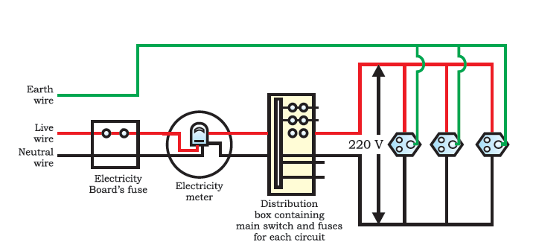

**Figure 13.20** A schematic diagram of one of the common domestic circuits

Figure 13.20 gives a schematic diagram of one of the common domestic circuits. In each separate circuit, different appliances can be connected across the live and neutral wires. Each appliance has a separate switch to ‘ON’/’OFF’ the flow of current through it. In order that each appliance has equal potential difference, they are connected parallel to each other.

Electric fuse is an important component of all domestic circuits. We have already studied the principle and working of a fuse in the previous chapter (see Section 12.7). A fuse in a circuit prevents damage to the appliances and the circuit due to overloading. Overloading can occur when the live wire and the neutral wire come into direct contact. (This occurs when the insulation of wires is damaged or there is a fault in the appliance.) In such a situation, the current in the circuit abruptly increases. This is called short-circuiting. The use of an electric fuse prevents the electric circuit and the appliance from a possible damage by stopping the flow of unduly high electric current. The Joule heating that takes place in the fuse melts it to break the electric circuit. Overloading can also occur due to an accidental hike in the supply voltage. Sometimes overloading is caused by connecting too many appliances to a single socket.

#### Questions

Name two safety measures commonly used in electric circuits and appliances.

An electric oven of 2 kW power rating is operated in a domestic electric circuit (220 V) that has a current rating of 5 A. What result do you expect? Explain.

What precaution should be taken to avoid the overloading of domestic electric circuits?

### What you have learnt

A compass needle is a small magnet. Its one end, which points towards north, is called a north pole, and the other end, which points towards south, is called a south pole.

A magnetic field exists in the region surrounding a magnet, in which the force of the magnet can be detected.

Field lines are used to represent a magnetic field. A field line is the path along which a hypothetical free north pole would tend to move. The direction of the magnetic field at a point is given by the direction that a north pole placed at that point would take. Field lines are shown closer together where the magnetic field is greater.

A metallic wire carrying an electric current has associated with it a magnetic field. The field lines about the wire consist of a series of concentric circles whose direction is given by the right-hand rule.

The pattern of the magnetic field around a conductor due to an electric current flowing through it depends on the shape of the conductor. The magnetic field of a solenoid carrying a current is similar to that of a bar magnet.

An electromagnet consists of a core of soft iron wrapped around with a coil of insulated copper wire.

A current-carrying conductor when placed in a magnetic field experiences a force. If the direction of the field and that of the current are mutually perpendicular to each other, then the force acting on the conductor will be perpendicular to both and will be given by Fleming’s left-hand rule. This is the basis of an electric motor. An electric motor is a device that converts electric energy into mechanical energy.

The phenomenon of electromagnetic induction is the production of induced current in a coil placed in a region where the magnetic field changes with time. The magnetic field may change due to a relative motion between the coil and a magnet placed near to the coil. If the coil is placed near to a current-carrying conductor, the magnetic field may change either due to a change in the current through the conductor or due to the relative motion between the coil and conductor. The direction of the induced current is given by the Fleming’s right-hand rule.

A generator converts mechanical energy into electrical energy. It works on the basis of electromagnetic induction.

In our houses we receive AC electric power of 220 V with a frequency of 50 Hz. One of the wires in this supply is with red insulation, called live wire. The other one is of black insulation, which is a neutral wire. The potential difference between the two is 220 V. The third is the earth wire that has green insulation and this is connected to a metallic body deep inside earth. It is used as a safety measure to ensure that any leakage of current to a metallic body does not give any severe shock to a user.

Fuse is the most important safety device, used for protecting the circuits due to short-circuiting or overloading of the circuits.

### Exercises

Which of the following correctly describes the magnetic field near a long straight wire?

The field consists of straight lines perpendicular to the wire.

The field consists of straight lines parallel to the wire.

The field consists of radial lines originating from the wire.

The field consists of concentric circles centred on the wire.

The phenomenon of electromagnetic induction is

the process of charging a body.

the process of generating magnetic field due to a current passing through a coil.

producing induced current in a coil due to relative motion between a magnet and the coil.

the process of rotating a coil of an electric motor.

The device used for producing electric current is called a

generator.

galvanometer.

ammeter.

motor.

The essential difference between an AC generator and a DC generator is that

AC generator has an electromagnet while a DC generator has permanent magnet.

DC generator will generate a higher voltage.

AC generator will generate a higher voltage.

AC generator has slip rings while the DC generator has a commutator.

At the time of short circuit, the current in the circuit

reduces substantially.

does not change.

increases heavily.

vary continuously.

State whether the following statements are true or false.

An electric motor converts mechanical energy into electrical energy.

An electric generator works on the principle of electromagnetic induction.

The field at the centre of a long circular coil carrying current will be parallel straight lines.

A wire with a green insulation is usually the live wire of an electric supply.

List two methods of producing magnetic fields.

How does a solenoid behave like a magnet? Can you determine the north and south poles of a current–carrying solenoid with the help of a bar magnet? Explain.

When is the force experienced by a current–carrying conductor placed in a magnetic field largest?

Imagine that you are sitting in a chamber with your back to one wall. An electron beam, moving horizontally from back wall towards the front wall, is deflected by a strong magnetic field to your right side. What is the direction of magnetic field?

Draw a labelled diagram of an electric motor. Explain its principle and working. What is the function of a split ring in an electric motor?

Name some devices in which electric motors are used.

A coil of insulated copper wire is connected to a galvanometer. What will happen if a bar magnet is (i) pushed into the coil, (ii) withdrawn from inside the coil, (iii) held stationary inside the coil?

Two circular coils A and B are placed closed to each other. If the current in the coil A is changed, will some current be induced in the coil B? Give reason.

State the rule to determine the direction of a (i) magnetic field produced around a straight conductor-carrying current, (ii) force experienced by a current-carrying straight conductor placed in a magnetic field which is perpendicular to it, and (iii) current induced in a coil due to its rotation in a magnetic field.

Explain the underlying principle and working of an electric generator by drawing a labelled diagram. What is the function of brushes?

When does an electric short circuit occur?

What is the function of an earth wire? Why is it necessary to earth metallic appliances?

## Chapter 14 – Sources of Energy



1064CH14

In Class IX, we learnt that the total energy during a physical or chemical process is conserved. Why, then, do we hear so much about the energy crisis? If energy can neither be created nor destroyed, we should have no worries! We should be able to perform endless activities without thinking about energy resources!

This riddle can be solved if we recall what else we learnt about energy. Energy comes in different forms and one form can be converted to another. For example, if we drop a plate from a height, the potential energy of the plate is converted mostly to sound energy when it hits the ground. If we light a candle, the process is highly exothermic so that the chemical energy in the wax is converted to heat energy and light energy on burning. What other products are obtained when we burn a candle?

The total energy during a physical or chemical process remains the same but suppose we consider the burning candle again – can we somehow put together the heat and light generated along with the products of the reaction to get back the chemical energy in the form of wax?

Let us consider another example. Suppose we take 100 mL of water which has a temperature of 348 K (75°C) and leave it in a room where the temperature is 298 K (25°C). What will happen? Is there any way of collecting all the heat lost to the environment and making the water hot once it has cooled down?

In any example that we consider, we will see that energy, in the usable form, is dissipated to the surroundings in less usable forms. Hence, any source of energy we use, to do work, is consumed and cannot be used again.

### 14.1 - What Is A Good Source Of Energy?

What can then be considered a good source of energy? We, in our daily lives, use energy from various sources for doing work. We use diesel to run our trains. We use electricity to light our street-lamps. Or we use energy in our muscles to cycle to school.

#### Activity 14.1

List four forms of energy that you use from morning, when you wake up, till you reach the school.

From where do we get these different forms of energy?

Can we call these ‘sources’ of energy? Why or why not?

The muscular energy for carrying out physical work, electrical energy for running various appliances, chemical energy for cooking food or running a vehicle all come from some source. We need to know how do we select the source needed for obtaining the energy in its usable form.

#### Activity 14.2

Consider the various options we have when we choose a fuel for cooking our food.

What are the criteria you would consider when trying to categorise something as a good fuel?

Would your choice be different if you lived

in a forest?

in a remote mountain village or small island?

in New Delhi?

lived five centuries ago?

How are the factors different in each case?

After going through the two activities above, we can see that the particular source of energy, or fuel, we select for performing some work depends on many different factors. For example, while selecting a fuel, we would ask ourselves the following questions.

How much heat does it release on burning?

Does it produce a lot of smoke?

Is it easily available?

Can you think of three more relevant questions to ask about a fuel?

Given the range of fuels we have today, what are the factors which would limit our choices when it comes to a particular task like cooking our food? Would the fuel selected also depend on the work to be done? For example, would we choose one fuel for cooking and another for heating the room in winter?

We could then say that a good source of energy would be one

which would do a large amount of work per unit volume or mass,

be easily accessible,

be easy to store and transport, and

perhaps most importantly, be economical.

#### Questions

What is a good source of energy?

What is a good fuel?

If you could use any source of energy for heating your food, which one would you use and why?

### 14.2 - Conventional Sources Of Energy

#### 14.2.1 - Fossil Fuels

In ancient times, wood was the most common source of heat energy. The energy of flowing water and wind was also used for limited activities. Can you think of some of these uses? The exploitation of coal as a source of energy made the industrial revolution possible. Increasing industrialisation has led to a better quality of life all over the world. It has also caused the global demand for energy to grow at a tremendous rate. The growing demand for energy was largely met by the fossil fuels – coal and petroleum. Our technologies were also developed for using these energy sources. But these fuels were formed over millions of years ago and there are only limited reserves. The fossil fuels are non-renewable sources of energy, so we need to conserve them. If we were to continue consuming these sources at such alarming rates, we would soon run out of energy! In order to avoid this, alternate sources of energy were explored. But we continue to be largely dependent on fossil fuels for most of our energy requirements (Fig. 14.1).

Burning fossil fuels has other disadvantages too. We learnt in Class IX about the air pollution caused by burning of coal or petroleum products. The oxides of carbon, nitrogen and sulphur that are released on burning fossil fuels are acidic oxides. These lead to acid rain which affects our water and soil resources. In addition to the problem of air pollution, recall the green-house effect of gases like carbon dioxide.

The pollution caused by burning fossil fuels can be somewhat reduced by increasing the efficiency of the combustion process and using various techniques to reduce the escape of harmful gases and ashes into the surroundings. Besides being used directly for various purposes – in gas stoves and vehicles, do you know fossil fuels are the major fuels used for generating electricity? Let us produce some electricity at our own small plant in the class and see what goes into producing our favourite form of energy.

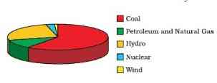

**Figure 14.1** Pie-chart showing the major sources of energy for our requirements in India

##### Think it over

How would our lives change if we could no longer get electricity supply?

The availability of electrical energy to each individual in a country is one of the parameters to measure the growth of the country.

##### Activity 14.3

Take a table-tennis ball and make three slits into it.

Put semicircular fins cut out of a metal sheet into these slits.

Pivot the tennis ball on an axle through its centre with a straight metal wire fixed to a rigid support. Ensure that the tennis ball rotates freely about the axle.

Now connect a cycle dynamo to this.

Connect a bulb in series.

Direct a jet of water or steam produced in a pressure cooker at the fins (Fig. 14.2). What do you observe?

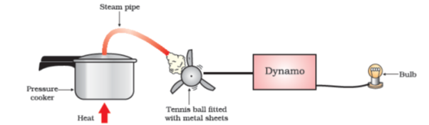

**Figure 14.2** A model to demonstrate the process of thermoelectric production

This is our turbine for generating electricity. The simplest turbines have one moving part, a rotor-blade assembly. The moving fluid acts on the blades to spin them and impart energy to the rotor. Thus, we see that basically we need to move the fan, the rotor blade, with speed which would turn the shaft of the dynamo and convert the mechanical energy into electrical energy — the form of energy which has become a necessity in today’s scenario. The various ways in which this can be done depends upon availability of the resources. We will see how various sources of energy can be harnessed to run the turbine and generate electricity in the following sections.

#### 14.2.2 - Thermal Power Plant

Large amount of fossil fuels are burnt every day in power stations to heat up water to produce steam which further runs the turbine to generate electricity. The transmission of electricity is more efficient than transporting coal or petroleum over the same distance. Therefore, many thermal power plants are set up near coal or oil fields. The term thermal power plant is used since fuel is burnt to produce heat energy which is converted into electrical energy.

#### 14.2.3 - Hydro Power Plants

Another traditional source of energy was the kinetic energy of flowing water or the potential energy of water at a height. Hydro power plants convert the potential energy of falling water into electricity. Since there are very few water-falls which could be used as a source of potential energy, hydro power plants are associated with dams. In the last century, a large number of dams were built all over the world. As we can see from Fig. 14.1, a quarter of our energy requirement in India is met by hydro power plants.

In order to produce hydel electricity, high-rise dams are constructed on the river to obstruct the flow of water and thereby collect water in larger reservoirs. The water level rises and in this process the kinetic energy of flowing water gets transformed into potential energy. The water from the high level in the dam is carried through pipes, to the turbine, at the bottom of the dam (Fig. 14.3). Since the water in the reservoir would be refilled each time it rains (hydro power is a renewable source of energy) we would not have to worry about hydro electricity sources getting used up the way fossil fuels would get finished one day.

But, constructions of big dams have certain problems associated with it. The dams can be constructed only in a limited number of places, preferably in hilly terrains. Large areas of agricultural land and human habitation are to be sacrificed as they get submerged. Large eco-systems are destroyed when submerged under the water in dams. The vegetation which is submerged rots under anaerobic conditions and gives rise to large amounts of methane which is also a green-house gas. It creates the problem of satisfactory rehabilitation of displaced people. Opposition to the construction of Tehri Dam on the river Ganga and Sardar Sarovar project on the river Narmada are due to such problems.

#### 14.2.4 - Improvements in the Technology for using Conventional Sources of Energy

**Bio-Mass**

We mentioned earlier that wood has been used as a fuel for a long time. If we can ensure that enough trees are planted, a continuous supply of fire-wood can be assured. You must also be familiar with the use of cow-dung cakes as a fuel. Given the large live-stock population in India, this can also assure us a steady source of fuel. Since these fuels are plant and animal products, the source of these fuels is said to be bio-mass. These fuels, however, do not produce much heat on burning and a lot of smoke is given out when they are burnt. Therefore, technological inputs to improve the efficiency of these fuels are necessary. When wood is burnt in a limited supply of oxygen, water and volatile materials present in it get removed and charcoal is left behind as the residue. Charcoal burns without flames, is comparatively smokeless and has a higher heat generation efficiency.

Similarly, cow-dung, various plant materials like the residue after harvesting the crops, vegetable waste and sewage are decomposed in the absence of oxygen to give bio-gas. Since the starting material is mainly cow-dung, it is popularly known as ‘*gobar-gas’*. Bio-gas is produced in a plant as shown in Fig. 14.4.

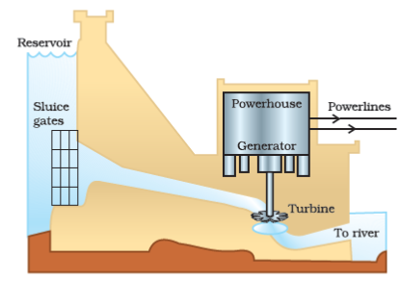

**Figure 14.3** A schematic view of a hydro power plant

The plant has a dome-like structure built with bricks. A slurry of cow-dung and water is made in the mixing tank from where it is fed into the digester. The digester is a sealed chamber in which there is no oxygen. Anaerobic micro-organisms that do not require oxygen decompose or break down complex compounds of the cow-dung slurry. It takes a few days for the decomposition process to be complete and generate gases like methane, carbon dioxide, hydrogen and hydrogen sulphide. The bio-gas is stored in the gas tank above the digester from which they are drawn through pipes for use.

Bio-gas is an excellent fuel as it contains up to 75% methane. It burns without smoke, leaves no residue like ash in wood, charcoal and coal burning. Its heating capacity is high. Bio-gas is also used for lighting. The slurry left behind is removed periodically and used as excellent manure, rich in nitrogen and phosphorous. The large-scale utilisation of bio-waste and sewage material provides a safe and efficient method of waste-disposal besides supplying energy and manure. Do you think that bio-mass is a renewable source of energy?

**Wind Energy**

We saw in Class IX how unequal heating of the landmass and water bodies by solar radiation generates air movement and causes winds to blow. This kinetic energy of the wind can be used to do work. This energy was harnessed by windmills in the past to do mechanical work. For example, in a water-lifting pump, the rotatory motion of windmill is utilised to lift water from a well. Today, wind energy is also used to generate electricity. A windmill essentially consists of a structure similar to a large electric fan that is erected at some height on a rigid support (Fig. 14.5).

To generate electricity, the rotatory motion of the windmill is used to turn the turbine of the electric generator. The output of a single windmill is quite small and cannot be used for commercial purposes. Therefore, a number of windmills are erected over a large area, which is known as wind energy farm. The energy output of each windmill in a farm is coupled together to get electricity on a commercial scale.

##### Do you know!

Denmark is called the country of ‘winds’. More than 25% of their electricity needs are generated through a vast network of windmills. In terms of total output, Germany is the leader, while India is ranked fifth in harnessing wind energy for the production of electricity. It is estimated that nearly 45,000 MW of electrical power can be generated if India’s wind potential is fully exploited. The largest wind energy farm has been established near Kanyakumari in Tamil Nadu and it generates 380 MW of electricity.

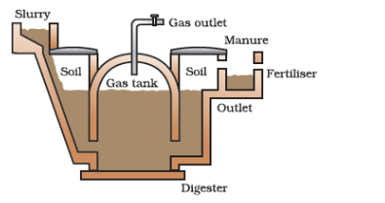

**Figure 14.4** Schematic diagram of a bio-gas plant

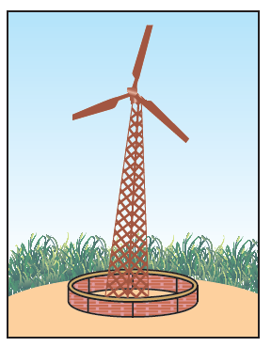

Figure 14.5 A windmill

Wind energy is an environment-friendly and efficient source of renewable energy. It requires no recurring expenses for the production of electricity. But there are many limitations in harnessing wind energy. Firstly, wind energy farms can be established only at those places where wind blows for the greater part of a year. The wind speed should also be higher than 15 km/h to maintain the required speed of the turbine. Furthermore, there should be some back-up facilities (like storage cells) to take care of the energy needs during a period when there is no wind. Establishment of wind energy farms requires large area of land. For a 1 MW generator, the farm needs about 2 hectares of land. The initial cost of establishment of the farm is quite high. Moreover, since the tower and blades are exposed to the vagaries of nature like rain, Sun, storm and cyclone, they need a high level of maintenance.

#### Questions

What are the disadvantages of fossil fuels?

Why are we looking at alternate sources of energy?

How has the traditional use of wind and water energy been modified for our convenience?

### 14.3 - Alternative Or Non-Conventional Sources Of Energy

With technological progress, our demand for energy increases day by day. Our life-styles are also changing, we use machines to do more and more of our tasks. Our basic requirements are also increasing as industrialisation improves our living standards.

#### Activity 14.4

Find out from your grand-parents or other elders –

how did they go to school?

how did they get water for their daily needs when they were young?

what means of entertainment did they use?

Compare the above answers with how you do these tasks now.

Is there a difference? If yes, in which case more energy from external sources is consumed?

As our demand for energy increases, we need to look for more and more sources of energy. We could develop the technology to use the available or known sources of energy more efficiently and also look to new sources of energy. Any new source of energy we seek to exploit would need specific devices developed with that source in mind. We shall now look at some of the latest sources of energy that we seek to tap, and the technology designed to capture and store energy from that source.

##### Think it over!

Some people say that if we start living as our ancestors, this would conserve energy and our ecosystem. Do you think this idea is feasible?

#### 14.3.1 - Solar Energy

The Sun has been radiating an enormous amount of energy at the present rate for nearly 5 billion years and will continue radiating at that rate for about 5 billion years more. Only a small part of solar energy reaches the outer layer of the earth’s atmosphere. Nearly half of it is absorbed while passing through the atmosphere and the rest reaches the earth’s surface.

A black surface absorbs more heat as compared to a white or a reflecting surface under identical conditions. Solar cookers (Fig. 14.6) and solar water heaters use this property in their working. Some solar cookers achieve a higher temperature by using mirrors to focus the rays of the Sun. Solar cookers are covered with a glass plate. Recall what we have learnt about the green-house effect. Does this explain why a glass plate is used?

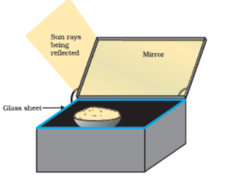

**Figure 14.6** A solar cooker

It is easy to see that these devices are useful only at certain times during the day. This limitation of using solar energy is overcome by using solar cells that convert solar energy into electricity. A typical cell develops a voltage of 0.5-1V and can produce about 0.7 W of electricity when exposed to the Sun. A large number of solar cells are, combined in an arrangement called solar cell panel (Fig. 14.7) that can deliver enough electricity for practical use.

The principal advantages associated with solar cells are that they have no moving parts, require little maintenance and work quite satisfactorily without the use of any focussing device. Another advantage is that they can be set up in remote and inaccessible hamlets or very sparsely inhabited areas in which laying of a power transmission line may be expensive and not commercially viable.

Silicon, which is used for making solar cells, is abundant in nature but availability of the special grade silicon for making solar cells is limited. The entire process of manufacture is still very expensive, silver used for interconnection of the cells in the panel further adds to the cost. In spite of the high cost and low efficiency, solar cells are used for many scientific and technological applications. Artificial satellites and space probes like Mars orbiters use solar cells as the main source of energy. Radio or wireless transmission systems or TV relay stations in remote locations use solar cell panels. Traffic signals, calculators and many toys are fitted with solar cells. The solar cell panels are mounted on specially designed inclined roof tops so that more solar energy is incident over it. The domestic use of solar cells is, however, limited due to its high cost.

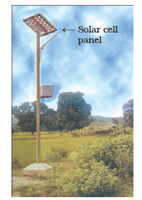

**Figure 14.7** A solar cell panel

##### Do you know?

India is lucky to receive solar energy for greater part of the year. It is estimated that during a year India receives the energy equivalent to more than 5,000 trillion kWh. Under clear (cloudless) sky conditions, the daily average varies from 4 to 7kWh/m27kWh/m^{2}\

. The solar energy reaching unit area at outer edge of the earth’s atmosphere exposed perpendicularly to the rays of the Sun at the average distance between the Sun and earth is known as the solar constant. It is estimated to be approximately 1.4 kJ per second per square metre or 1.4kW/m21.4kW/m^{2}\

.

##### Activity 14.5

Take two conical flasks and paint one white and the other black. Fill both with water.

Place the conical flasks in direct sunlight for half an hour to one hour.

Touch the conical flasks. Which one is hotter? You could also measure the temperature of the water in the two conical flasks with a thermometer.

Can you think of ways in which this finding could be used in your daily life?

##### Activity 14.6

Study the structure and working of a solar cooker and/or a solar water-heater, particularly with regard to how it is insulated and maximum heat absorption is ensured.

Design and build a solar cooker or water-heater using low-cost material available and check what temperatures are achieved in your system.

Discuss what would be the advantages and limitations of using the solar cooker or water-heater.